 Escuela Normal de Educación Preescolar del Estado de Coahuila

Licenciature in preschool education

2020-2021 school year

English

-Workbook-

Student. Paulina García Sánchez

1” A”

Teacher. Beatriz Eugenia Valdés Rodríguez

Saltillo, Coahuila March 2021

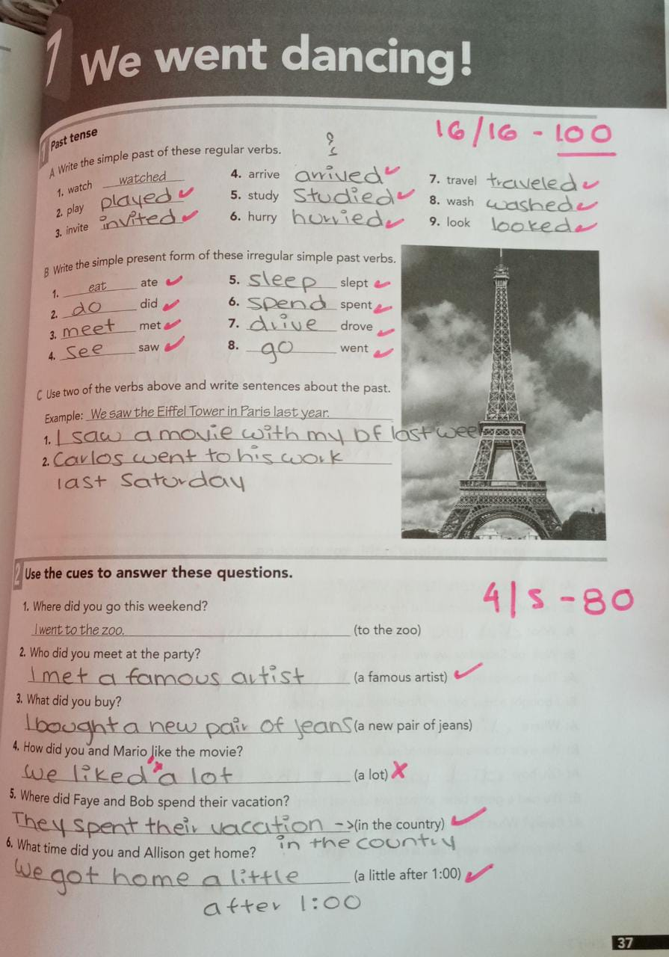

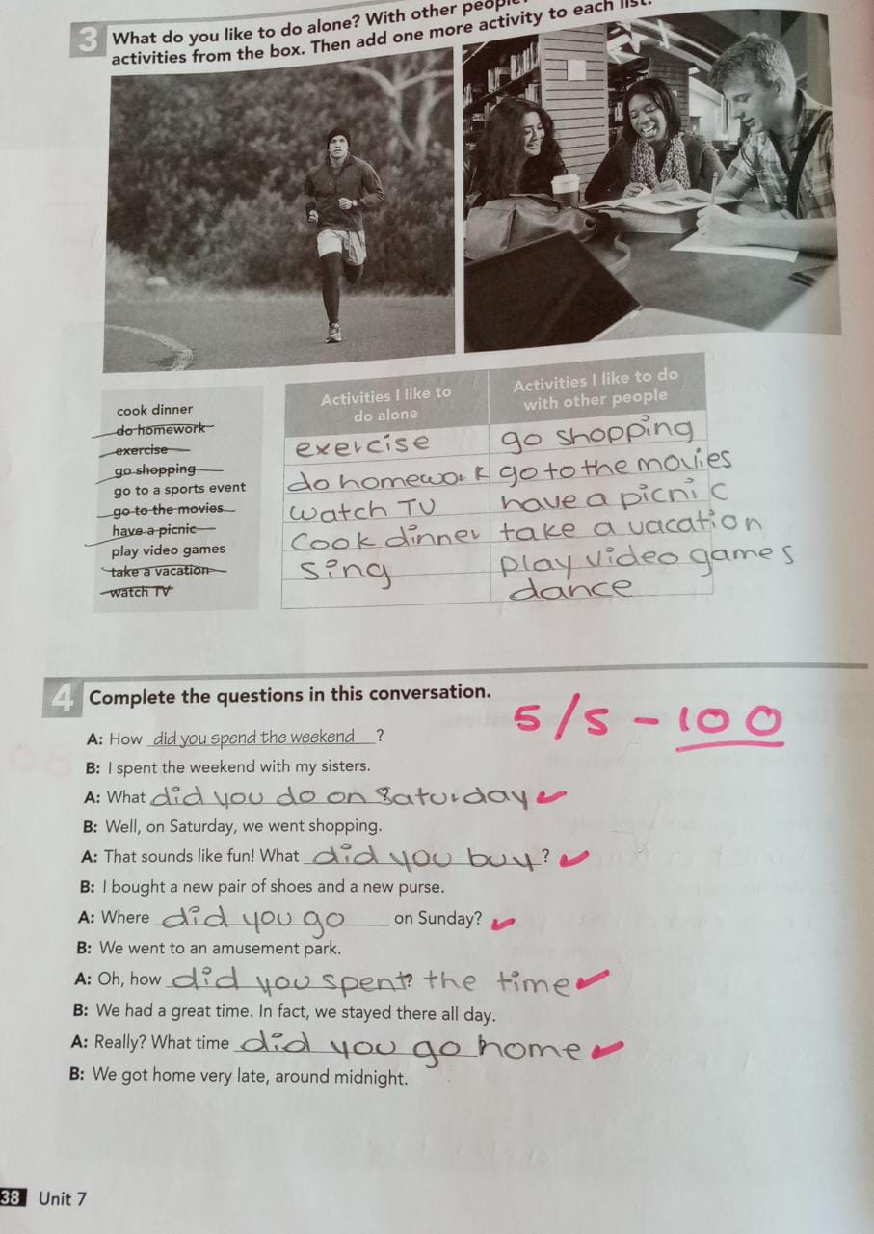

Ex. 4Oh, how did you spend (not spent) the time?....

Ex. 5. No. 4. We finished…. No. 5 . I took,

