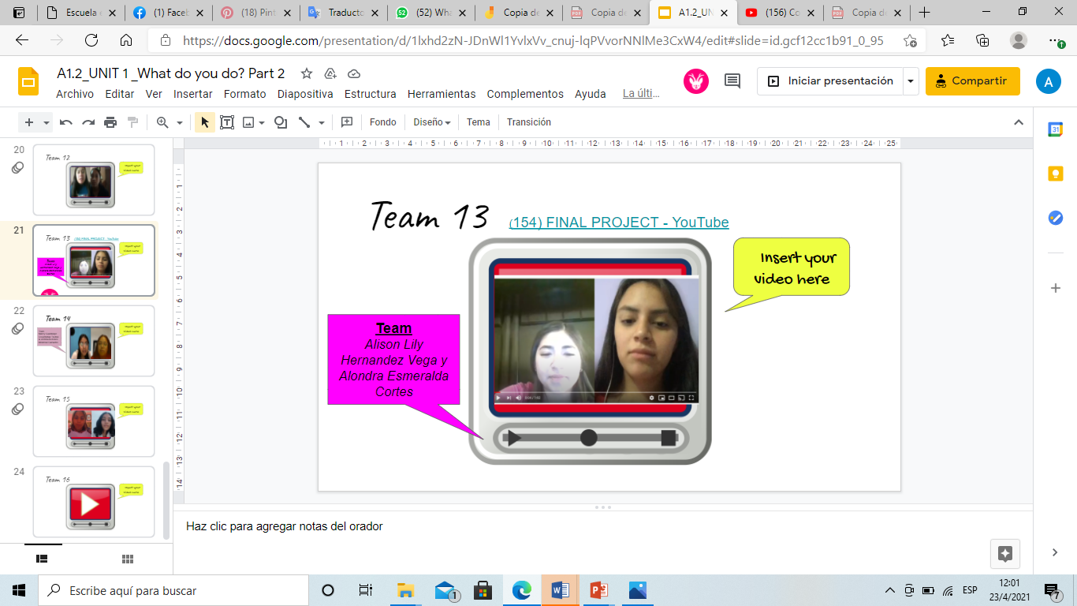Screenshot of the final English project

Team:

Alondra Esmeralda Cortes

Alison Hernandez