**ESCUELA NORMAL DE EDUCACIÓN PREESCOLAR**

**ENGLISH A2.2**

**UNIT 7 – WE WENT DANCING – SIMPLE PAST**

**VOCABULARY**

Dear students, during the week we will practice the **simple past tense**. You will learn how to talk about past events using regular and irregular verbs in affirmative and negative statements. Let’s start with some useful vocabulary!

**ACTIVITY 1 – FREE TIME ACTIVITIES – 15 PTS.**

Check the activities you do in your free time.

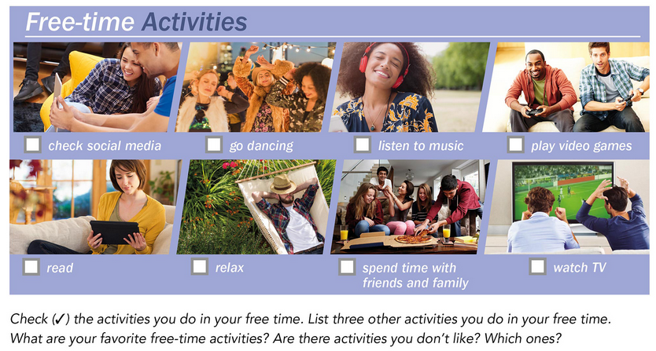

List five other activities you do in your free time.

1. _______ Shopping_________ ___
2. _____Calling my friends_______ ___
3. _ Watching videos on YouTube ____
4. ______Drawing _________________
5. ______Remodel my room ____ ____

**ACTIVITY 2 – FREE TIME ACTIVITIES VOCABULARY – 40 PTS.**

Paste a picture for each action included in the following chart.

|  |  |  |  |
| --- | --- | --- | --- |
| **DAILY ROUTINES** | | | |
| **ACTION** | **PICTURE** | **ACTION** | **PICTURE** |
| Check social media | Social Media Archives - Tweak Library | Have a terrible time | https://i.pinimg.com/564x/fe/44/92/fe44926b25f1f640a5f110d8217df2c7.jpg |
| Do chores | https://i.pinimg.com/564x/eb/b3/58/ebb3586c03f27f8f6845aec8d3458cd0.jpg | Listen to music | https://i.pinimg.com/564x/da/83/cb/da83cb37ae92c5048e16b47575250f18.jpg |
| Do homework | https://i.pinimg.com/564x/79/18/86/791886533c7dc1eebda067f42883de6b.jpg | Make a phone call | https://i.pinimg.com/564x/55/3e/b8/553eb8e2a5f5f0d71152a7312ac3d482.jpg |
| Do the laundry | https://i.pinimg.com/564x/2f/6a/d9/2f6ad96f827f817e4d5685113721f00a.jpg | Make a video | https://i.pinimg.com/564x/49/4e/d0/494ed047ed70b40af63b302ff585341e.jpg |
| Go dancing | https://i.pinimg.com/564x/94/03/36/940336c81bded1e9ef7d32ff72ec6b3e.jpg | Make the bed | https://i.pinimg.com/564x/42/e0/5d/42e05d917f327755ee49090498208f47.jpg |
| Go on a trip | https://i.pinimg.com/564x/1f/40/41/1f4041215e6b41727b6ecb1c0a111430.jpg | Play sports | https://i.pinimg.com/564x/82/8a/f9/828af9d28ef00b2b06879b371d01f7ba.jpg |
| Go online | https://i.pinimg.com/564x/60/eb/1a/60eb1a4f917416661c86335b5e3609cc.jpg | Play video games | https://i.pinimg.com/564x/f9/ee/20/f9ee20f4d5ee26f06c1a8986b2e621c2.jpg |
| Go out with friends | https://i.pinimg.com/564x/fa/c1/2a/fac12a448b6ffa58e0c0f4c407ff22f4.jpg | Read | https://i.pinimg.com/564x/95/1b/5d/951b5dbf15fe53c797171d68eea3dfba.jpg |
| Go shopping | https://i.pinimg.com/564x/96/2c/db/962cdb77b05b3565548dcdafe299c91e.jpg | Relax | https://i.pinimg.com/564x/fd/f0/87/fdf0871d4b6d49fb794e6be42ea38ec2.jpg |
| Go snorkeling | https://i.pinimg.com/564x/c8/5a/00/c85a00373f9398ba36b47fc94d2dbe51.jpg | Spend time with family and friends | https://i.pinimg.com/564x/3c/75/cf/3c75cfb3e957ed884e17fe938a42779e.jpg |
| Go surfing | https://i.pinimg.com/564x/20/bd/7d/20bd7d47a28e2fb9adfe7234b2b38f26.jpg | Take a bike ride | https://i.pinimg.com/564x/68/8a/e3/688ae3c4e6342955e12fbb6e87b69943.jpg |
| Go to a karaoke bar | https://i.pinimg.com/564x/29/56/df/2956df7c9d8b43c3341ac2c1e89e327c.jpg | Take a day off | https://i.pinimg.com/564x/16/b4/7a/16b47a8c1576f0fd46c93bb5004d4d04.jpg |
| Have a boring time | https://i.pinimg.com/564x/fc/f0/de/fcf0de44f24fa5aa85b0b76e05d3830b.jpg | Take a trip | https://i.pinimg.com/564x/29/59/56/2959563ffcb4fbd373945af6fe63c10f.jpg |
| Have a good time | https://i.pinimg.com/564x/ee/a3/df/eea3df55e91693d14131cbfa6c270205.jpg | Take a vacation | https://i.pinimg.com/564x/c1/05/d9/c105d98f5befe94515acb2db708352b3.jpg |
| Have a lot of fun | https://i.pinimg.com/564x/d0/08/5a/d0085a5cbdf59e46716882f095e807c5.jpg | Watch TV | https://i.pinimg.com/564x/89/bf/c1/89bfc10fc0d17f395e32e5159294411c.jpg |
| Have a party | https://i.pinimg.com/564x/f8/4e/58/f84e58e5bc9d76f89ad4ad46e52aeeb8.jpg |  |  |

**ACTIVITY 3 – FREE TIME ACTIVITIES PRACTICE – 15 PTS.**

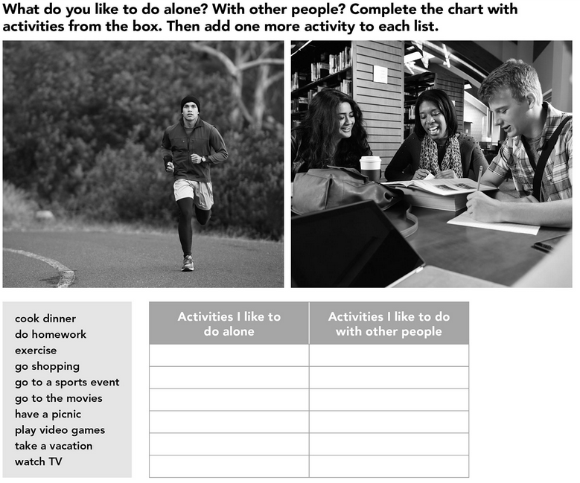

Go shopping

Go to a sports event

Go to movies

Have a picnic

Play video games

Take a vacation

Cook dinner

Do homework

Exercise

Watch TV

**ACTIVITY 4 – WRITING ABOUT FREE TIME ACTIVITIES – 30 PTS.**

Write ten sentences using the vocabulary you learned.

1. I don't always like to make the bed.
2. I like read at night.
3. When there are long vacations and I don’t know what to do, I usually have a boring time.
4. Many of my friends have even said to me "Take a day off".
5. I used to go dancing with my friends in a square in my hometown.
6. ¡ Watching TV in the evening is the best part of the day!
7. In my house we take turns to do the chores.
8. We all have a party for Sara's birth.
9. My routine is to do my homework from 6:00 p.m. onwards.
10. I would like to take a vacation in a meadow.