**ESCUELA NORMAL DE EDUCACIÓN PREESCOLAR**

**ENGLISH A2.2**

**UNIT 7 – WE WENT DANCING – SIMPLE PAST**

**GRAMMAR – AFFIRMATIVE AND NEGATIVE STATEMENTS**

Dear students, during the week we will practice the **simple past tense**. You will learn how to talk about past events using regular and irregular verbs in affirmative and negative statements.

**ACTIVITY 1 – USING THE SIMPLE PAST**

Read the information about when to use the simple past.

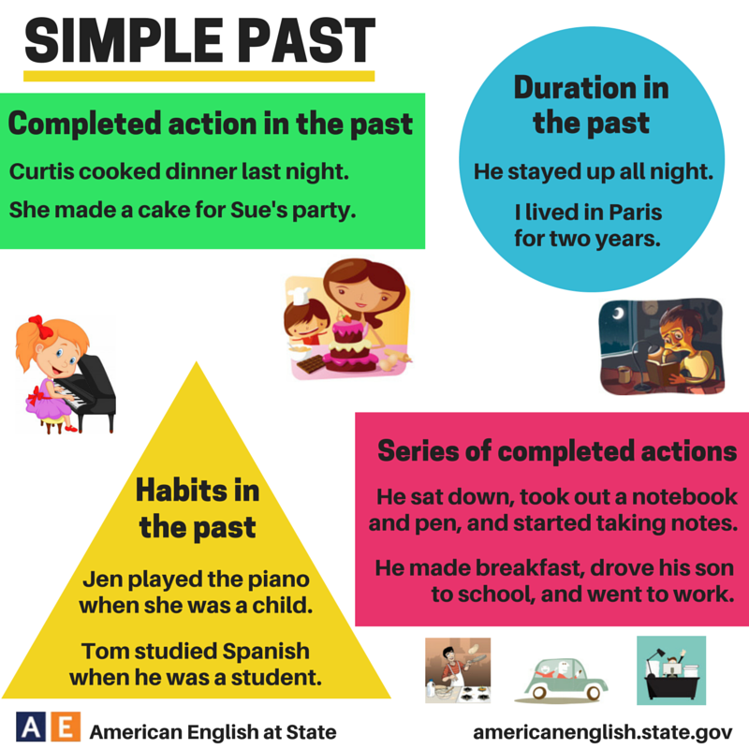

Utilizamos el **pasado simple** para:

* Hablar de una acción o una serie de acciones que ocurrieron en el pasado.
  + *I went to the movies last weekend. / Fui al cine el fin de semana pasado.*
  + *My father took a shower, ate breakfast and went to work. / Mi papa se tomó un baño, comió el desayuno y se fue a trabajar.*
* Hablar de acciones que ocurrieron durante un período de tiempo en el pasado.
  + *I lived in Mérida for two years. / Yo viví en Mérida por dos años.*
* Hablar de cosas que solíamos hacer en el pasado.
  + *She played the piano when she was a child. / Ella tocó el piano cuando era niña.*
  + *Tom studied Spanish when he was a student. / Tom estudió español cuando era estudiante.*

**Go to** [**https://www.youtube.com/watch?v=vYF4uYCUsD0**](https://www.youtube.com/watch?v=vYF4uYCUsD0) **watch the video and analyze the information, then complete the following tasks.**

**ACTIVITY 2 – TIME EXPRESSIONS – 30 PTS.**

Classify the expressions from the box according to the tense in which they are used.

Everyday Now Last year Three weeks ago on weekends

Right now Yesterday At the moment An hour ago Last month

Two days ago Always Last night Sometimes In 1999

In the morning When I was little Just now Never

|  |  |  |
| --- | --- | --- |
| **SIMPLE PRESENT**  **(routines)** | **PRESENT CONTINUOUS**  **(events happening now)** | **SIMPLE PAST**  **(events in the past)** |
| **On weekends**  **Everyday**  **In the morning**  **Sometimes**  **Always**  **Never** | **Now**  **Right now**  **At the moment**  **Just now** | **Last year**  **Three weeks ago**  **When I was little**  **In 1999**  **Last night**  **Two days ago**  **Last month**  **Yesterday**  **An hour ago** |

**When was the last time you did these activities?** Complete the sentences with your own information using the time expressions to talk about the past.

1. I went to a party ______last nigth_________.
2. I visited my grandparents ________always________.
3. I ate meat ________sometimes______________.
4. I bought something online ______two day ago__________.
5. I woke up late ______in the morning_________.
6. I gave a birthday present _______yesterday______.
7. I helped my mother _______everyday_______.
8. I did the laundry _____just now_________.
9. I traveled with my family _______last week__________.
10. I rode a bicycle ______on weekend____.

**ACTIVITY 3 – REGULAR AND IRREGULAR VERBS – 20 PTS.**

Cuando utilizamos el pasado simple para hablar de eventos que ya ocurrieron, el verbo cambia. Los verbos se clasifican en:

* **Verbos regulares:** aquellos a los que solamente se les agrega -d, -ed o -ied al hablar en pasado. Para conocer las reglas para los verbos regulares en pasado ve a <https://www.youtube.com/watch?v=fLHrVG3IpbM> observa y analiza el video.

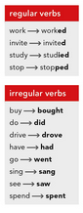

* **Verbos irregulares:** aquellos que cambian por completo al utilizarlos en tiempo pasado.



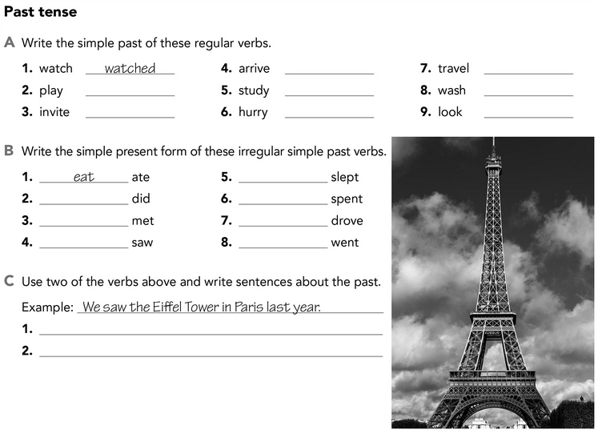

I slept on the flight to Paris

We went to see the soccer game last week

go

drive

spend

Sleep

see

meet

do

looked

washed

traveled

hurried

studied

arrived

invited

played

**ACTIVITY 4 – AFFIRMATIVE AND NEGATIVE STATEMENTS – 30 PTS.**

**Go to** [**https://www.youtube.com/watch?v=vYF4uYCUsD0**](https://www.youtube.com/watch?v=vYF4uYCUsD0) **watch the video and analyze the information, then complete the following tasks.**

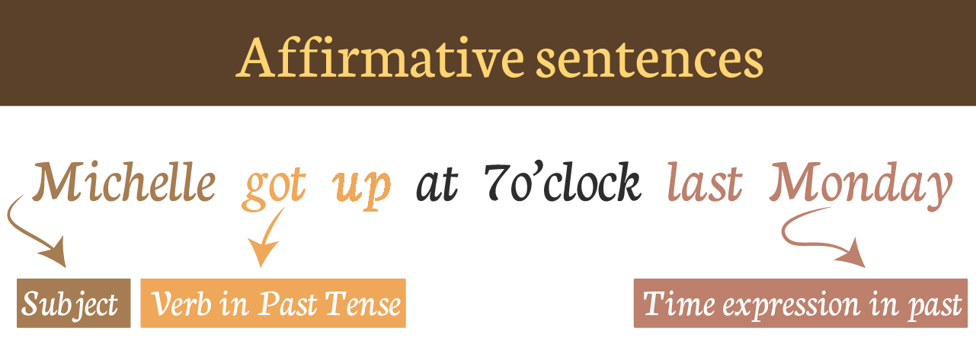

Let´s practice. Look at the following sentences. Write in the box the verbs that are in parenthesis to simple past. The first 10 sentences use regular verbs and the following 10 irregular verbs. You can check the list of verbs in Escuela en Red.

*Example. We (work)****worked****in our garden all day yesterday.*

I (listen) ___listened___ to the news on TV last night.

They (live) ___lived__ in England many years.

She (worry) ____worried____ about her exam last Friday morning.

The meeting (last) ___lasted____ for about two hours.

They (paint) ____painted___ their house last weekend.

We (change) ___changed___ trains in Liverpool.

He (like) ___liked____ the movie very much.

She always (want) ____wanted___ to learn English.

We (wait) _____waited_____ for Helen for two hours.

They (tell) ____telled____ us about their plans for next year.

The weather was warm, so we (sit) ___sited____ in our backyard.

The meeting last night (begin) ___begined____ an hour late.

Mr. López finally (sell) ___selled____ his house last week.

The ticket (cost) ___costed___ 75 pesos.

I (hear) ___heared____ the presidential debate last Wednesday.

Susan (feel) ____feeled___ bad last class.

I (see) ___saw_____ my exboyfriend with another woman.

He (write) ___writed___ many love letters to her.

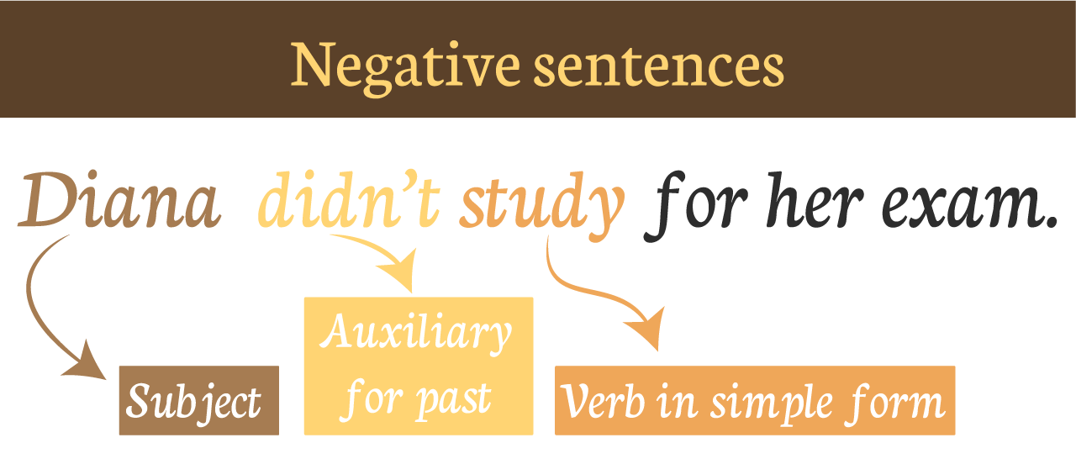

Diana is Michelle’s friend, she likes to party, and she didn’t study for her exam because she went out with her boyfriend.  
Read the following sentences about activities that Michelle DID and rewrite them describing what Diana DIDN’T do. Look at the example.  
**Example:**  
  
Michelle prepared her things for school on Sunday night.  
**You write:** Diana ***didn’t prepare*** her things on Sunday night.

Michelle went to bed early.

Diana ____didn’t was____ to bed early.

Michelle studied for her exams.

Diana __didn`t study___ for her exams.

Michelle had breakfast on Monday morning.

Diana didn't has breakfast on Monday morning.

Michelle passed her exams.

Diana didn’t pass her exams.

Michelle got up early.

Diana didn't get up early.

Michelle arrived to school on time.

Diana didn't arrive to school on time.

Michelle gave good news to her mother.

Diana didn't give good news to her mother.

Michelle read books in the library before her exam.

Diana didn`t read books in the library before her exam.

Michelle paid attention in class.

Diana didn't pay attention in class.

**ACTIVITY 4 – PAST OF BE – 20 PTS.**

El verbo “be” (ser o estar) puede ser usado en pasado utilizando las palabras “was” o “were” dependiendo del pronombre que se utiliza.

* **Para los pronombres singulares** (I, He, She, It) se utiliza WAS.
  + I WAS in Mazatlán last week. / Yo estuve en Mazatlán la semana pasada.
  + The weather WAS cold yesterday. / El clima estuvo frío ayer.
  + My sister WAS a dancer for 5 years. / Mi hermana fue bailarina por 5 años.
* **Para los pronombres plurales** (You, We, They) se utiliza WERE.
  + My parents WERE mad at me. / Mis papás estaban enojados conmigo.
  + You WERE my best friend at school. / Tú eras mi major amigo en la escuela.

Go to <https://www.youtube.com/watch?v=r8Hv3GOv_b0> and watch the video for more examples and a more detailed explanation.

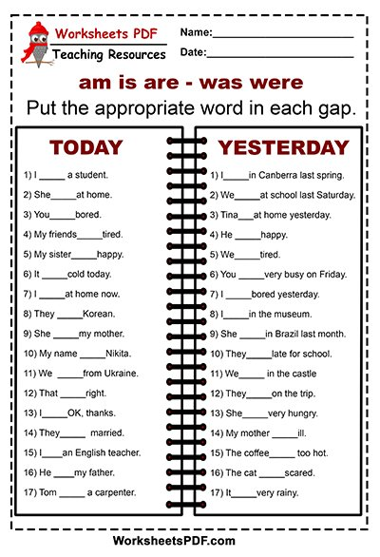

was

were

were

was

was

was

were

were

were

was

was

was

were

were

was

were

was