**ESCUELA NORMAL DE EDUCACIÓN PREESCOLAR**

**ENGLISH A2.2**

**UNIT 5 – EXPANDING YOUR HORIZONS**

**VOCABULARY**

Dear students, during the week we will discuss living in a foreign country and describe cultural expectations and differences. Let’s start with some useful vocabulary!

**ACTIVITY 1 – FEELINGS – 40 PTS.**

Find the meaning of each one of these feelings and write how often you have them. Write **A** for *always*, **U** for *usually*, **S** for *sometimes*, or **N** for *never*. Then complete the chart with situations when you have these feelings. Look at the example.

|  |  |  |
| --- | --- | --- |
| **FEELING** | **HOW OFTEN?** | **SITUATION** |
| Anxious | **S** | *I feel anxious when I’m waiting for my final grades.* |
| Cheerful | **U** | *I feel cheerful when I’m on vacation* |
| Comfortable | **U** | *I feel comfortable when I’m I sleep well* |
| Confident | **S** | *I feel confident when i talk to a friend i can trust* |
| Curious | **S** | *I feel curious when my dog is silent* |
| Depressed | **S** | *I feel depressed when I don't understand some things about school* |
| Embarrassed | **S** | *I feel embarrassed when I talk to someone, I don't know very well* |
| Enthusiastic | **U** | *I feel enthusiastic when I start a new school year* |
| Excited | **U** | *I feel excited when tell me that we are going to return to face-to-face classes* |
| Fascinated | **N** | *I feel* Fascinated when they don't leave me much homework |
| Grouchy | **S** | *I feel* Grouchy when i haven't slept well |
| Homesick | **S** | *I feel* Homesick when I watch a romantic movie |
| Hopeful | **S** | *I feel* Hopeful when I watch a news |
| Insecure | **U** | *I feel* Insecure when I walk alone in the street |
| Lonely | **U** | *I feel* Lonely when my whole family is going to work |
| Nervous | **U** | *I feel* Nervous when i meet someone new |
| Proud | **U** | *I feel* Proud when i get good grades |
| Silly | **N** | *I feel* Silly when I don't understand some task |
| Sleepy | **S** | *I feel* Sleepy when I wake up watching movies |
| Uncertain | **N** | *I feel* Uncertain when I don't feel like going somewhere |
| Uncomfortable | **S** | *I feel* Uncomfortable when I don't know anyone at the party |
| Worried | **S** | *I feel* Worried when I don't have more time to send homework |

**ACTIVITY 2 – FEELINGS – 20 PTS.**

Write P for positive feelings and N for negative feelings.

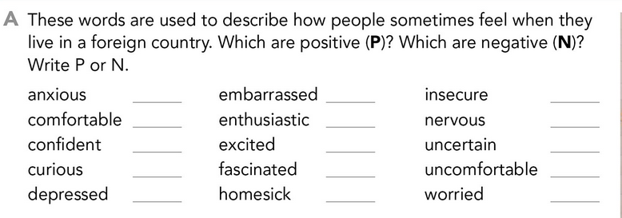



**ACTIVITY 3 – FEELINGS – 20 PTS.**

Complete these sentences, use the words from the box.

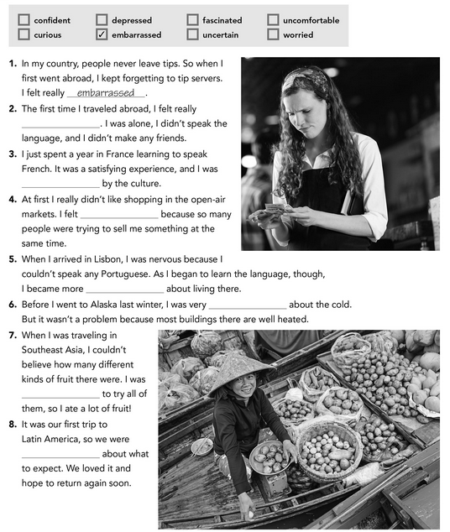



**ACTIVITY 4 – WRITING – 20 PTS.**

Answer the following questions. Provide extended responses.

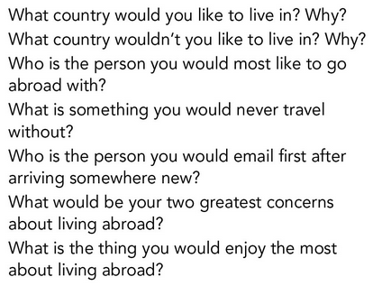

Write your answers here:

1. I would like to live in France because there are many beautiful places to visit, usually, people dress well, the clothes are very cute.
2. I would not like to live in Antarctica since it is very cold and I have never liked going out in the cold, even though I like snow, I wouldn't take it every day
3. with my best friend, because I've always traveled with her, and she's a lot of fun, and we both like to see new places
4. I would never travel without my cell phone because I could not take photos and if I get lost it can be very useful
5. to my parents, because they are always worried about where I am
6. not being able to see my family every day, having to meet new people and learn their language, traditions and culture
7. the same way, that everything will be new both the people, the traditions. the culture, the place