**ESCUELA NORMAL DE EDUCACIÓN PREESCOLAR**

**ENGLISH A2.2**

**UNIT 5 – EXPANDING YOUR HORIZONS**

**VOCABULARY**

Dear students, during the week we will discuss living in a foreign country and describe cultural expectations and differences. Let’s start with some useful vocabulary!

**ACTIVITY 1 – FEELINGS – 40 PTS.**

Find the meaning of each one of these feelings and write how often you have them. Write **A** for *always*, **U** for *usually*, **S** for *sometimes*, or **N** for *never*. Then complete the chart with situations when you have these feelings. Look at the example.

|  |  |  |
| --- | --- | --- |
| **FEELING** | **HOW OFTEN?** | **SITUATION** |
| Anxious | **S** | *I feel anxious when I’m waiting for my final grades.* |
| Cheerful | **U** | *I usually feel cheerful when I´m going on vacation.* |
| Comfortable | **U** | *I feel comfortable when I´m in my bed watching movies.* |
| Confident | **U** | *When I look good I feel confident.* |
| Curious | **S** | *When I don't know a subject I feel curious about it.* |
| Depressed | **S** | *In a rainy and cold day I feel a little depressed.* |
| Embarrassed | **S** | *When I fall down in the street I feel embarrassed.* |
| Enthusiastic | **S** | *I feel enthusiastic when I do something new.* |
| Excited | **A** | *I feel excited when I get on a roller coaster.* |
| Fascinated | **S** | *When I go to a magic place like Disney I feel fascinated.* |
| Grouchy | **A** | *I feel grouchy when I haven't eat.* |
| Homesick | **U** | *I feel homesick when I sit to watch a album with photos of my family.* |
| Hopeful | **S** | *Once I was in love and I was hopeful he would be the love of my life.* |
| Insecure | **A** | *When I´m in a bikini I feel insecure of my body.* |
| Lonely | **U** | *When my family go to a trip without me I feel lonely.* |
| Nervous | **U** | *When I have a date with a boy I usually feel nervous.* |
| Proud | **S** | *I feel proud when I receive a an acknowledgment.* |
| Silly | **S** | *In a congress I feel silly, around all that people with a lot of knowledge.* |
| Sleepy | **A** | *In the first class I feel sleepy, because it's at 7:45 am.* |
| Uncertain | **U** | *When it´s weekend I have an uncertain plan. I do the plan at the moment.* |
| Uncomfortable | **S** | *When I have a bad grade without explanation, I feel uncomfortable.* |
| Worried | **U** | *I feel worried when I need to deliver a homework in less than a hour.* |

**ACTIVITY 2 – FEELINGS – 20 PTS.**

Write P for positive feelings and N for negative feelings.

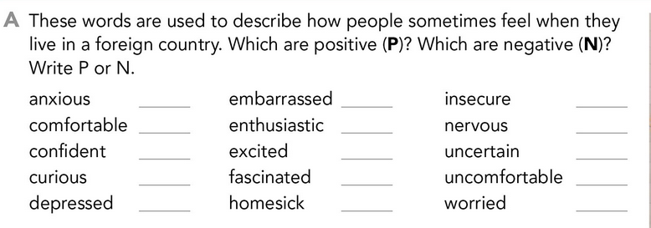

P

P

P

P

P

P

N

N

N

N

N

N

N

N

N

**ACTIVITY 3 – FEELINGS – 20 PTS.**

Complete these sentences, use the words from the box.

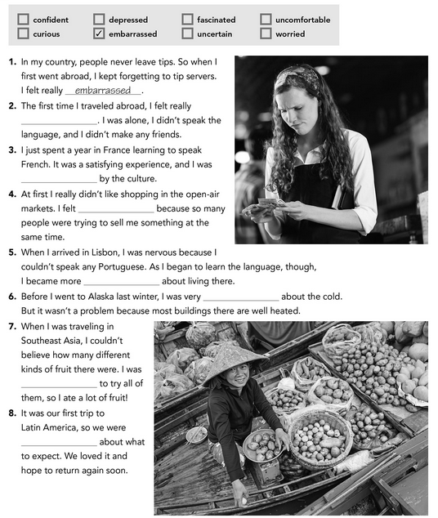

uncertain

curious

fascinated

worried

confident

worried

depressed

**ACTIVITY 4 – WRITING – 20 PTS.**

Answer the following questions. Provide extended responses.

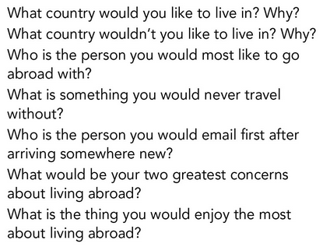

Write your answers here:

1. I would like to live in Germany because I like how they have everything in order. Public transportation and medical secure.
2. I wouldn't like to live in Africa because I think they don't respect or give the value they need to the women’s and its insecure.
3. I would like to travel with persons who like to take pictures, adventures people and easygoing.
4. I wouldn't like to travel with short temper people and people that always is angry or doesn´t like to do adventurous things.
5. I will email my mother to report that I´m fine.
6. You will have a culture shock and it´s a new culture.
7. The thing you would enjoy are the experience , adventures and memories you'll receive.