**ESCUELA NORMAL DE EDUCACIÓN PREESCOLAR**

**ENGLISH A2.2**

**UNIT 5 – EXPANDING YOUR HORIZONS**

**VOCABULARY**

Dear students, during the week we will discuss living in a foreign country and describe cultural expectations and differences. Let’s start with some useful vocabulary!

**ACTIVITY 1 – FEELINGS – 40 PTS.**

Find the meaning of each one of these feelings and write how often you have them. Write **A** for *always*, **U** for *usually*, **S** for *sometimes*, or **N** for *never*. Then complete the chart with situations when you have these feelings. Look at the example.

|  |  |  |
| --- | --- | --- |
| **FEELING** | **HOW OFTEN?** | **SITUATION** |
| Anxious | **S** | *I feel anxious when I’m waiting for my final grades.* |
| Cheerful | **A** | *I feel cheerful when I go to the gym* |
| Comfortable | **U** | *I feel comfortable when I wear pants* |
| Confident | **U** | *I feel confident when I’m talking with my best friends* |
| Curious | **S** | *I feel curious when I hear a gossip* |
| Depressed | **S** | *I feel depressed when a man disappoints me* |
| Embarrassed | **S** | *I feel embarrassed when I forgot how to say a word in english* |
| Enthusiastic | **A** | *I feel enthusiastic when i go to dance* |
| Excited | **A** | *I feel excited when I get good grades* |
| Fascinated | **S** | *I feel fascinated when I go to a trip* |
| Grouchy | **S** | *I feel grouchy when the waiter is late to bring me the food* |
| Homesick | **U** | *I feel homesick when I have a lot of homework* |
| Hopeful | **A** | *I feel hopeful when I studied for a math exam.* |
| Insecure | **U** | *I feel insecure when i go to run.* |
| Lonely | **S** | *I feel lonely when there´s no one at my home.* |
| Nervous | **S** | *I feel nervous when I go on a date* |
| Proud | **A** | *I feel proud when I do all the died.* |
| Silly | **A** | *I feel silly when I’m on math class* |
| Sleepy | **U** | *I feel sleepy when I don’t sleep well the day before* |
| Uncertain | **U** | *I feel uncertain when I don´t know someone´s intentions.* |
| Uncomfortable | **S** | *I feel uncomfortable when I use shorts on public* |
| Worried | **U** | *I feel worried for my future* |

**ACTIVITY 2 – FEELINGS – 20 PTS.**

Write P for positive feelings and N for negative feelings.

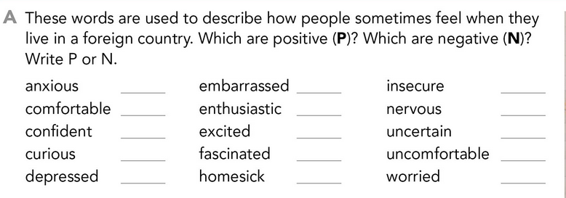

N

P

P

P

P

P

N

N

N

N

N

N

N

N

N

**ACTIVITY 3 – FEELINGS – 20 PTS.**

Complete these sentences, use the words from the box.

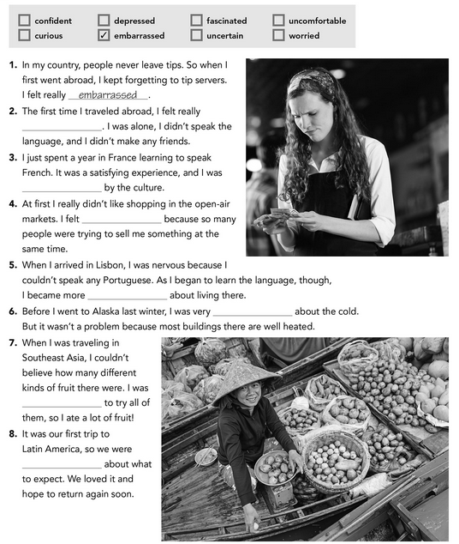

depressed

curious

uncomfortable

uncertain

fascinated

worried

**ACTIVITY 4 – WRITING – 20 PTS.**

Answer the following questions. Provide extended responses.

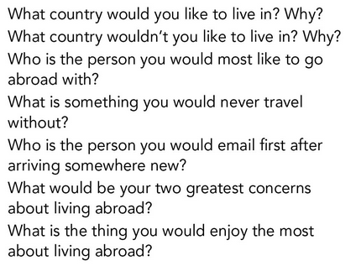

Write your answers here:

1. I would like to live in Saltillo or San Antonio Tx. They are both beautiful cities and I love them.
2. I wouldn´t like to live in Monterrey because is a very huge city, the people in there is and the worst of it is that has a LOT of traffic, I hate traffic!!
3. I’m always glad and happy to talk with my mom.
4. I would never travel without my air pods, I hate go on a trip and don´t listen music.
5. I would write an email to my dad or my sister.
6. I think two concerns of living abroad would be that I need to cook by myself and know their native language
7. I would be enjoy and excited to meet new people.