**ESCUELA NORMAL DE EDUCACIÓN PREESCOLAR**

**ENGLISH A2.2**

**UNIT 5 – EXPANDING YOUR HORIZONS**

**VOCABULARY**

Dear students, during the week we will discuss living in a foreign country and describe cultural expectations and differences. Let’s start with some useful vocabulary!

**ACTIVITY 1 – FEELINGS – 40 PTS.**

Find the meaning of each one of these feelings and write how often you have them. Write **A** for *always*, **U** for *usually*, **S** for *sometimes*, or **N** for *never*. Then complete the chart with situations when you have these feelings. Look at the example.

|  |  |  |
| --- | --- | --- |
| **FEELING** | **HOW OFTEN?** | **SITUATION** |
| Anxious | **S** | *I feel anxious when I’m waiting for my final grades.* |
| Cheerful | **A** | *I feel cheerful when It's Saturday and they pay at work.* |
| Comfortable | **U** | *I feel comfortable when I finish my homework.* |
| Confident | **U** | *I feel confident when I study for an exam.* |
| Curious | **S** | *I feel curious when a new class starts.* |
| Depressed | **S** | *I feel depressed when they don't give me attention.* |
| Embarrassed | **S** | *I feel embarrassed when I fall and people see me.* |
| Enthusiastic | **A** | *I feel enthusiastic when it’s Monday.* |
| Excited | **A** | *I feel excited when they ask me out.* |
| Fascinated | **A** | *I feel fascinated when my grandma makes my favorite food* |
| Grouchy | **U** | *I feel grouchy when they pressure me.* |
| Homesick | **U** | *I feel homesick when it dawns cloudy.* |
| Hopeful | **A** | *I feel hopeful when I pray.* |
| Insecure | **S** | *I feel secure when I’m wrong at work.* |
| Lonely | **U** | *I feel lonely when my friends go out without me.* |
| Nervous | **U** | *I feel nervous when the teacher asks me something I don't know.* |
| Proud | **A** | *I feel proud when I do things right.* |
| Silly | **S** | *I feel silly when I get distracted in class.* |
| Sleepy | **A** | *I feel sleepy when I have classes at 7:45.* |
| Uncertain |  |  |
| Uncomfortable | **S** | *I feel uncomfortable when someone walks behind me.* |
| Worried | **U** | *I feel worried when I don't understand the homework.* |

**ACTIVITY 2 – FEELINGS – 20 PTS.**

Write P for positive feelings and N for negative feelings.

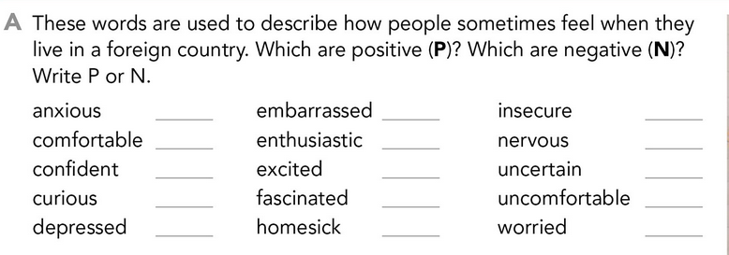

N

N

N

N

N

N

P

P

P

N

N

P

P

P

P

**ACTIVITY 3 – FEELINGS – 20 PTS.**

Complete these sentences, use the words from the box.

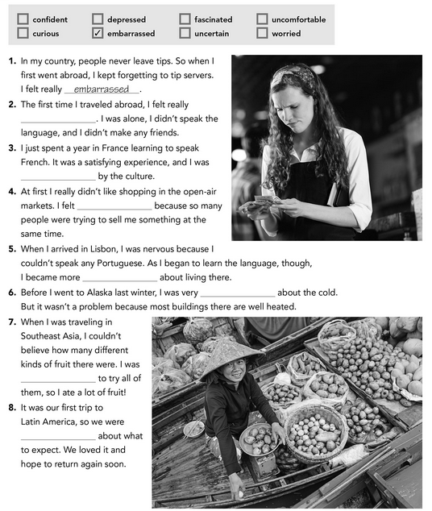

uncertain

Curious

worried

confident

Uncomfortable 

fascinated

depressed

**ACTIVITY 4 – WRITING – 20 PTS.**

Answer the following questions. Provide extended responses.

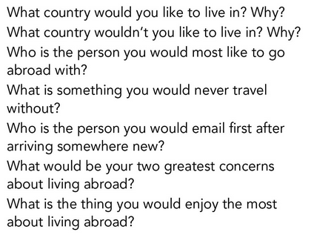

Write your answers here:

1. I would like to live in Canada because I like its climate.
2. I would not like to live in China because I do not like their food and I think their language is very difficult.
3. The person I would like to travel abroad with is my friend Ciany because she speaks English very well and likes to travel.
4. I would never travel without my cell phone to be in communication with my family and without my camera.
5. I would email my family to let me know that I am already at the hotel.
6. Not being able to communicate correctly and get lost.
7. What I would most enjoy living abroad would be being able to see new places.