**ESCUELA NORMAL DE EDUCACIÓN PREESCOLAR**

**ENGLISH B1.2**

**BOOK UNIT 5 – EXPANDING YOUR HORIZONS**

**GRAMMAR**

Dear students, during the week we will discuss living in a foreign country and describing cultural expectations and differences.

**ACTIVITY 1 – READING ABOUT TRAVELING ABROAD – 10 PTS.**

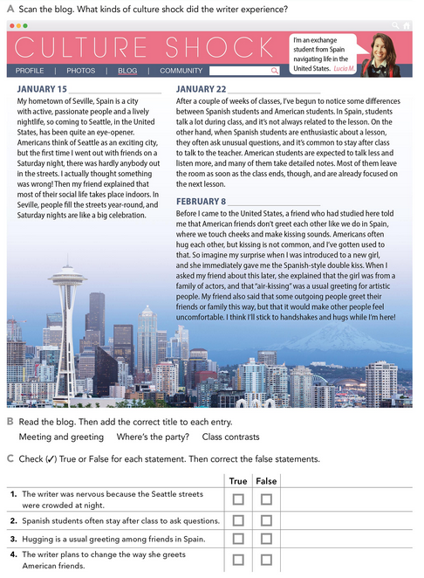

**ACTIVITY 2 – NOUN PHRASES CONTAINING RELATIVE CLAUSES – 45 PTS.**

Read the following information and analyze the examples. These are expressions to discuss living in a foreign country.

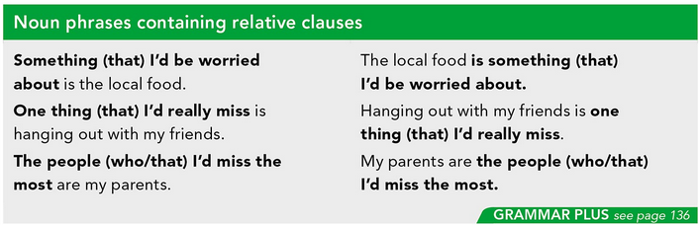

Complete the sentences about living in a foreign country using the phrases in the box. Look at the examples.

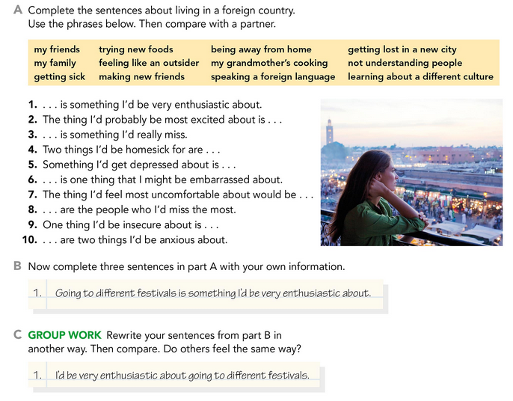

Write your responses here:

1. Making new friends is something i´d be very enthusiastic about.

2. The thing i´d probably be most excited about is speaking a foreign language

3. My friends is something i´d really miss

4. two things i´d be homesick for are my family and my grandmother´s cooking.

5. Something i´d get depressed about is being away from home.

6. Not understand people is something that I might be embarrassed about.

7. The thing i´d feel most comfortable about would be learning about different culture.

8. My family are the people who I’d miss the most.

9. One thing I’d be insecure about it is not understanding people.

10. Getting lost in a new city and being away from home are two things I’d be anxious about.

**B**. 3 Different sentences with my own information:

1. Something I’d get depressed about is being away of my dog.
2. The thing I’d feel comfortable about would be dancing ballet or jazz.
3. Going to Hawaii or Disneyland is something I’d be very enthusiastic about.

Write about living in a foreign country. In the first paragraph, write about two things you would enjoy. In the second paragraph, write about two things you might worry about. Look at the example.

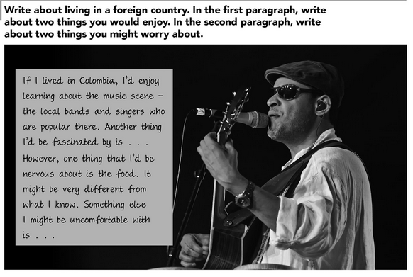

**If I lived in Spain, I’ll be enjoy to meet new people and I won’t be nervous because they speak the same language as me. Also I’m excited because they have presentations on the streets about people dancing flamenco, is a very beautiful and traditional type of dance of spain.**

**ACTIVITY 3 – EXPECTATIONS – 45 PTS.**

Read the following information and analyze the examples. These are expressions to describe cultural differences and customs.

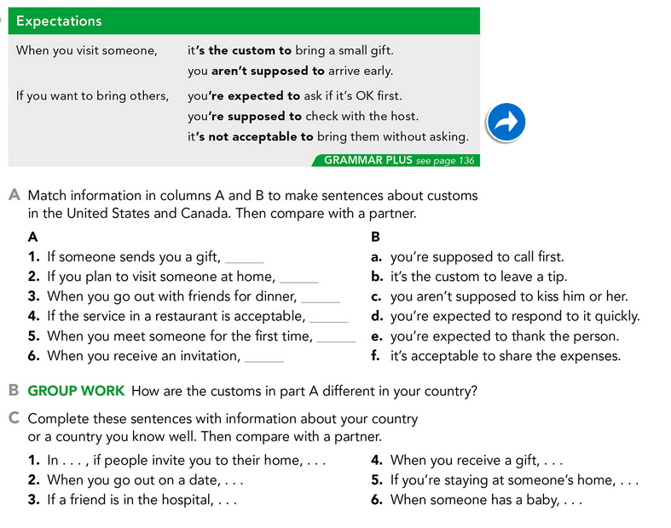

Write your responses here:

1. If someone sends you a gift, you’re expected to thank the person
2. If you plan to visit someone at home, you´re supposed to call first.
3. When you go out with friends for dinner, it’s acceptable to share the expenses
4. If the service on the restaurants is acceptable, it´s the custom to leave a tip.
5. When you meet someone for the first time, you aren´t supposed to kiss him or her.
6. When you receive an invitation, you´re expected to respond quickly.

1. In Mexico, if people invite you to their home, it´s acceptable to bring some food to snack

2. When you out on a date in Mexico, the guy is supposed to go through you.

3. If a friend is in the hospital, you´re supposed to go to visited him or her with a present.

4. When you receive a gift, you´re expected to thank the person.

5. if you´re staying at someone´s home, its the custom to go to sleep late.

6. When someone has a baby, it´s the custom when you go to meet it, you gave a present.

Complete these sentences by giving information about customs in a country you know.

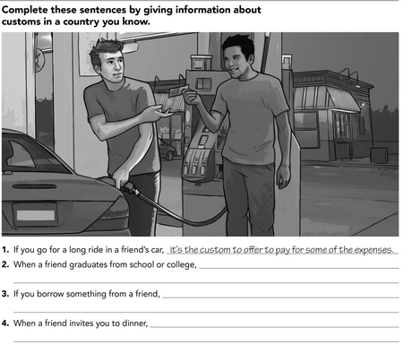

It’s the custom to offer to pay your part of the dinner.

It’s the custom to return it when you finish to used

It’s the custom to go to their graduation party