**Units 7–8 *QUIZ***

Name: Nataly Melissa Reynoso Pérez

Date: 04/23/2021

Score: 83+89+75+100+75= 84.4

Graded by Samantha Sanchez

Vicky and Paolo are talking about their vacations. Listen and check (✓) the correct answers. **⅚ = 83**

**A**

|  |  |  |  |  |  |  |  |
| --- | --- | --- | --- | --- | --- | --- | --- |
| **Name** | **Country visited** | | | **Weather** | | | |
| **Vicky** | ✔️ Costa Rica | ⬜ China | ⬜ India | ✔️windy | ⬜ sunny | ⬜ warm | ✔️cool |
| **Paolo** | ⬜ Australia game | ⬜ Chile | ✔️ Canada | ⬜ windy | ✔️ sunny | warm | ✔️ cool |

Complete the conversation. Use the correct form of verbs. **(8 POINTS) 8/9 = 89**

**B**

A: _____________ you _____________ (stay) home last night?

*Did*

*stay*

B: No, I didn’t.

A: What **did** you **do** (do)?

B: I **went** (go) dancing at the new club on Eighth Street.   
Suzie and Mike **were** (be) there, too.

A: Oh, really?

B: Yes, we **had** (have) a great time! But where **was** (be) you?

A: Well, I **was** (be) in the laundromat all evening.

B: How boring!

A: Actually, it wasn’t boring. I **met** (meet) my girlfriend there.   
We **spent** (spend) the evening laughing and talking.

Write the correct place in each set of sentences. **(4 POINTS) ¾ = 75**

**C**

*hair salon*

*Example:* My hair was pretty long. I needed a haircut, so I went to the ~~theater~~.

1. All my clothes were dirty. I wanted to wash them, so I went to the ~~library~~  **laundromat.**

2. I went to the ~~post office~~ **grocery store**. I was very hungry. I needed to buy food.

3. I went to the ~~drugstore~~ **shopping clothe** . I want to go to a party. I need a new T-shirt and jeans.

4. I don’t have a computer. I wanted to read the news, so I went to the ~~grocery store~~ **newsstand**.

Circle the correct word or phrase. **(5 POINTS) 7/7 = 100**

**D**

1. A: Excuse me. Is there a bank near here?

B: Yes, there is. There’s (any / one/some) around the corner.

2. A: Are there (few / many / much) drugstores in this neighborhood?

B: Well, there are (a few / a little / not much).

3. A: Is there (many / much / one) public transportation near here?

B: No, there isn’t (any / one / none) public transportation in this town.

4. A. Hi there! Are there (any/ much / a little) bus stops nearby?

B. No, there is (any / much / none) around here. You have to walk one mile.

Read Gina’s email. Then check (✓) four things you can do at places in her neighborhood. **(4 POINTS) ¾ = 75**

**E**

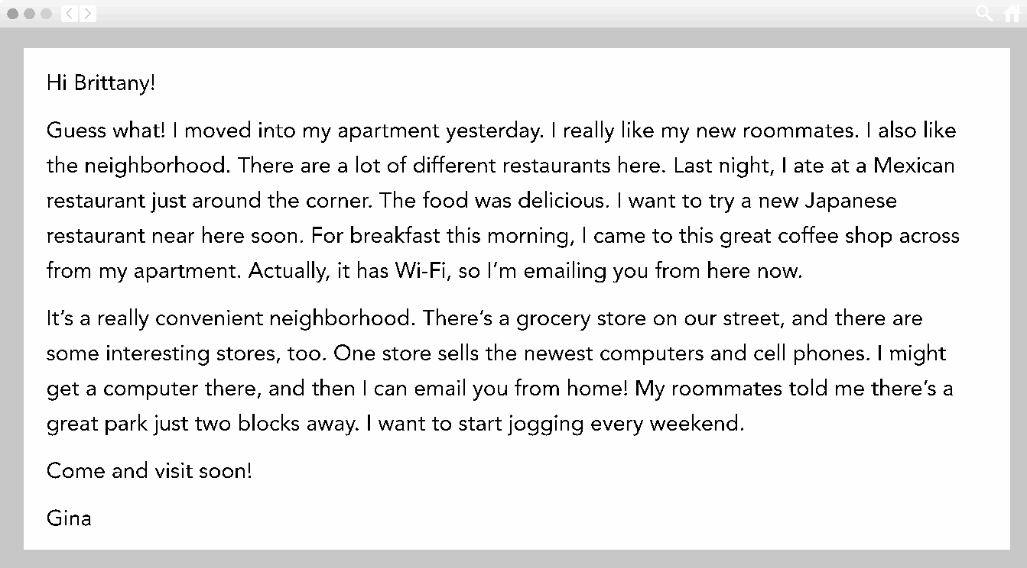

|  |  |
| --- | --- |
| ⬜ borrow books | ✔️ buy electronics |
| ✔️ eat different kinds of food | ⬜ make travel arrangements |
| ✔️ go jogging | ⬜ see movies |
| ⬜ get a haircut | ⬜ send emails |
| ⬜ go dancing | ⬜ wash and dry clothes |