**Units 7–8** *QUIZ*

Name: Carla Samantha Sanchez Calderón

Date: Friday April 23th 2021

Score: ____100 +___67 + 100 + 71 + 100 = 438 /5 =87.6

Graded by: Andrea Sanguino

Vicky and Paolo are talking about their vacations. Listen and check (✓) the correct answers. **(4 POINTS)****6/6 100**

**A**

|  |  |  |  |  |  |  |  |
| --- | --- | --- | --- | --- | --- | --- | --- |
| **Name** | **Country visited** | | | **Weather** | | | |
| **Vicky** | ⬜ Costa Rica | ⬜ China | ⬜ India | ⬜ windy | ⬜ sunny | ⬜ warm | ⬜ cool |
| **Paolo** | ⬜ Australia game | ⬜ Chile | ⬜ Canada | ⬜ windy | ⬜ sunny | ⬜ warm | ⬜ cool |

Complete the conversation. Use the correct form of verbs. **(8 POINTS)** **6/9 67**

**B**

A: _did_OK you stay_ (stay) home last night? OK

*Did*

*stay*

B: No, I didn’t.

A: What _did__ OKyou __do__ (do)? OK

B: I __went__OK (go) dancing at the new club on Eighth Street. OK  
Suzie and Mike __being_ (be) there, too.

A: Oh, really?

B: Yes, we __had__ (have) a great time! But where _be__ (be) you?

A: Well, I __being__ (be) in the laundromat all evening.

B: How boring!

A: Actually, it wasn’t boring. I __met_ (meet) my girlfriend there. OK  
We ___spent__ (spend) the evening laughing and talking.OK

Write the correct place in each set of sentences. **(4 POINTS)** **4/4 100**

**C**

*hair salon*

*Example:* My hair was pretty long. I needed a haircut, so I went to the ~~theater~~.

1. All my clothes were dirty. I wanted to wash them, so I went to the library. Laundromat OK

2. I went to the post office. supermarket.I was very hungry. I needed to buy food.OK

3. I went to the drugstore. Clothing store. I want to go to a party. I need a new T-shirt and jeans. OK

4. I don’t have a computer. I wanted to read the news, so I went to the grocery store. Newspaper stand OK

Circle the correct word or phrase. **(5 POINTS)** **5/7 71**

**D**

1. A: Excuse me. Is there a bank near here?

B: Yes, there is. There’s (any / one/some) around the corner. OK

2. A: Are there (few / many / much) drugstores in this neighborhood? OK

B: Well, there are (a few / a little / not much). OK

3. A: Is there (many / much / one) public transportation near here? OK

B: No, there isn’t (any / one / none) public transportation in this town.

4. A. Hi there! Are there (any/ much / a little) bus stops nearby? OK

B. No, there is (any / much / none) around here. You have to walk one mile.

Read Gina’s email. Then check (✓) four things you can do at places in her neighborhood. **(4 POINTS)** **4/4 100**

**E**

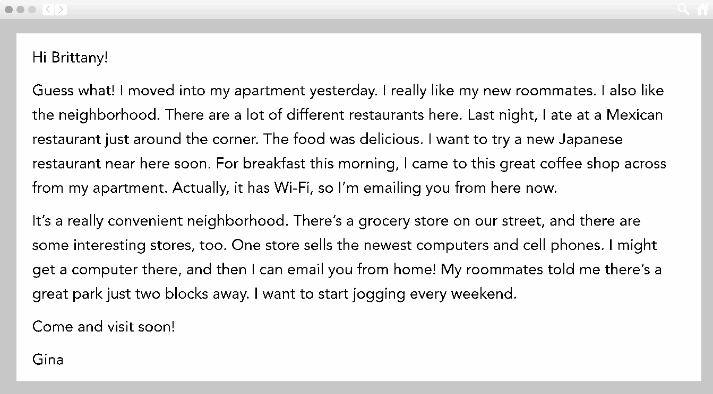

|  |  |
| --- | --- |
| ⬜ borrow books | ⬜ buy electronics |
| ⬜ eat different kinds of food | ⬜ make travel arrangements |
| ⬜ go jogging | ⬜ see movies |
| ⬜ get a haircut | ⬜ send emails |
| ⬜ go dancing | ⬜ wash and dry clothes |