**ESCUELA NORMAL DE EDUCACIÓN PREESCOLAR**

**ENGLISH A2.2 SHARING INFORMATION AND IDEAS**

**UNIT 7 PROJECT**

**“CHILDHOOD MEMORIES”**

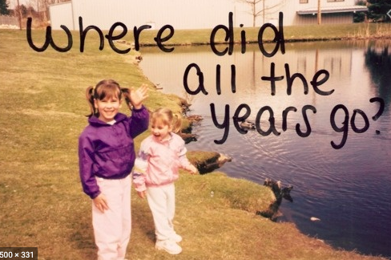

**Aim of the project:**

Give students practice talking about past events.

**Preparation:**

* Look for pictures of you when you were a child.
* Find 10 pictures that represent different and important moments or experiences to talk about them and share them in a short video.
* Think about sentences in past tense to describe what happened when the pictures were taken. Use a variety of verbs and time expresions.

**Development:**

* Use varied time expressions and affirmative and negative sentences to talk about each memory.
* Record a video where you talk about your ten different pictures, include several sentences (at least five) to talk about each experience. **TRY NOT TO READ.**

**Products:**

* You must upload this **document** to Escuela en Red with the preparation activities completed.
* Go to <https://padlet.com/alvaradocris87/cdyptcca6vtz95by> and upload your **video** to the Padlet.

**PREPARATION ACTIVITIES**

**Draw lines to match the present tense and the past tense of verbs.**

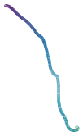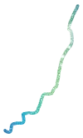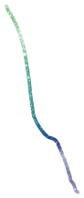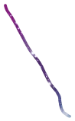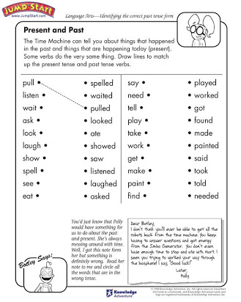



**Complete the paragraph below by filling in the missing words – be sure to change the verbs to past tense.**

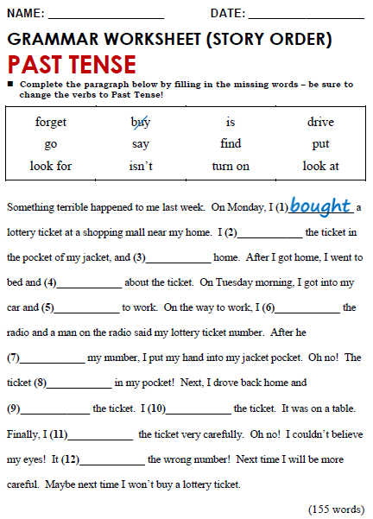

**DEVELOPMENT**

**Look at the example and complete the chart with your own pictures and sentences. Remember to include varied time expressions and verbs in affirmative and negative sentences.**

|  |  |
| --- | --- |
| **PICTURE** | **SENTENCES (FIVE VERBS PER PICTURE)** |
| *Example:* | 1. I **was** five years old and I **lived** in Monclova.  2. I **dressed** up like Bella and **danced** in a theater.  3. My parents **saw** me dance.  4. I **didn’t feel** nervous. |
|  | It was the day of my christening, they dressed me in a white silk dress, They threw me a big party, I was 1 year old, They had taken many photos of me |
|  | In this photo I was 2 years old, I was at my cousin's party, I had gone up to some games, I was afraid to get off, it was very cold |
|  | In this photo I was 3 years old, I was at the ranch watching the cows, I was about to throw myself in the food, I liked to feed them, I was very excited to be there |
|  | Here I was 5 years old, I was at my grandparents' house, this was the place where I loved to spend it, I always loved my family a lot, I will miss my grandfather |
|  | I was 6 years old, I was at the ranch, I had a sheep loaded, I was smiling and the sheep, I was very happy |
|  | In this photo I was 7 years old, I did not like to smile, I took that photo to send it to my mother, I had just taken a bath, I was wearing my favorite blouse |
|  | I was 9 years old, I had taken this photo for Facebook, I liked to imitate my sister, I was in elementary school, I was in my parents' room |
|  | I was 10 years old, we had attended the horror fest, they had made me a zombie, that day I had entered a horror house for the first time, it was an event in Monterrey |
|  | I was 11 years old, we were at my ranch, I was singing with my cousins, I was nervous, my whole family was together |
|  | I was 12 years old, it was my birthday, they made me a strawberry cake, I was very happy because it was a Mexican party, it was one of the best birthdays. |

**RUBRIC**

