**ESCUELA NORMAL DE EDUCACIÓN PREESCOLAR**

**ENGLISH A2.2 SHARING INFORMATION AND IDEAS**

**UNIT 7 PROJECT**

**“CHILDHOOD MEMORIES”**

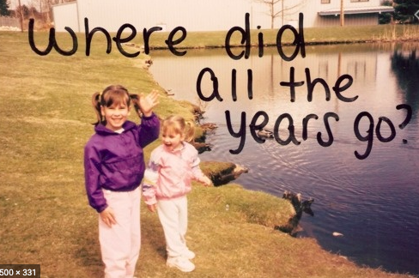

**Aim of the project:**

Give students practice talking about past events.

**Preparation:**

* Look for pictures of you when you were a child.
* Find 10 pictures that represent different and important moments or experiences to talk about them and share them in a short video.
* Think about sentences in past tense to describe what happened when the pictures were taken. Use a variety of verbs and time expresions.

**Development:**

* Use varied time expressions and affirmative and negative sentences to talk about each memory.
* Record a video where you talk about your ten different pictures, include several sentences (at least five) to talk about each experience. **TRY NOT TO READ.**

**Products:**

* You must upload this **document** to Escuela en Red with the preparation activities completed.
* Go to <https://padlet.com/alvaradocris87/cdyptcca6vtz95by> and upload your **video** to the Padlet.

**PREPARATION ACTIVITIES**

**Draw lines to match the present tense and the past tense of verbs.**

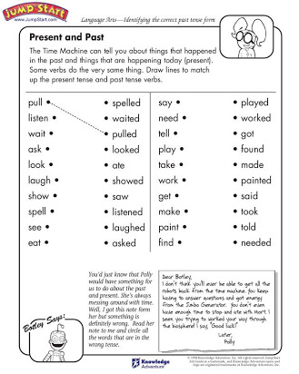

**Complete the paragraph below by filling in the missing words – be sure to change the verbs to past tense.**

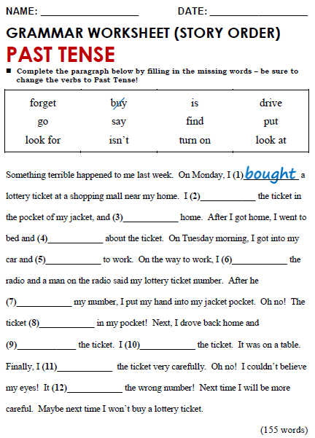

Look for

finded

Look at

is

forgot

isnt

Turn on

put

said

drove

went

**DEVELOPMENT**

**Look at the example and complete the chart with your own pictures and sentences. Remember to include varied time expressions and verbs in affirmative and negative sentences.**

|  |  |
| --- | --- |
| **PICTURE** | **SENTENCES (FIVE VERBS PER PICTURE)** |
| *Example:* | 1. I **was** five years old and I **lived** in Monclova.  2. I **dressed** up like Bella and **danced** in a theater.  3. My parents **saw** me dance.  4. I **didn’t feel** nervous. |
|  | 1. I was 9 months old 2. I was with my sister Graciela she was 18 years old 3. I felt very happy I miss felt this 4. I dressd collorfull pants with letters |
|  | 1. I combed with pigtails 2. I was two years old 3. I hugged my nephew 4. He didn’t feel sad |
|  | 1-i was in my new house  2-i dressed a princess blouse  3- I was getting smallpox  4- I liked posing for photos |
|  | 1. I was 11 months old and I lived in my old house 2. I taked a shower 3. I liked Minnie mouse so much 4. I had pierced ears |
|  | 1. I had my Barbie party 2. I was five years old 3. I dressed a princess dress 4. I felt so excited |
| - | 1- I was six years old  2- I got on the carousel of plaza patio I miss him  3- I always combed same  4-i was a riding a very strange tiger |
|  | 1. I sat in daddy legs 2. I was 8 months old 3. I hated this shoes 4. I didn’t feel happy |
|  | 1. It was Christmas 2. I had my new scooter 3. I broke the piñata 4. I wore pink boots |
|  | 1. I was in the preeschoolar 2. I was four years old 3. I dancing with my father 4. It was fathers day |
|  | 1. I did a photoshoot 2. I was 1 year old 3. I didn’t feel sad 4. I loved this outfit |

**RUBRIC**

