**ESCUELA NORMAL DE EDUCACIÓN PREESCOLAR**

**ENGLISH A2.2 SHARING INFORMATION AND IDEAS**

**UNIT 7 PROJECT**

**“CHILDHOOD MEMORIES”**

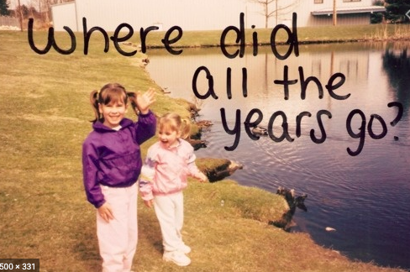

**Aim of the project:**

Give students practice talking about past events.

**Preparation:**

* Look for pictures of you when you were a child.
* Find 10 pictures that represent different and important moments or experiences to talk about them and share them in a short video.
* Think about sentences in past tense to describe what happened when the pictures were taken. Use a variety of verbs and time expresions.

**Development:**

* Use varied time expressions and affirmative and negative sentences to talk about each memory.
* Record a video where you talk about your ten different pictures, include several sentences (at least five) to talk about each experience. **TRY NOT TO READ.**

**Products:**

* You must upload this **document** to Escuela en Red with the preparation activities completed.
* Go to <https://padlet.com/alvaradocris87/cdyptcca6vtz95by> and upload your **video** to the Padlet.

**PREPARATION ACTIVITIES**

**Draw lines to match the present tense and the past tense of verbs.**

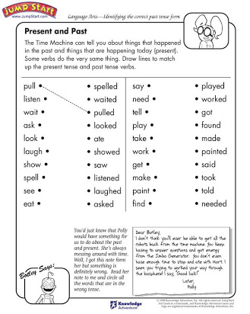

**Complete the paragraph below by filling in the missing words – be sure to change the verbs to past tense.**

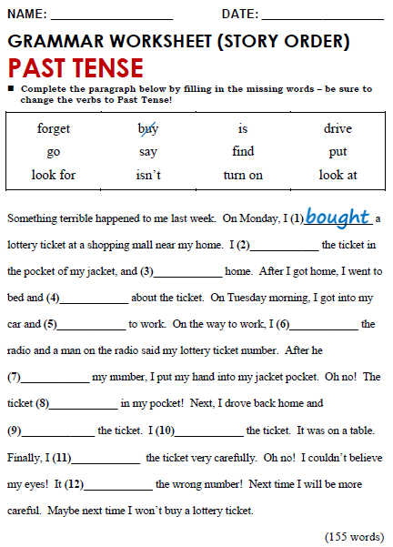

looked at

put

turned on

found

is

didn’t

said

looked for

forgot

drove

get

**DEVELOPMENT**

**Look at the example and complete the chart with your own pictures and sentences. Remember to include varied time expressions and verbs in affirmative and negative sentences.**

|  |  |
| --- | --- |
| **PICTURE** | **SENTENCES (FIVE VERBS PER PICTURE)** |
| *Example:* | 1. I **was** five years old and I **lived** in Monclova.  2. I **dressed** up like Bella and **danced** in a theater.  3. My parents **saw** me dance.  4. I **didn’t feel** nervous. |
|  | 1. I was three years old 2. I used hat 3. I didn’t feel angry |
|  | 1. I dressed up like doll for the kids day 2. I went the kinder garden 3. I didn’t drees princess |
|  | 1. I dressed up like for the Halloween 2. I went for sweets 3. My sister are didn’t feel scary |
|  | 1. It was my spongebob party 2. I opened the gifts 3. My mom didn´t help |
|  | 1. I jumped the trampoline 2. I was very happy 3. I didn´t jump alone |
|  | 1. I danced in the festival 2. I had fun with my friends 3. I didn´t feel sorrow |
|  | 1. I ate the spongebob cake 2. I loved the cake 3. I didn´t stomach hurt |
|  | 1. I went to my graduation 2. I put white dress 3. I didn´t feel sad |
|  | 1. I hit the piñata 2. I sun bothered 3. I didn´t feel happy |
|  | 1. I visited the Santa Claus 2. They took a picture 3. My father didn´t smile for the picture |

**RUBRIC**

