**ESCUELA NORMAL DE EDUCACIÓN PREESCOLAR**

**ENGLISH A2.2 SHARING INFORMATION AND IDEAS**

**UNIT 7 PROJECT**

**“CHILDHOOD MEMORIES”**

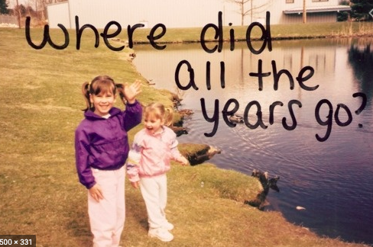

**Aim of the project:**

Give students practice talking about past events.

**Preparation:**

* Look for pictures of you when you were a child.
* Find 10 pictures that represent different and important moments or experiences to talk about them and share them in a short video.
* Think about sentences in past tense to describe what happened when the pictures were taken. Use a variety of verbs and time expresions.

**Development:**

* Use varied time expressions and affirmative and negative sentences to talk about each memory.
* Record a video where you talk about your ten different pictures, include several sentences (at least five) to talk about each experience. **TRY NOT TO READ.**

**Products:**

* You must upload this **document** to Escuela en Red with the preparation activities completed.
* Go to <https://padlet.com/alvaradocris87/cdyptcca6vtz95by> and upload your **video** to the Padlet.

**PREPARATION ACTIVITIES**

**Draw lines to match the present tense and the past tense of verbs.**

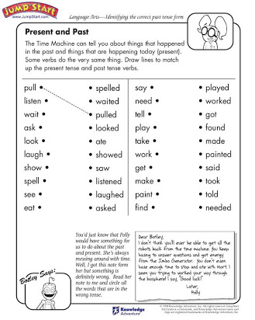

**Complete the paragraph below by filling in the missing words – be sure to change the verbs to past tense.**

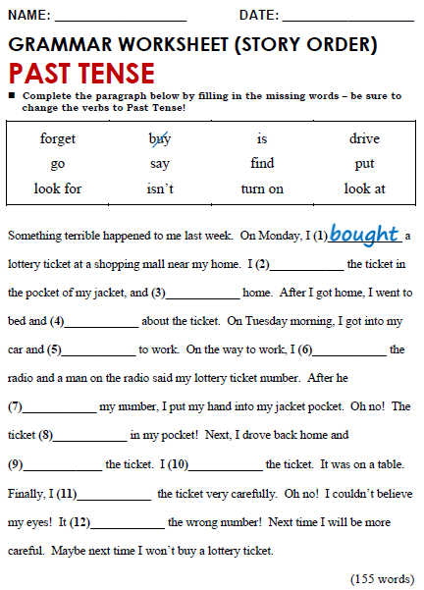

driving

Didn´t

found

forget

went

Loked for

Looked at

said

was

put

Turned on

**DEVELOPMENT**

**Look at the example and complete the chart with your own pictures and sentences. Remember to include varied time expressions and verbs in affirmative and negative sentences.**

|  |  |
| --- | --- |
| **PICTURE** | **SENTENCES (FIVE VERBS PER PICTURE)** |
| *Example:* | 1. I **was** five years old and I **lived** in Monclova.  2. I **dressed** up like Bella and **danced** in a theater.  3. My parents **saw** me dance.  4. I **didn’t feel** nervous. |
|  | **MY COUSIN IS BIRTHDAY**  **I WAS IN AGUASCALIENTES** |
|  | **In this photo she was wearing a party dress**  **I was going to a wedding with my parents** |
|  | **This photo with the children of my cousins**  **We are playing at my grandmother's house** |
|  | **In this photograph it was my birthday**  **I was on top of a jumper**  **That day there was another girl who has a birthday and is celebrating next to** |
|  | **This day she had her birthday**  **I went to McDonald's to party**  **I had cried because they didn't give me a balloon** |
|  | **They were going to take my three-year-old photograph**  **I was very angry because I did not want photos**  **I go out with an angry face**  **I threw her from the bouquet of flowers to my godmother** |
|  | **I was in preschool**  **There was a regional dance** |
|  | **I went with my parents to an aunt's wedding**  **I was the girl wearing the bridal veil and I fell** |
|  | **On February 2, 2004 my brother was born**  **I was angry because my brother was born**  **Also because my mom didn't want to play with me** |
|  | **I turned 10 years old**  **It was all my cousins** |

**RUBRIC**

