**ESCUELA NORMAL DE EDUCACIÓN PREESCOLAR**

**ENGLISH A2.2 SHARING INFORMATION AND IDEAS**

**UNIT 7 PROJECT**

**“CHILDHOOD MEMORIES”**

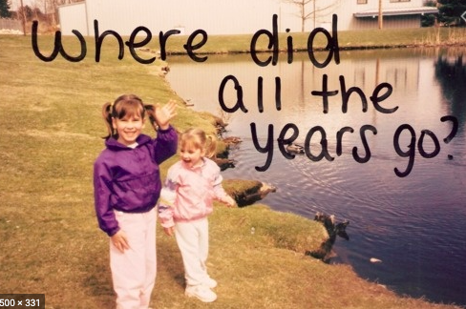

**Aim of the project:**

Give students practice talking about past events.

**Preparation:**

* Look for pictures of you when you were a child.
* Find 10 pictures that represent different and important moments or experiences to talk about them and share them in a short video.
* Think about sentences in past tense to describe what happened when the pictures were taken. Use a variety of verbs and time expresions.

**Development:**

* Use varied time expressions and affirmative and negative sentences to talk about each memory.
* Record a video where you talk about your ten different pictures, include several sentences (at least five) to talk about each experience. **TRY NOT TO READ.**

**Products:**

* You must upload this **document** to Escuela en Red with the preparation activities completed.
* Go to <https://padlet.com/alvaradocris87/cdyptcca6vtz95by> and upload your **video** to the Padlet.

**PREPARATION ACTIVITIES**

**Draw lines to match the present tense and the past tense of verbs.**

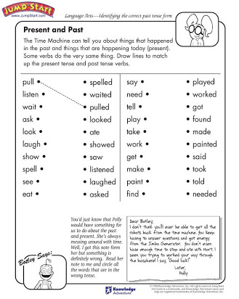

**Complete the paragraph below by filling in the missing words – be sure to change the verbs to past tense.**

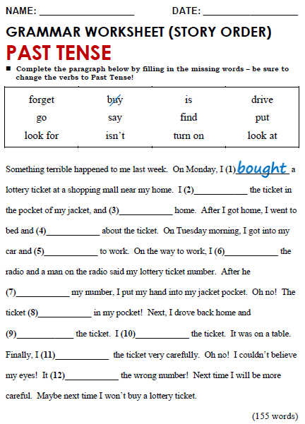

Looked for

Looked at

FOUND

Drove

WENT

PUT ON

Said

S

Wasn’t

FORGOT

TURNED ON

**DEVELOPMENT**

**Look at the example and complete the chart with your own pictures and sentences. Remember to include varied time expressions and verbs in affirmative and negative sentences.**

|  |  |
| --- | --- |
| **PICTURE** | **SENTENCES (FIVE VERBS PER PICTURE)** |
| *Example:* | 1. I **was** five years old and I **lived** in Monclova.  2. I **dressed** up like Bella and **danced** in a theater.  3. My parents **saw** me dance.  4. I **didn’t feel** nervous. |
|  |  |
|  |  |
|  |  |
|  |  |
|  |  |
|  |  |
|  |  |
|  |  |
|  |  |
|  |  |

**RUBRIC**

