**ESCUELA NORMAL DE EDUCACIÓN PREESCOLAR**

**ENGLISH B1.2**

**UNIT 5 PROJECT**

**“EXPANDING YOUR HORIZONS”**



**Aim of the project:**

Give students practice discussing living abroad and talking about their greatest concerns.

**Preparation:**

* + - Choose a country you want to learn more about.
    - Read about the customs and lifestyle in this country and complete the preparation activities.
    - Make a 3 minute video with pictures and talk about the **customs** in the country you chose, you must also talk about how it would be for you to travel to this country (your concerns).

**Development:**

* Use varied time expressions to talk about your biggest concerns when living abroad and to talk about customs in a foreign country. Use grammar and vocabulary from the unit.
* Record a video where you include pictures and talk about the **customs** in the country you chose, you must also talk about how it would be for you to travel to this country (your concerns).**TRY NOT TO READ.**

**Products:**

* You must upload this **document** to Escuela en Red with the preparation activities completed.
* Go to <https://padlet.com/alvaradocris87/btrml0zwovpq7dv2> and upload your **video** to the Padlet.

**PREPARATION ACTIVITIES**

**Read these five cross-cultural situations. Write sentences describing what the visitors did wrong. USE THE EXPRESSIONS IN THE BOX.**

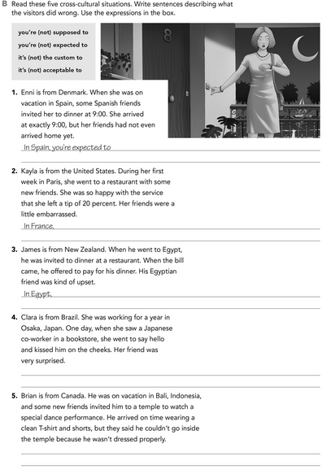

In Bali, It’s not aceptable to go inside of the temples if you don’t dress appropiately

the people were more punctual

In Japan, It’s the custom to just say hello

It’s not the custom to the invited pay

It’s not acceptable to leave a tip

**Imagine you are going to travel to a country you have never visited before. Write sentences using the factors and feelings given. Then add another sentence explaining your feelings. Look at the example.**

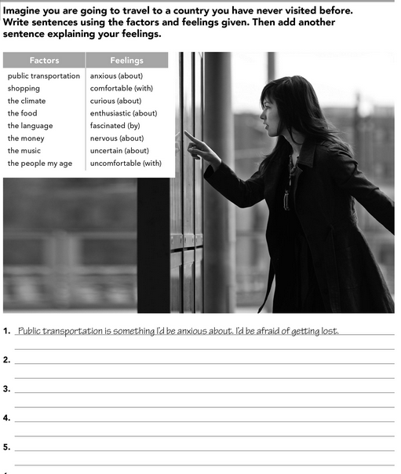

The shopping is someting I’d be facinated by, I want buy a lot of things

I’d be comfortable with the cimate if it was a Little cold, I don’t like hot climate

The food is someting I’d be curious with, I love to try food from other countries

I’d be nervous by the people my age because I don´t know how to start a conversation

**Complete these sentences with information about yourself (1-4) and about a country you know well (5-8).**

is because I’d miss my family

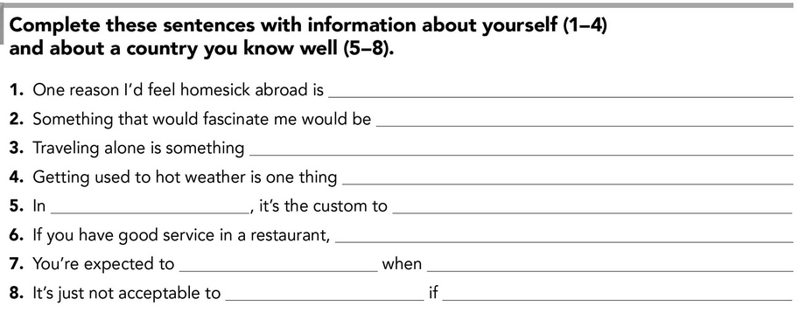

Someone help you

Don’t say tank you

They have a party or invite you to dinner

The people were punctual

It’s optional to leave a tip

Make a great party when you turn fisteen

México

horrible, you have drink water all the day

That is a Little scary

Meet new people

**DEVELOPMENT**

**Look at the example and complete the chart with your own pictures and sentences. Remember to include varied time expressions and verbs in affirmative and negative sentences.**

Japan

**NAME OF THE COUNTRY YOU CHOSE: _____________________________________**

**FIND TEN CUSTOMS FROM THIS COUNTRY AND WRITE THEM USING THE FOLLOWING EXPRESSIONS:**

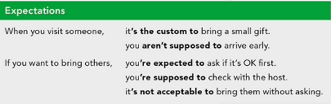

1. When you visit someone it’s the custom to leave shoes outside the home.
2. If you go to restaurant, it’s not acceptable to leave a tip for the waiters.
3. When you say hello it’s the custom to just take a little bow.
4. If someone invited you to give a pass you are supposed to be on time.
5. If you are sick, you´re supposed to use a surgical mask.
6. When you go walking in the street, It’s not acceptable to eat on public roads.
7. When you eat pasta, It’s acceptable to slurp it
8. If you leave some food on your plate you’re supposed to want more food
9. When you eat, it’s the custom to thank for the food
10. If someone invites you to their house it’s the custom to bring a gift

**Write about how would your experience be if you had to move to the country you chose. Use some of the expressions below:**

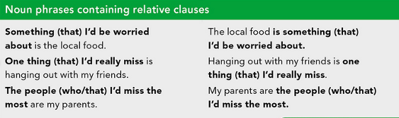

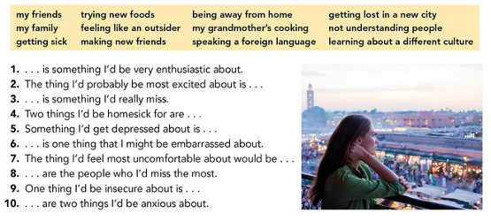

1. Visiting Japan with my boyfriend is something that I'd very excited about
2. The thing I’d probably excite me the most is visiting the world of Super Nintendo because it is one of the things that I share a great feeling thanks to my family
3. Not seeing my family is something I'd really miss, if i go to travel
4. Two things I've been nostalgic for are food and time with my brother, I'm almost always with him
5. Something that would make me depressed is not being able to spend time with my friends and go to dance, I really enjoy do those things.
6. Being lost or trying to speak the language and saying something wrong is something I´d be ashamed of.
7. the thing i'd feel most uncomfortable is not understand what they say to me and make them repeat it
8. My brother and my grandmother are the people who i'd miss the most
9. One thing I'd be insecure about is with locations, I get lost easily and am ashamed to ask for help
10. its language and visit the temples are two things i'd be anxious about because I maybe Not might understand everything

**NOW FIND SOME PICTURES RELATED TO THE THINGS YOU WROTE ABOUT, RECORD YOUR VIDEO AND UPLOAD IT TO THE PADLET.**

**RUBRIC**

