**ESCUELA NORMAL DE EDUCACIÓN PREESCOLAR**

**ENGLISH B1.2**

**UNIT 5 PROJECT**

**“EXPANDING YOUR HORIZONS”**



**Aim of the project:**

Give students practice discussing living abroad and talking about their greatest concerns.

**Preparation:**

* + - Choose a country you want to learn more about.
    - Read about the customs and lifestyle in this country and complete the preparation activities.
    - Make a 3 minute video with pictures and talk about the **customs** in the country you chose, you must also talk about how it would be for you to travel to this country (your concerns).

**Development:**

* Use varied time expressions to talk about your biggest concerns when living abroad and to talk about customs in a foreign country. Use grammar and vocabulary from the unit.
* Record a video where you include pictures and talk about the **customs** in the country you chose, you must also talk about how it would be for you to travel to this country (your concerns).**TRY NOT TO READ.**

**Products:**

* You must upload this **document** to Escuela en Red with the preparation activities completed.
* Go to <https://padlet.com/alvaradocris87/btrml0zwovpq7dv2> and upload your **video** to the Padlet.

**PREPARATION ACTIVITIES**

**Read these five cross-cultural situations. Write sentences describing what the visitors did wrong. USE THE EXPRESSIONS IN THE BOX.**

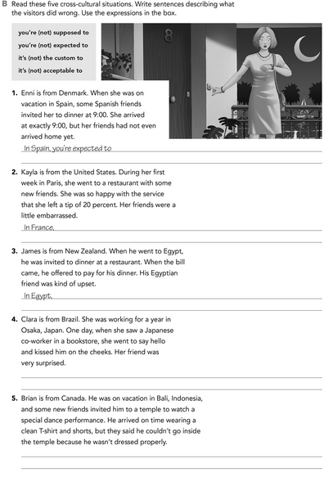

In Indonesia, it’s not acceptable to dress casual or informal to go the temple.

In Japan, it’s not expected to say hello kissing the cheeks.

In Egypt, it’s not acceptable to pay the bill if they invite you.

In France, it’s not the custom to leave an additional tip to the waiter.

In Spain, you're expected to arrive some minutes after the appointment.

**Imagine you are going to travel to a country you have never visited before. Write sentences using the factors and feelings given. Then add another sentence explaining your feelings. Look at the example.**

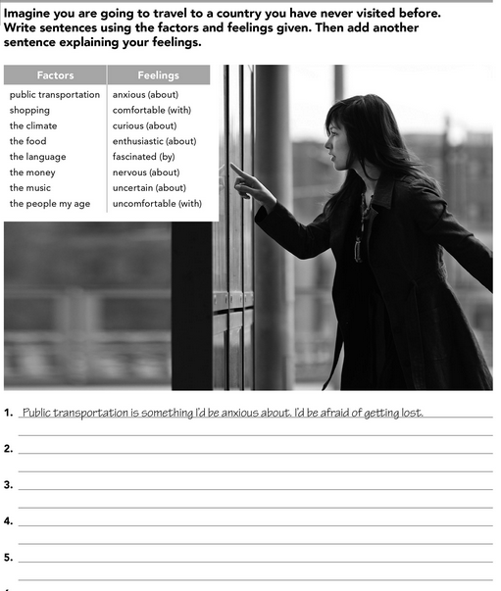

The language is something I’d be nervous about I'd be embarrassed If the people not understand me.

The people my age are the ones I’d be comfortable with, I’d be exciting for make new friends.

Food is something I'd be curious about, I'd be nervous to taste different food.

Shopping is something I’d be enthusiastic about, I’d buy everything I can.

**Complete these sentences with information about yourself (1-4) and about a country you know well (5-8).**

my mother's cooking.

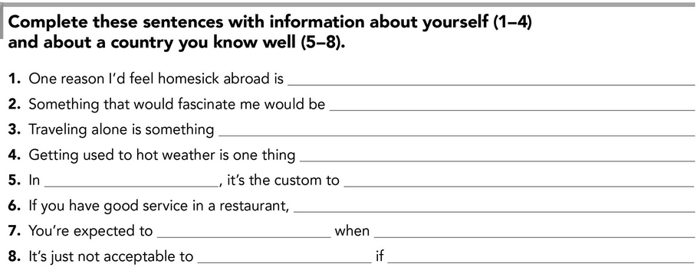

my mother's cooking.

my mother's cooking.

my mother's cooking.

my mother's cooking.

my mother's cooking.

**DEVELOPMENT**

**Look at the example and complete the chart with your own pictures and sentences. Remember to include varied time expressions and verbs in affirmative and negative sentences.**

**NAME OF THE COUNTRY YOU CHOSE: _____________________________________**

**FIND TEN CUSTOMS FROM THIS COUNTRY AND WRITE THEM USING THE FOLLOWING EXPRESSIONS:**

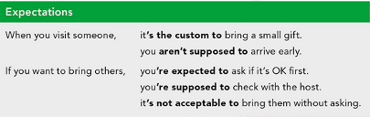



**Write about how would your experience be if you had to move to the country you chose. Use some of the expressions below:**

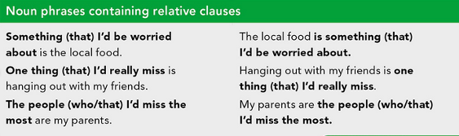

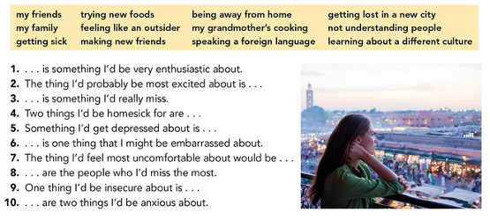



**NOW FIND SOME PICTURES RELATED TO THE THINGS YOU WROTE ABOUT, RECORD YOUR VIDEO AND UPLOAD IT TO THE PADLET.**

**RUBRIC**

