**ESCUELA NORMAL DE EDUCACIÓN PREESCOLAR**

**ENGLISH B1.2**

**UNIT 5 PROJECT**

**“EXPANDING YOUR HORIZONS”**



**Aim of the project:**

Give students practice discussing living abroad and talking about their greatest concerns.

**Preparation:**

* + - Choose a country you want to learn more about.
    - Read about the customs and lifestyle in this country and complete the preparation activities.
    - Make a 3 minute video with pictures and talk about the **customs** in the country you chose, you must also talk about how it would be for you to travel to this country (your concerns).

**Development:**

* Use varied time expressions to talk about your biggest concerns when living abroad and to talk about customs in a foreign country. Use grammar and vocabulary from the unit.
* Record a video where you include pictures and talk about the **customs** in the country you chose, you must also talk about how it would be for you to travel to this country (your concerns).**TRY NOT TO READ.**

**Products:**

* You must upload this **document** to Escuela en Red with the preparation activities completed.
* Go to <https://padlet.com/alvaradocris87/btrml0zwovpq7dv2> and upload your **video** to the Padlet.

**PREPARATION ACTIVITIES**

**Read these five cross-cultural situations. Write sentences describing what the visitors did wrong. USE THE EXPRESSIONS IN THE BOX.** 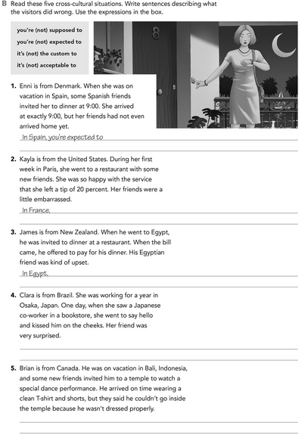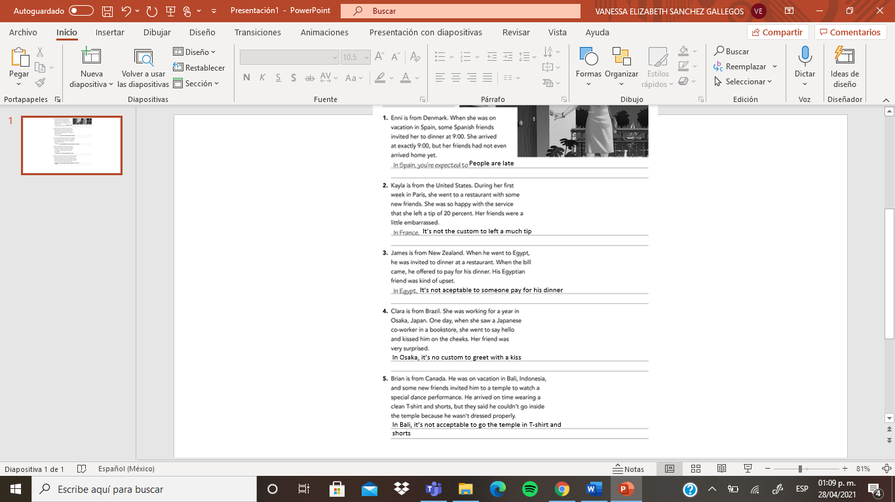

**Imagine you are going to travel to a country you have never visited before. Write sentences using the factors and feelings given. Then add another sentence explaining your feelings. Look at the example.**

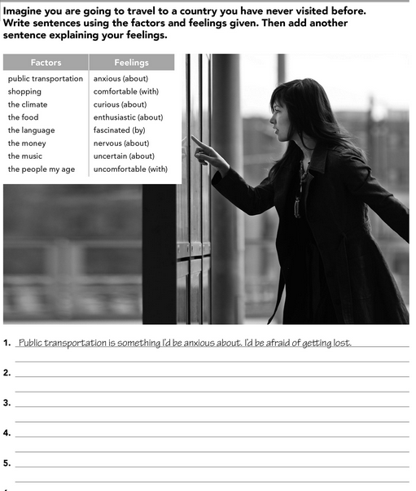

2.Shopping is something i’d be enthusiastic about the clothes are amazing

3. I’d be comfortable with the climate because it’s not very cold nor very hot

4. The food is something I’d be fascinated about try new food

5. the language is something I’d be nervous about I don't know the language well

6. i´d be uncomfortable with the money because It’s not used the same as in my country and I would have to exchange some

7. the music is something I’d be curios about I don't know the musical culture of that place

8. I’d be uncertain about the people my age about they don't usually do the same things since their culture is different

**Complete these sentences with information about yourself (1-4) and about a country you know well (5-8).**

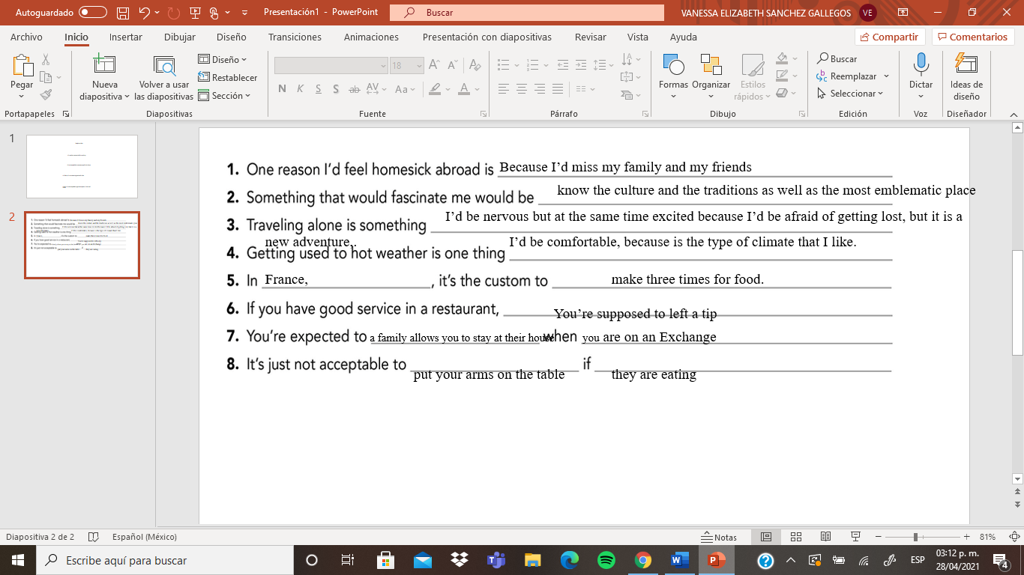

**DEVELOPMENT**

**Look at the example and complete the chart with your own pictures and sentences. Remember to include varied time expressions and verbs in affirmative and negative sentences.**

**NAME OF THE COUNTRY YOU CHOSE: France**

**FIND TEN CUSTOMS FROM THIS COUNTRY AND WRITE THEM USING THE FOLLOWING EXPRESSIONS:**

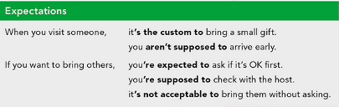

1. when you see someone on the street it’s custom to shake hands or just say salut!
2. If you are invited to a social gathering, it’s not acceptable arrive more than 15 minutes late
3. When it’s time for the dinner are expected to the whole family is at the table
4. When your talk in your language, it’s not acceptable to them and very rarely responds.
5. If you already ate your lunch, you should not eat more, it’s not custom to eat between meals
6. When you visit a public place, are supposed you’d speak slowly so as not to disturb others
7. when you make friends, you didn't say hello with a kiss, its not acceptable show affect
8. If you work, you are supposed to go out on weekends
9. when they make an appointment, the custom is to go to a cafe
10. If you go on an exchange, someone from the country you’re expected to let you stay at their home

**Write about how would your experience be if you had to move to the country you chose. Use some of the expressions below:**

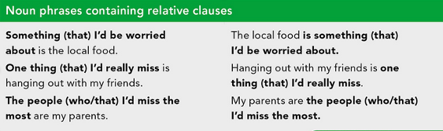

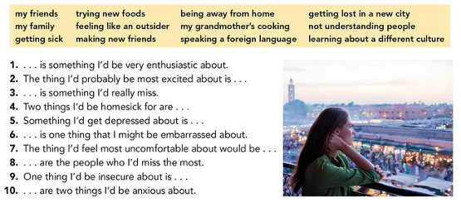

1. Trying new foods is something I’d be very enthusiastic about
2. The thing I’d probably be most excited about it is making new friends
3. My grandmother’s cooking Is something I’d really miss
4. Two things I’d be homesick for are my friends and my family
5. Something I’d get depressed about is Being away from home
6. Not understanding people Is one thing that I’d might be embarrassed about
7. The thing I’d feel most uncomfortable about would be feeling like an outsider
8. my family Are their people who I’d miss the most
9. one thing I'd be insecure about is getting lost in a new city
10. getting sick and speaking a foreign language are two things I be anxious about

**NOW FIND SOME PICTURES RELATED TO THE THINGS YOU WROTE ABOUT, RECORD YOUR VIDEO AND UPLOAD IT TO THE PADLET.**

**RUBRIC**

