**ESCUELA NORMAL DE EDUCACIÓN PREESCOLAR**

**ENGLISH B1.2**

**UNIT 5 PROJECT**

**“EXPANDING YOUR HORIZONS”**



**Aim of the project:**

Give students practice discussing living abroad and talking about their greatest concerns.

**Preparation:**

* + - Choose a country you want to learn more about.
    - Read about the customs and lifestyle in this country and complete the preparation activities.
    - Make a 3 minute video with pictures and talk about the **customs** in the country you chose, you must also talk about how it would be for you to travel to this country (your concerns).

**Development:**

* Use varied time expressions to talk about your biggest concerns when living abroad and to talk about customs in a foreign country. Use grammar and vocabulary from the unit.
* Record a video where you include pictures and talk about the **customs** in the country you chose, you must also talk about how it would be for you to travel to this country (your concerns).**TRY NOT TO READ.**

**Products:**

* You must upload this **document** to Escuela en Red with the preparation activities completed.
* Go to <https://padlet.com/alvaradocris87/btrml0zwovpq7dv2> and upload your **video** to the Padlet.

**PREPARATION ACTIVITIES**

**Read these five cross-cultural situations. Write sentences describing what the visitors did wrong. USE THE EXPRESSIONS IN THE BOX.**

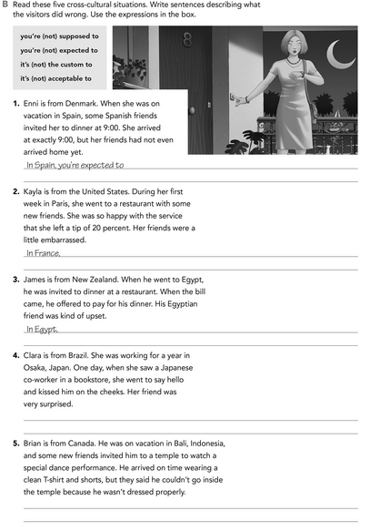

In Indonesia, it´s the custom to wear the proper attire to ascribe to the temple

In Japan, it´s aceptable that you only bow to greet one person.

It´s not acceptable to leave tips to the waiters.

arrive late at reunions.

**Imagine you are going to travel to a country you have never visited before. Write sentences using the factors and feelings given. Then add another sentence explaining your feelings. Look at the example.**

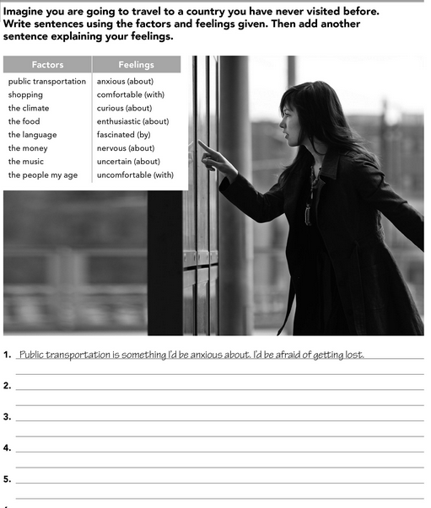

The language is something i´d be nervous about. I´d be very nervous to talk to the locals

The shopping is something i´d be enthusiastic about. I´d be stylish if I buy clothes in that place

The food is something i´d be curious about. I´d be scared it they only eat fish

The climate is something i´d be uncertain about. I´d be confused if it´s hot or cold.

**Complete these sentences with information about yourself (1-4) and about a country you know well (5-8).**

About my house and my comforts.

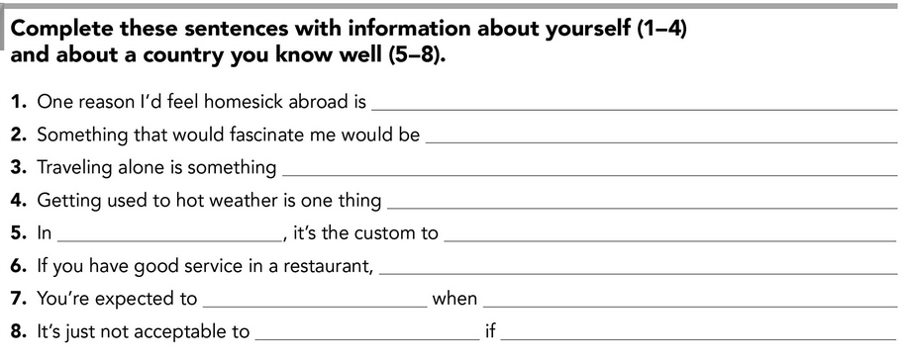

You go a house party in mexico

Don´t bring your own cheve

you go to a Mexican house to watch soccer.

Support the opposing team

It´s acceptable if you leave a 10% tip for the waiter

celebrate anything with carne asada.

Mexico

That I can´t do. I can´t stand hot flashes. 

I´d be enthusiastic about. I like to travel alone.

The lifestyle and the night social life.

**DEVELOPMENT**

**Look at the example and complete the chart with your own pictures and sentences. Remember to include varied time expressions and verbs in affirmative and negative sentences.**

**NAME OF THE COUNTRY YOU CHOSE: _____________JAPAN______________________**

**FIND TEN CUSTOMS FROM THIS COUNTRY AND WRITE THEM USING THE FOLLOWING EXPRESSIONS:**

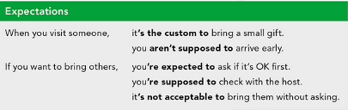

1. When you´re talking with a Nippon you´re expected to avoid mentioning the number 4 in the conversation because the Japanese relate it to the sound of the word death.
2. If you want to visit other Japanese people, it´s the custom to take off your shoes and put on the slippers for guests.
3. If you go down the street and there´re people, it´s not acceptable for you to blow your nose.
4. When you´re visiting Japan and you´re allergic to polen, you´re expected to wear a surgical mask.
5. If you want to eat in the street you aren´t supposed to take a plate and eat it while you walk.
6. When you go to someone´s house, it´s the custom to carry a bottle of sake, but it´s must be delivered at the end of dinner.
7. When you visit a Japanese and bring a present, you aren´t supposed to give it to the table because if you do you have to give something identical to everyone. Handing it over privately is a sign of gratitude.
8. If you go on the subway and someone falls asleep next to you it´s the custom to let them lean on your shoulder.
9. In japan it´s not acceptable for people to attract attention, so answer your cell phone at another time.
10. If you visit Tokio, it´s acceptable if you know the minimum rules of etiquette.

**Write about how would your experience be if you had to move to the country you chose. Use some of the expressions below:**

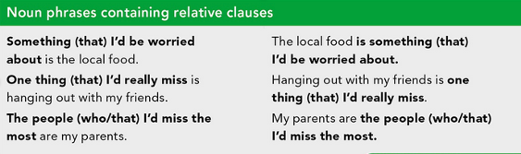

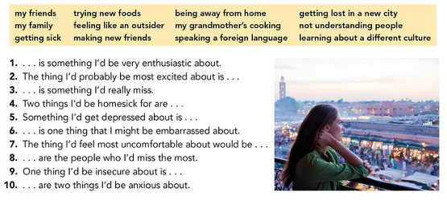

1. Knowing the city alone is something i´d be very enthusiastic about.
2. The thing i´d probably be most excited about is hang out with locals.
3. The food is something i´d really miss.
4. Two things i´d be homesick for are my house and my friends.
5. Something i´d get depressed about is not be able to talk with the Japanese people.
6. Talk to the village elders is one thing that I might be embarrassed about.
7. The thing i´d feel most uncomfortable about would be meet a nasty guy on the streets.
8. My family are the people who I´d miss the most.
9. One thing i´d be insecure about is find a job to live there.
10. The food and the pollution are two things i´d be anxious about.

**NOW FIND SOME PICTURES RELATED TO THE THINGS YOU WROTE ABOUT, RECORD YOUR VIDEO AND UPLOAD IT TO THE PADLET.**

[**https://youtu.be/UYdjpwm8H5k**](https://youtu.be/UYdjpwm8H5k)

**RUBRIC**

