**ESCUELA NORMAL DE EDUCACIÓN PREESCOLAR**

**ENGLISH B1.2**

**UNIT 5 PROJECT**

**“EXPANDING YOUR HORIZONS”**



**Aim of the project:**

Give students practice discussing living abroad and talking about their greatest concerns.

**Preparation:**

* + - Choose a country you want to learn more about.
    - Read about the customs and lifestyle in this country and complete the preparation activities.
    - Make a 3 minute video with pictures and talk about the **customs** in the country you chose, you must also talk about how it would be for you to travel to this country (your concerns).

**Development:**

* Use varied time expressions to talk about your biggest concerns when living abroad and to talk about customs in a foreign country. Use grammar and vocabulary from the unit.
* Record a video where you include pictures and talk about the **customs** in the country you chose, you must also talk about how it would be for you to travel to this country (your concerns).**TRY NOT TO READ.**

**Products:**

* You must upload this **document** to Escuela en Red with the preparation activities completed.
* Go to <https://padlet.com/alvaradocris87/btrml0zwovpq7dv2> and upload your **video** to the Padlet.

**PREPARATION ACTIVITIES**

**Read these five cross-cultural situations. Write sentences describing what the visitors did wrong. USE THE EXPRESSIONS IN THE BOX.**

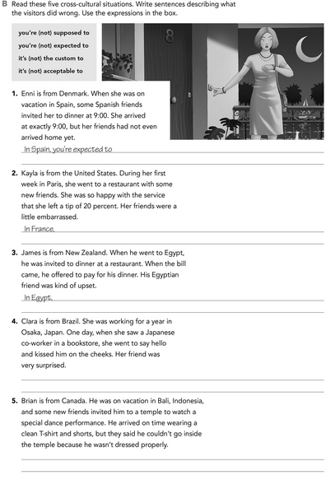

In Indonesia it is not acceptable to wear casual clothing to attend a temple.

In Japan, it is not customary to greet people with a kiss. They greet each other with a bow.

you are not supposed to pay the bill of the person who invited you.

It's not the custom to to give a good percentage of tips.

Arrive a few minutes after the agreed hour.

**Imagine you are going to travel to a country you have never visited before. Write sentences using the factors and feelings given. Then add another sentence explaining your feelings. Look at the example.**

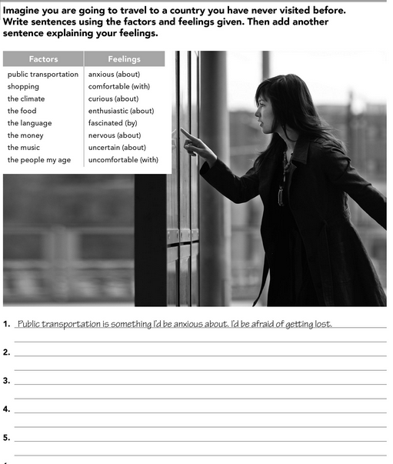

Shopping is something I’d be uncomfortable with, I’d be embarrassed if my money was not enough to buy something nice.

I’d be nervous about meet the people my age, I’d feel uncomfortable with their customs.

The food is something I’d be enthusiastic about, I’d love to know the gastronomy of the place

The language is something I’d be curious about, I’d love to discover how they communicate

**Complete these sentences with information about yourself (1-4) and about a country you know well (5-8).**

My family, my friends and my pet.

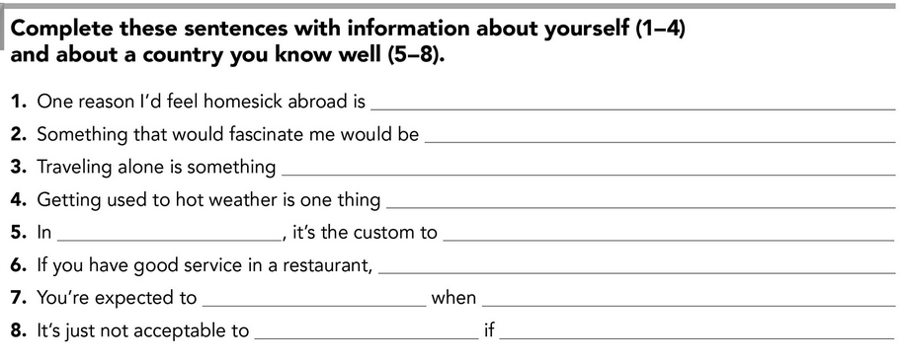

you are pregnant.

refuse food

you arrive at a place.

greet all people

You’re supposed to leave a good tip.

celebrate the day of de dead.

Mexico

I’d be uncomfortable with, because I don’t like this wearher.

I’d be nervous about.

know tourist places.

**DEVELOPMENT**

**Look at the example and complete the chart with your own pictures and sentences. Remember to include varied time expressions and verbs in affirmative and negative sentences.**

**NAME OF THE COUNTRY YOU CHOSE: _______Rio de Janeiro________**

**FIND TEN CUSTOMS FROM THIS COUNTRY AND WRITE THEM USING THE FOLLOWING EXPRESSIONS:**

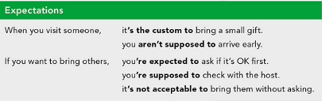

1. When you go to greet a person, it’s the custom to give him two kisses on the cheek.
2. When you are talking to another person, you’re supposed to let the distance between you be short.
3. If you want to have a pleasant conversation, you’re expected to use the suffix "-inho / inha" to add affection to the words.
4. When you are eating it’s not acceptable to touch food with your hands, it’s rude.
5. If you want to eat pizza or hamburger, you are supposed to take it with a napkin.
6. When you are eating it’s the custom to use napkins to hold food, not to clean yourself.
7. If you want to spend a few days in this exotic country, you are supposed to know La capoeira, so that it doesn’t surprise you when you interact with its natives.
8. When you meet a person it’s not acceptable to criticize their religion because they respect it so much.
9. If you are in a restaurant it’s not acceptable to lose the menu, you can get into big trouble.
10. When you are in a restaurant, you’re supposed to eat as quickly as possible because they tend to clear the dishes early.

**Write about how would your experience be if you had to move to the country you chose. Use some of the expressions below:**

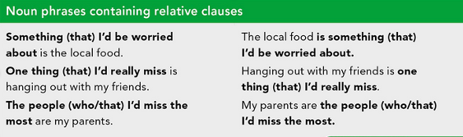

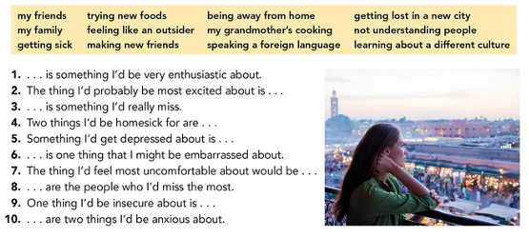

1. Getting to know new places is something I’d be very enthusiastic about
2. The thing I’d probably be most excited about is learning about other culture.
3. Family reunions is something I’d really miss.
4. Two things I’d be homesick for are the landscapes and being away from my mom.
5. Something I’d get depressed about is thinking about when I’ll see my family again.
6. Getting lost in the city is one thing that I might be embarrassed about.
7. The thing I’d feel most uncomfortable about would be not understanding when people talk to me.
8. My parents and my grandparents are the people who I’d miss the most.
9. One thing I’d be insecure about is the language.
10. Meeting new people and new customs are two things I’d be anxious about.

**NOW FIND SOME PICTURES RELATED TO THE THINGS YOU WROTE ABOUT, RECORD YOUR VIDEO AND UPLOAD IT TO THE PADLET.**

**RUBRIC**

