**ESCUELA NORMAL DE EDUCACIÓN PREESCOLAR**

**ENGLISH B1.2**

**UNIT 5 PROJECT**

**“EXPANDING YOUR HORIZONS”**



**Aim of the project:**

Give students practice discussing living abroad and talking about their greatest concerns.

**Preparation:**

* + - Choose a country you want to learn more about.
    - Read about the customs and lifestyle in this country and complete the preparation activities.
    - Make a 3 minute video with pictures and talk about the **customs** in the country you chose, you must also talk about how it would be for you to travel to this country (your concerns).

**Development:**

* Use varied time expressions to talk about your biggest concerns when living abroad and to talk about customs in a foreign country. Use grammar and vocabulary from the unit.
* Record a video where you include pictures and talk about the **customs** in the country you chose, you must also talk about how it would be for you to travel to this country (your concerns).**TRY NOT TO READ.**

**Products:**

* You must upload this **document** to Escuela en Red with the preparation activities completed.
* Go to <https://padlet.com/alvaradocris87/btrml0zwovpq7dv2> and upload your **video** to the Padlet.

**PREPARATION ACTIVITIES**

**Read these five cross-cultural situations. Write sentences describing what the visitors did wrong. USE THE EXPRESSIONS IN THE BOX.**

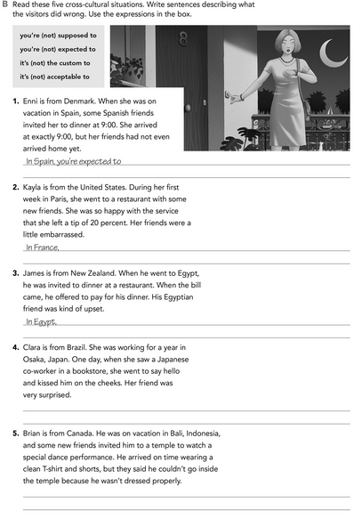

**1-.** In France it´s not the customs to

**2.** In Egypt it´s not acceptable to

**3.** In Japan you´re not expected to

**4**. In Bali it´s notsupposed to

**Imagine you are going to travel to a country you have never visited before. Write sentences using the factors and feelings given. Then add another sentence explaining your feelings. Look at the example.**

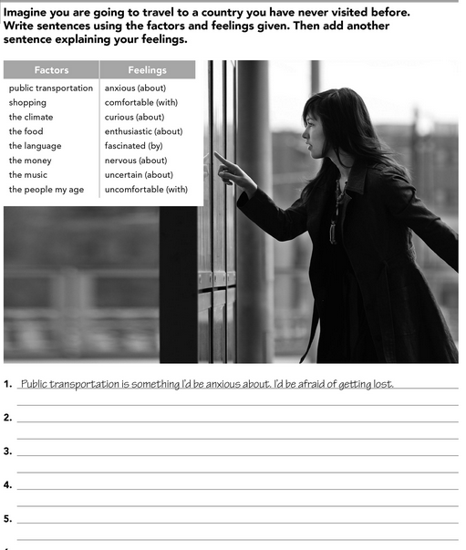

1-. The climate is uncertain. The sky is cloudy.

2-. The food is different. I´d be anxious for try to food.

3-. The language is curios. They have very complicated words.

4-. The music is fascinated, by the use of different musical instrument.

**Complete these sentences with information about yourself (1-4) and about a country you know well (5-8).**

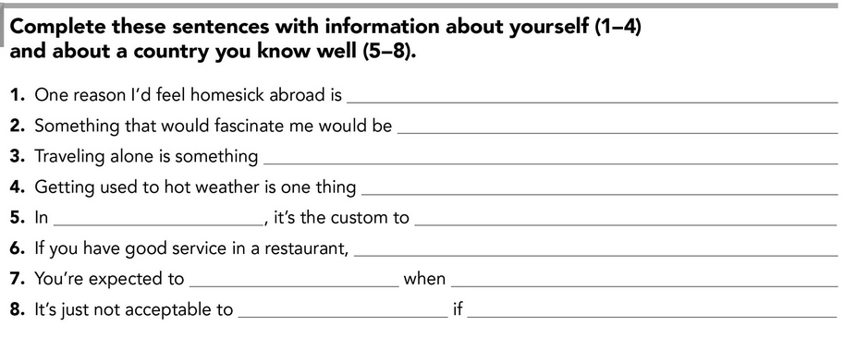

1-. For being away from my family.

2-. Learn to dance folklore.

3-. What I wouldn’t like to do.

4-. Complicated.

5-. in

6-. I´d be return again

7-. The weather is nice when the sky is cloudy.

8-. Drive a car if your alcohol drink.

**DEVELOPMENT**

**Look at the example and complete the chart with your own pictures and sentences. Remember to include varied time expressions and verbs in affirmative and negative sentences.**

**NAME OF THE COUNTRY YOU CHOSE: BRASIL**

**FIND TEN CUSTOMS FROM THIS COUNTRY AND WRITE THEM USING THE FOLLOWING EXPRESSIONS:**

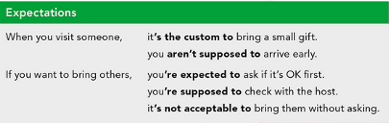

1. when you visit brazil, it's the custom to see the famous carnival
2. when you visit brazil, you´re supposed to learning the traditional samba dance

**Write about how would your experience be if you had to move to the country you chose. Use some of the expressions below:**

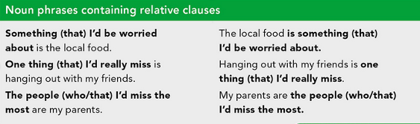

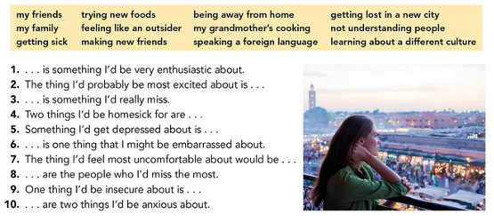



**NOW FIND SOME PICTURES RELATED TO THE THINGS YOU WROTE ABOUT, RECORD YOUR VIDEO AND UPLOAD IT TO THE PADLET.**

**RUBRIC**

