**ESCUELA NORMAL DE EDUCACIÓN PREESCOLAR**

**ENGLISH B1.2**

**UNIT 5 PROJECT**

**“EXPANDING YOUR HORIZONS”**



**Aim of the project:**

Give students practice discussing living abroad and talking about their greatest concerns.

**Preparation:**

* + - Choose a country you want to learn more about.
    - Read about the customs and lifestyle in this country and complete the preparation activities.
    - Make a 3 minute video with pictures and talk about the **customs** in the country you chose, you must also talk about how it would be for you to travel to this country (your concerns).

**Development:**

* Use varied time expressions to talk about your biggest concerns when living abroad and to talk about customs in a foreign country. Use grammar and vocabulary from the unit.
* Record a video where you include pictures and talk about the **customs** in the country you chose, you must also talk about how it would be for you to travel to this country (your concerns).**TRY NOT TO READ.**

**Products:**

* You must upload this **document** to Escuela en Red with the preparation activities completed.
* Go to <https://padlet.com/alvaradocris87/btrml0zwovpq7dv2> and upload your **video** to the Padlet.

**PREPARATION ACTIVITIES**

**Read these five cross-cultural situations. Write sentences describing what the visitors did wrong. USE THE EXPRESSIONS IN THE BOX.**

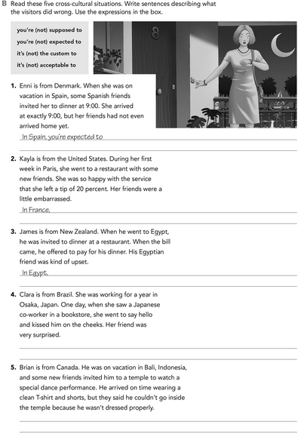

In indonesia, It´s not aceptable to to dress casual to enter to the temples

In Japan, you are not expected to someone come out of nowhere to greet you with a kiss on the cheek

It’s not the custom to let other people pay your dinner.

You are not supposed to leave more than 10 percent of tip.

arrive later than the appointed time

**Imagine you are going to travel to a country you have never visited before. Write sentences using the factors and feelings given. Then add another sentence explaining your feelings. Look at the example.**

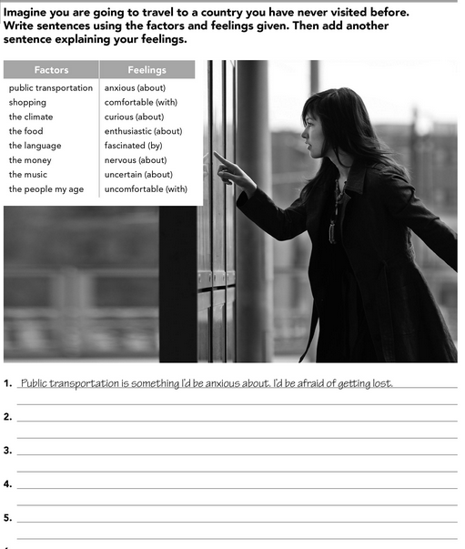

I´d be comfortable with people of my age. I´d ask them things i had doubts.

The food is something i´d be curious about. I´d be eating things that look reliable to eat

The language is something i´d be nervous about. I´d be shock if i forget how to say

Shopping is something i´d be enthusiastic about. I´d love to shop everything i want.

**Complete these sentences with information about yourself (1-4) and about a country you know well (5-8).**

about my family

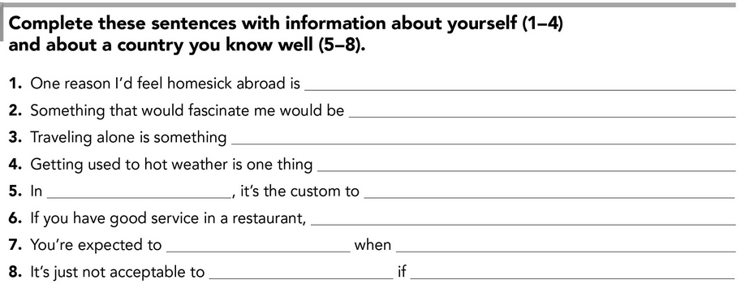

You´re not dressed properly

Enter to a bar

You go out to dinner

Eat paella

You´re supposed to leave a good tip

know how to dance flamenco

Spain

I´d be nervous

that makes me nervous

Meet new people and learn a new language

**DEVELOPMENT**

**Look at the example and complete the chart with your own pictures and sentences. Remember to include varied time expressions and verbs in affirmative and negative sentences.**

**NAME OF THE COUNTRY YOU CHOSE: ___SPAIN____**

**FIND TEN CUSTOMS FROM THIS COUNTRY AND WRITE THEM USING THE FOLLOWING EXPRESSIONS:**

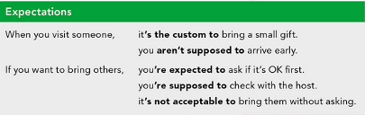

1. In Spain, you´re supposed to greet people and say goodbye with a kiss on each cheek.
2. Spain is known for its excellent wine culture, it´s the custom to order vino tinto in restaurants.
3. Lunch it´s supposed to eaten at two or three in the afternoon, and dinner around ten at night.
4. You´re expected to stop for some churros and hot chocolate at sunrise, after leaving a bar or night club.
5. It´s no acceptable to go to bed early.
6. You are not supposed to have you own personal space when you´re talking with someone.
7. In Spain, Tuesday the 13th, not Friday the 13th, is considered to be an unlucky day
8. You´re supposed to have a siesta between 2pm and 4 pm
9. When you visit someone you´re expected to bring some food to have a merienda.

**Write about how would your experience be if you had to move to the country you chose. Use some of the expressions below:**

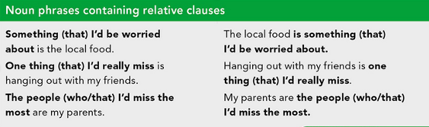

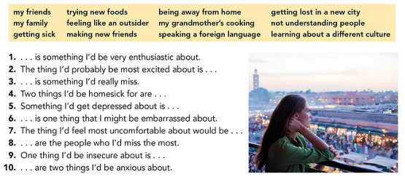

Meet new people is something i´d be very enthudiastic about



The thing i´d probable be most excited about is not seeing my family everyday.



My mom´s food is something i´d be really miss.



Two things i´d be homesick for are my family and Friends.



Something i´d get depressed about is being alone in a department



Don’t dress properly is one thing that i might be embarrassed about.



The thing i´d feel most uncomfortable about would be that they speak spanish like me.



My family are the people who i´d miss the most.



Meet about their culture and traditions are two things i´d be anxious about.

One thing i´d be insecure about is, to live alone.



**NOW FIND SOME PICTURES RELATED TO THE THINGS YOU WROTE ABOUT, RECORD YOUR VIDEO AND UPLOAD IT TO THE PADLET.**

**RUBRIC**

