**ESCUELA NORMAL DE EDUCACIÓN PREESCOLAR**

**ENGLISH B1.2**

**UNIT 5 PROJECT**

**“EXPANDING YOUR HORIZONS”**



**Aim of the project:**

Give students practice discussing living abroad and talking about their greatest concerns.

**Preparation:**

* + - Choose a country you want to learn more about.
    - Read about the customs and lifestyle in this country and complete the preparation activities.
    - Make a 3 minute video with pictures and talk about the **customs** in the country you chose, you must also talk about how it would be for you to travel to this country (your concerns).

**Development:**

* Use varied time expressions to talk about your biggest concerns when living abroad and to talk about customs in a foreign country. Use grammar and vocabulary from the unit.
* Record a video where you include pictures and talk about the **customs** in the country you chose, you must also talk about how it would be for you to travel to this country (your concerns).**TRY NOT TO READ.**

**Products:**

* You must upload this **document** to Escuela en Red with the preparation activities completed.
* Go to <https://padlet.com/alvaradocris87/btrml0zwovpq7dv2> and upload your **video** to the Padlet.

**PREPARATION ACTIVITIES**

**Read these five cross-cultural situations. Write sentences describing what the visitors did wrong. USE THE EXPRESSIONS IN THE BOX.**

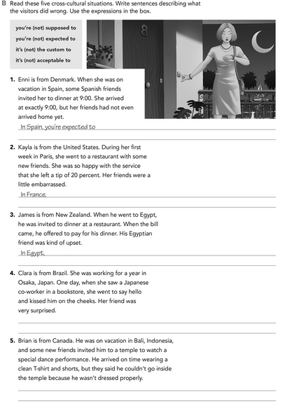

It’s custom that the tip is already included.

In Indonesia it is not acceptable to enter the temples with short garments showing shoulders and knees.

In Japan, it’s not the custom to greet with a kiss on the cheeks.

it's not acceptable to pay when you're invited.

arrive late.

**Imagine you are going to travel to a country you have never visited before. Write sentences using the factors and feelings given. Then add another sentence explaining your feelings. Look at the example.**

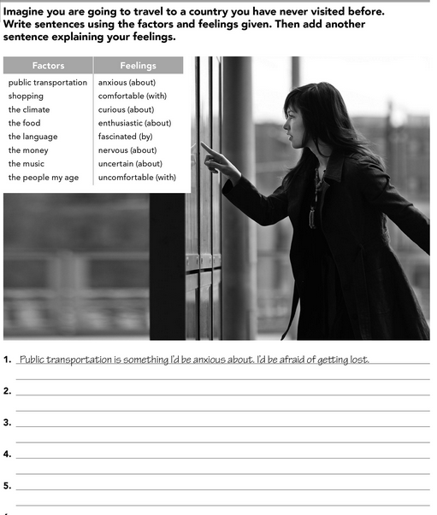

The food and climate are two things I'd be worried about. I'd be nervous of getting sick.

The music is something I'd be curious about. I'd be fascinated to know new rhythms and letters.

The people my age is something I'd be comfortable with. I'd be fascinated to share experiences with them.

The language is something I'd be enthusiastic about. I'd be curious to learn new phrases.

**Complete these sentences with information about yourself (1-4) and about a country you know well (5-8).**

is that I'd miss my family.

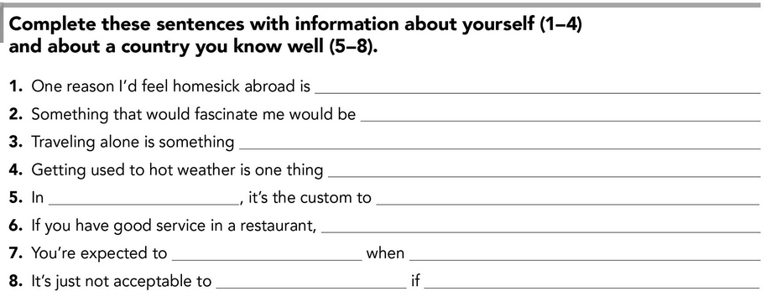

you are wearing your shoes.

to enter a home

someone invites you to their house.

bring a gift

it's not a custom to leave a tip.

to bow to greet.

Japan

I'd be comfortable with.

I’d be feeling insecure with.

to try new food and make friends.

**DEVELOPMENT**

**Look at the example and complete the chart with your own pictures and sentences. Remember to include varied time expressions and verbs in affirmative and negative sentences.**

**NAME OF THE COUNTRY YOU CHOSE: Japan**

**FIND TEN CUSTOMS FROM THIS COUNTRY AND WRITE THEM USING THE FOLLOWING EXPRESSIONS:**

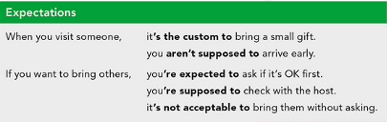

1. When you visit someone’s home, it´s the custom to take off your shoes before entering.
2. If you want to give a gift, you’re not expected to give watches or other objects that prominently display the numbers 4 and 7 because they represent death.
3. When you meet someone, you aren't supposed to be late.
4. If you want to greet someone, it's not acceptable to kiss them on the cheek.
5. When you travel on public transport, you aren’t supposed to speak loudly on the phone.
6. If you find something lost, it's custom to bring it to the Koban (police station)
7. When you go to a restaurant, you aren’t supposed to tip because they understand that good service is normal.
8. If you want to eat with chopsticks, it is not acceptable to place them vertically on a plate of rice, because they are reminiscent of incense placed in the sand, typically during funerals.
9. When you visit a place, you are expected to wear a mask to avoid catching a cold, infecting someone else or taking care of yourself from contamination.
10. If you want to visit a temple, it’s not acceptable to wear clothes that show your shoulders and knees.

**Write about how would your experience be if you had to move to the country you chose. Use some of the expressions below:**

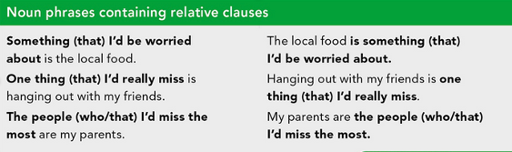

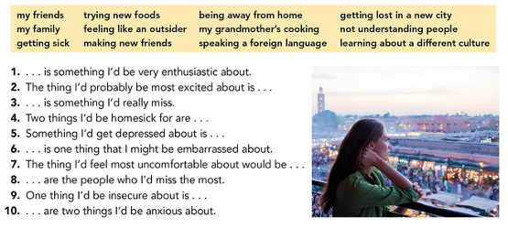

1. Meeting new people is something I’be very enthusiastic about.
2. The thing l'd probably be most excited about is know new places.
3. Hanging out with my friends is something I'd really miss.
4. Two things l'd be homesick for are my house and visit my grandmother on Sundays.
5. Something l'd get depressed about is that the trip was not what I expected.
6. Say something wrong is one thing that I might be embarrassed about.
7. The thing I’d feel most uncomfortable about would be feeling unwelcome for other people.
8. My mother and my brother are the people who I’d miss the most.
9. One thing I'd be insecure about is the language because is one of the most difficult in the world.
10. Getting lost in the city or getting sick are two things l'd be anxious about.

**NOW FIND SOME PICTURES RELATED TO THE THINGS YOU WROTE ABOUT, RECORD YOUR VIDEO AND UPLOAD IT TO THE PADLET.**

**RUBRIC**

