**ESCUELA NORMAL DE EDUCACIÓN PREESCOLAR**

**ENGLISH B1.2**

**UNIT 5 PROJECT**

**“EXPANDING YOUR HORIZONS”**

***María Paula González Valdez***



**Aim of the project:**

Give students practice discussing living abroad and talking about their greatest concerns.

**Preparation:**

* + - Choose a country you want to learn more about.
    - Read about the customs and lifestyle in this country and complete the preparation activities.
    - Make a 3 minute video with pictures and talk about the **customs** in the country you chose, you must also talk about how it would be for you to travel to this country (your concerns).

**Development:**

* Use varied time expressions to talk about your biggest concerns when living abroad and to talk about customs in a foreign country. Use grammar and vocabulary from the unit.
* Record a video where you include pictures and talk about the **customs** in the country you chose, you must also talk about how it would be for you to travel to this country (your concerns).**TRY NOT TO READ.**

**Products:**

* You must upload this **document** to Escuela en Red with the preparation activities completed.
* Go to <https://padlet.com/alvaradocris87/btrml0zwovpq7dv2> and upload your **video** to the Padlet.

**PREPARATION ACTIVITIES**

**Read these five cross-cultural situations. Write sentences describing what the visitors did wrong. USE THE EXPRESSIONS IN THE BOX.**

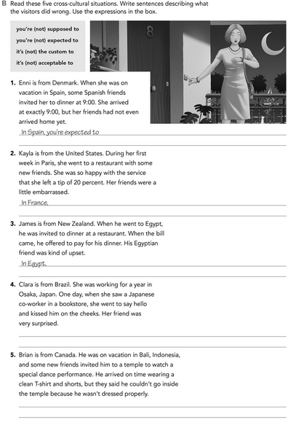

*it’s not the custom to tip a waiter.*

*arrive late, punctualy is not a friend of the Spain people.*

*In Indonesia, you’re supposed to waer clothing that covers your entire body.*

*In Japan, the Kiss greeting it’s not acceptable, you’re supposed to bow to say hello.*

*you’re expected to share the expenses and pay for your own food.*

**Imagine you are going to travel to a country you have never visited before. Write sentences using the factors and feelings given. Then add another sentence explaining your feelings. Look at the example.**

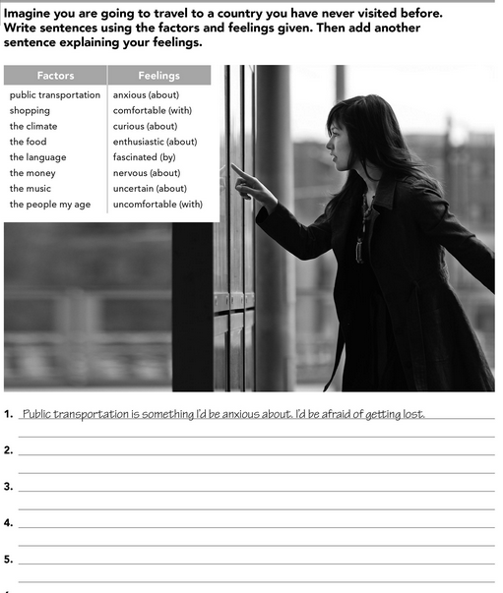

*The climate is one thing I’d be nervous about, I’d be afraid I don’t pack the right clothes.*

*The money is something I’d be uncertain about, I do not know the value of each coin.*

*The language is something I’d be nervous about, because I don’t know a word in Japanse.*

*I’d be very fascinated for shopping, the japanese fashion is lovely.*

**Complete these sentences with information about yourself (1-4) and about a country you know well (5-8).**

*miss my family and my country.*

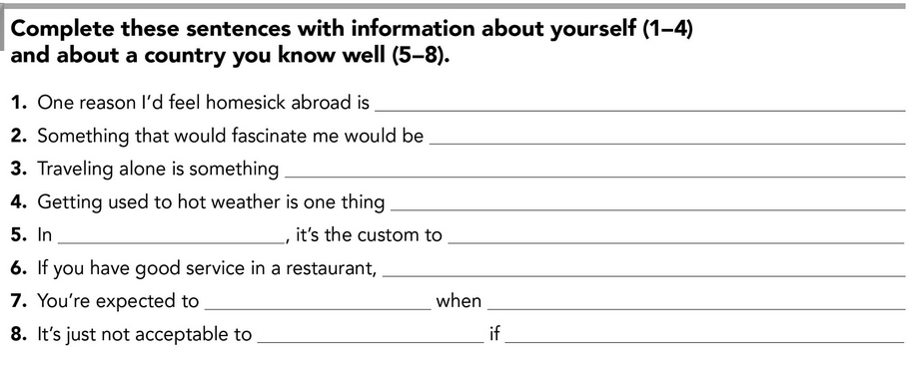

*getting good grates.*

*a friend give you a gift.*

*no said “Thank you”*

*you receive an invitation.*

*to respond quickly*

*you’re expected to tip the waiter.*

*take off your shoes when you enter to a house.*

*Japan*

*is a normal thing in Monclova, Coahuila.*

*I’d be insecure about.*

**DEVELOPMENT**

**Look at the example and complete the chart with your own pictures and sentences. Remember to include varied time expressions and verbs in affirmative and negative sentences.**

**NAME OF THE COUNTRY YOU CHOSE: ____*_Japan__________________________***

**FIND TEN CUSTOMS FROM THIS COUNTRY AND WRITE THEM USING THE FOLLOWING EXPRESSIONS:**

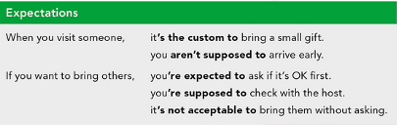

1. *If you go to a house it’s not acceptable to enter with shoes.*
2. *When you greet someone, it’s the custom to bow.*
3. *When you go to a restaurant, you aren’t supposed to tip the waiter.*
4. *When you go to restaurant, it’s the custom to eat directly from common dishes.*
5. *If you want to visit Japan, you’re expected to know how eat with chopsticks.*
6. *When you go to a public bath, it’s the custom clean yourself before entering.*
7. *You’re supposed to finish your food, because is considered impolite if you leave the food unfinished.*
8. *If you plan a meeting with the locals, you’re supposed to be on time.*
9. *When you are a little bit sick and you walk in the streets, it’s the custom to wear mask.*
10. *When you’re sick, it’s not acceptable to blowing your nose, is considered rude and disgusting.*

**Write about how would your experience be if you had to move to the country you chose. Use some of the expressions below:**

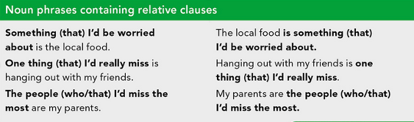

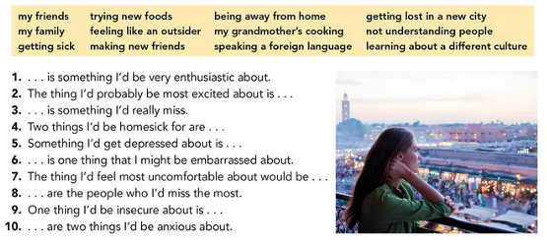

1. *Visit Disneyland Tokyo is something I’d be very enthusiastic about.*
2. *The thing I’d probably be most excited about is learning about a different culture.*
3. *One thing I’d be insecure about is getting lost in Japan.*
4. *Trying new food and making new friends are two things I’d be anxious about.*
5. *Something I’d get depressed about is not feeling welcomed by the Japanese.*

**NOW FIND SOME PICTURES RELATED TO THE THINGS YOU WROTE ABOUT, RECORD YOUR VIDEO AND UPLOAD IT TO THE PADLET.**

**Link:**

**https://www.youtube.com/watch?v=bJUGloJwQWo**

**RUBRIC**

