**ESCUELA NORMAL DE EDUCACIÓN PREESCOLAR**

**ENGLISH B1.2**

**UNIT 5 PROJECT**

**“EXPANDING YOUR HORIZONS”**



**Aim of the project:**

Give students practice discussing living abroad and talking about their greatest concerns.

**Preparation:**

* + - Choose a country you want to learn more about.
    - Read about the customs and lifestyle in this country and complete the preparation activities.
    - Make a 3 minute video with pictures and talk about the **customs** in the country you chose, you must also talk about how it would be for you to travel to this country (your concerns).

**Development:**

* Use varied time expressions to talk about your biggest concerns when living abroad and to talk about customs in a foreign country. Use grammar and vocabulary from the unit.
* Record a video where you include pictures and talk about the **customs** in the country you chose, you must also talk about how it would be for you to travel to this country (your concerns).**TRY NOT TO READ.**

**Products:**

* You must upload this **document** to Escuela en Red with the preparation activities completed.
* Go to <https://padlet.com/alvaradocris87/btrml0zwovpq7dv2> and upload your **video** to the Padlet.

**PREPARATION ACTIVITIES**

**Read these five cross-cultural situations. Write sentences describing what the visitors did wrong. USE THE EXPRESSIONS IN THE BOX.**

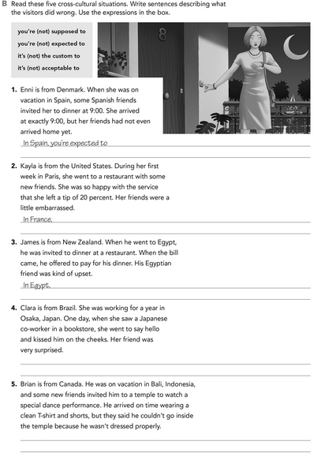

In Indonesia, you’re expected to follow

In Japan, it’s the custom to bow

you’re supposed to allow

it’s not the custom to leave

**Imagine you are going to travel to a country you have never visited before. Write sentences using the factors and feelings given. Then add another sentence explaining your feelings. Look at the example.**

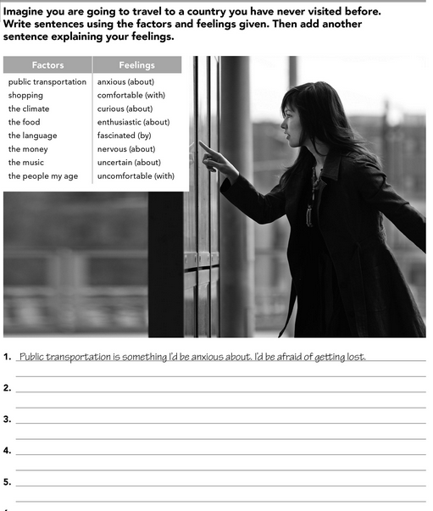

The language is something i'd be nervous. I'd feel desperate for not understanding

The climate is something I'd be anxious about I'd be afraid of not wearing suitable clothing

The money makes me insecure about I'd afraid it would run out

The food is something i’d be excites by because they are new flavors.

**Complete these sentences with information about yourself (1-4) and about a country you know well (5-8).**

i will miss my family

the culture

i'd make me nervous

easy for me

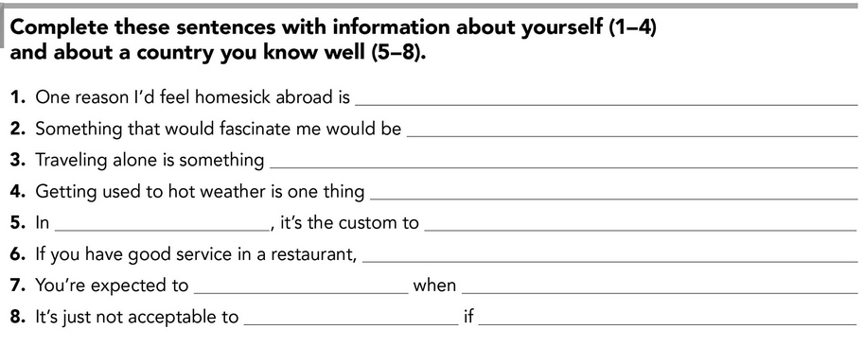

disrespecting a religious figure

The Día de muertos

are you religious

Give flowers

eat spicy

give thanks for the kindness

Mexico

**DEVELOPMENT**

**Look at the example and complete the chart with your own pictures and sentences. Remember to include varied time expressions and verbs in affirmative and negative sentences.**

**NAME OF THE COUNTRY YOU CHOSE: ___Japan________**

**FIND TEN CUSTOMS FROM THIS COUNTRY AND WRITE THEM USING THE FOLLOWING EXPRESSIONS:**

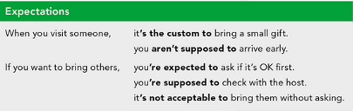

1. when you get to a house, It’s the custom to remove their shoes before entering.
2. when you pay, you’re supposed to try and give them extra money as a tip.
3. when you go down the street, it’s not acceptable to walk eating
4. when you invited to eat at a house, it’s the custom to bring a gift.
5. if you want to drink water at the table it’s not acceptable to fill the whole glass
6. it’s inappropriate to eat directly from common dishes.
7. It’s uncommon for restaurants to offer separate checks
8. Is very common shaking hands for business introductions in japan.
9. It’s the custom to knowledge in japan that many foreign people have difficulty sitting siza.
10. It’s customary to take off your backpack on a crowed train

**Write about how would your experience be if you had to move to the country you chose. Use some of the expressions below:**

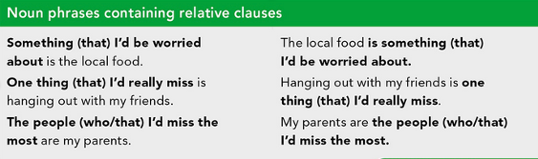

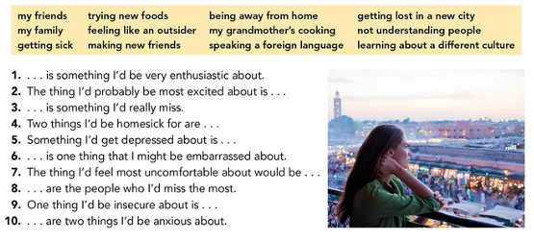

1. See new landscapes is something I'd be very enthusiastic about.

2. The thing I'd probably be most excited about is watch the buildings full of lights

3. play with my brother is something I'd really miss.

4. Two things I'd be homesick for are my mother's food and my room

5. Something I'd get depressed about is being away from my family

6. Do something wrong is one thing that I might be embarrassed about.

7. The thing I'd feel most uncomfortable about would be

8. to be wrong in the customs are the people who I'd miss the most.

9. One thing I'd be insecure about is be tried for being a foreigner

10. the language and the places are two things I'd be anxious about

**NOW FIND SOME PICTURES RELATED TO THE THINGS YOU WROTE ABOUT, RECORD YOUR VIDEO AND UPLOAD IT TO THE PADLET.**

**RUBRIC**

