**EESCUELA NORMAL DE EDUCACIÓN PREESCOLAR**

**ENGLISH B1.2**

**UNIT 5 PROJECT**

**“EXPANDING YOUR HORIZONS”**



**Aim of the project:**

Give students practice discussing living abroad and talking about their greatest concerns.

**Preparation:**

* + - Choose a country you want to learn more about.
    - Read about the customs and lifestyle in this country and complete the preparation activities.
    - Make a 3 minute video with pictures and talk about the **customs** in the country you chose, you must also talk about how it would be for you to travel to this country (your concerns).

**Development:**

* Use varied time expressions to talk about your biggest concerns when living abroad and to talk about customs in a foreign country. Use grammar and vocabulary from the unit.
* Record a video where you include pictures and talk about the **customs** in the country you chose, you must also talk about how it would be for you to travel to this country (your concerns).**TRY NOT TO READ.**

**Products:**

* You must upload this **document** to Escuela en Red with the preparation activities completed.
* Go to <https://padlet.com/alvaradocris87/btrml0zwovpq7dv2> and upload your **video** to the Padlet.

**PREPARATION ACTIVITIES**

**Read these five cross-cultural situations. Write sentences describing what the visitors did wrong. USE THE EXPRESSIONS IN THE BOX.**

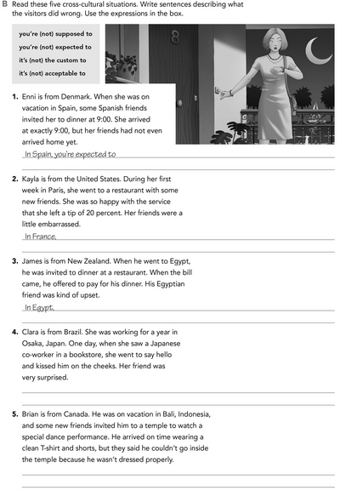

In Indonesia, it is not acceptable to wear shorts when you go to a temple

In Japan, is the custom to bow to the people and not to kiss them on the cheeks.

You are not expected to pay your dinner

You are not supposed to left a tip when you go to restaurant

Arrive late and not to be on time.

**Imagine you are going to travel to a country you have never visited before. Write sentences using the factors and feelings given. Then add another sentence explaining your feelings. Look at the example.**

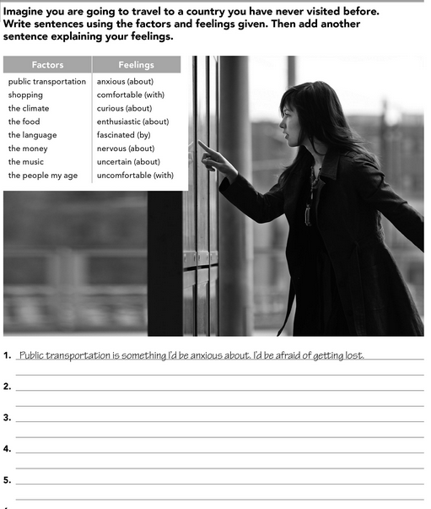

Shopping is something i would feel fascinated, I would like to see how is the style and clothes in other country

The people of my age are something I would feel uncertain about, I would feel depressed if I am like an outsider

The food is something I would feel curious about, It would be interesting to try new food.

The language is something i would feel nervous about, I am not good talking new languages.

**Complete these sentences with information about yourself (1-4) and about a country you know well (5-8).**

Missing my family and friends and my cat

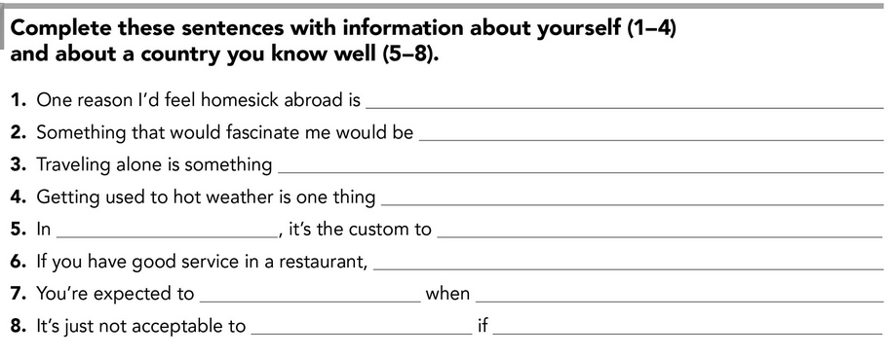

you are saying hello or goodbye

Kissing on the cheeks

You are invited to a friend´s house

Give a Little gift

It is not acceptable to left a tip

Be on time when you have a date

Japan

I would feel comfortable.

I would feel anxious and fascinated.

Trying new food

**DEVELOPMENT**

**Look at the example and complete the chart with your own pictures and sentences. Remember to include varied time expressions and verbs in affirmative and negative sentences.**

**NAME OF THE COUNTRY YOU CHOSE: COLOMBIA**

**FIND TEN CUSTOMS FROM THIS COUNTRY AND WRITE THEM USING THE FOLLOWING EXPRESSIONS:**

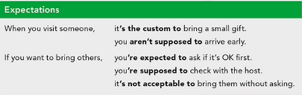

1. Is the custom to offer a cup of coffee.
2. You are expected to bring a little gift if you are invited to a friend´s house
3. It is acceptable to leave a tip in the restaurant
4. Is the custom to say hello with a kiss on the cheeks and a hug
5. You are supposed to dance cumbias in the carnivals and parties

**Write about how would your experience be if you had to move to the country you chose. Use some of the expressions below:**

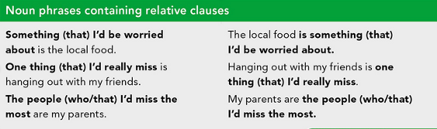

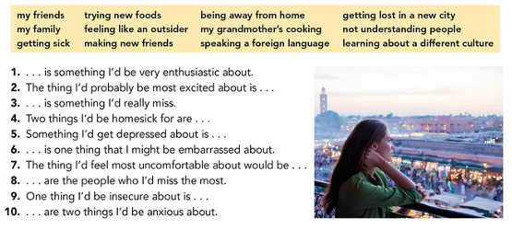

1. Making new friends is something I would be very enthusiastic about.
2. The thing I would probably be most excited about is trying new food.
3. My family is something I would really miss.
4. Two things I would be homesick for are my grandmother´s cooking and being away from home.
5. Something I would get depressed about is feeling like an outsider.
6. Speaking a foreign language is one thing thar I might not be embarrassed about.
7. The thing I would feel most uncomfortable about would be not understanding people.
8. My friends are the people who I would miss the most.
9. One thing I would be insecure about is getting lost in a new city.

**NOW FIND SOME PICTURES RELATED TO THE THINGS YOU WROTE ABOUT, RECORD YOUR VIDEO AND UPLOAD IT TO THE PADLET.**

**RUBRIC**

