**ESCUELA NORMAL DE EDUCACIÓN PREESCOLAR**

**ENGLISH B1.2**

**UNIT 5 PROJECT**

**“EXPANDING YOUR HORIZONS”**



**Aim of the project:**

Give students practice discussing living abroad and talking about their greatest concerns.

**Preparation:**

* + - Choose a country you want to learn more about.
    - Read about the customs and lifestyle in this country and complete the preparation activities.
    - Make a 3 minute video with pictures and talk about the **customs** in the country you chose, you must also talk about how it would be for you to travel to this country (your concerns).

**Development:**

* Use varied time expressions to talk about your biggest concerns when living abroad and to talk about customs in a foreign country. Use grammar and vocabulary from the unit.
* Record a video where you include pictures and talk about the **customs** in the country you chose, you must also talk about how it would be for you to travel to this country (your concerns).**TRY NOT TO READ.**

**Products:**

* You must upload this **document** to Escuela en Red with the preparation activities completed.
* Go to <https://padlet.com/alvaradocris87/btrml0zwovpq7dv2> and upload your **video** to the Padlet.

**PREPARATION ACTIVITIES**

**Read these five cross-cultural situations. Write sentences describing what the visitors did wrong. USE THE EXPRESSIONS IN THE BOX.**

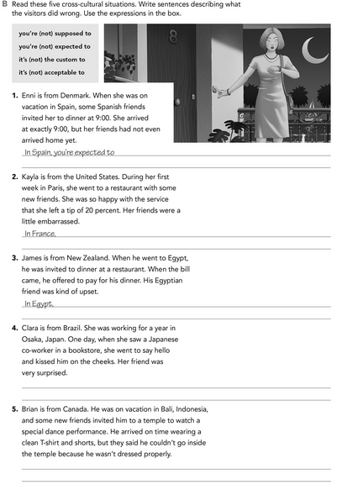

In Bali it is the custom to wear similar.

In Japan it is not the custom to kissed to other.

In Egypt it is not aceptable top ay for others.

In France is the custom pay for the service

In Spain you to expect to don't arrive early

**Imagine you are going to travel to a country you have never visited before. Write sentences using the factors and feelings given. Then add another sentence explaining your feelings. Look at the example.**

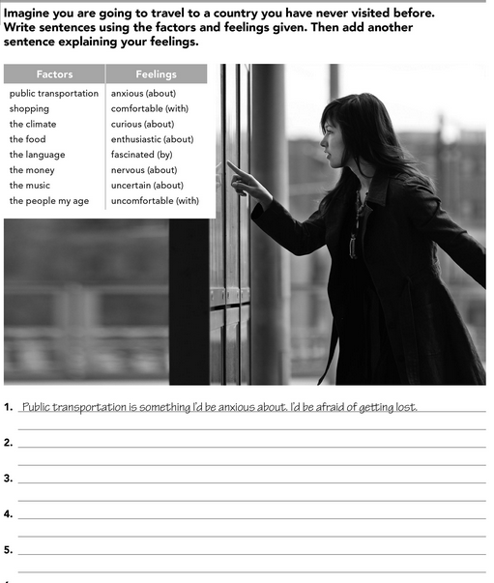

The music is something I´d be comfortable.

The people my age are something I´d be curious about their lives.

Shopping is something I´d be anxious when I don´t have a loto f money.

The food is something I´d be nervous when I never tasted it.

**Complete these sentences with information about yourself (1-4) and about a country you know well (5-8).**

Don´t have money to buy some things.

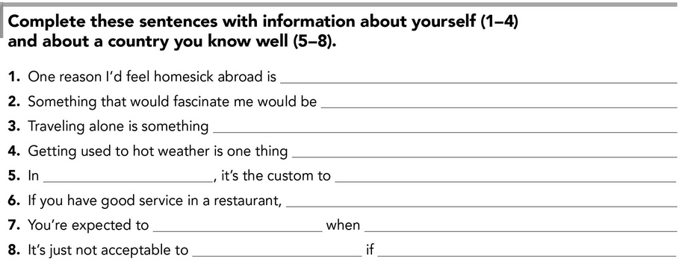

Your best friend is celebrating

Don´t go to the party

You go to the party

Give a present

You supposed top ay the service

Play to loteria in family

Mexico

Is traveling with my family

I´d be nervous

I´d be uncomfortable

**DEVELOPMENT**

**Look at the example and complete the chart with your own pictures and sentences. Remember to include varied time expressions and verbs in affirmative and negative sentences.**

**NAME OF THE COUNTRY YOU CHOSE: England**

**FIND TEN CUSTOMS FROM THIS COUNTRY AND WRITE THEM USING THE FOLLOWING EXPRESSIONS:**

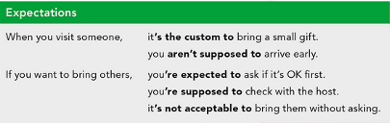

1. When you visit England it is the custom be very polite.
2. When you visit England you aren´t supposed to kissed to others.
3. When you visit England you are supposed to arrive early, very early.
4. In England it is the custom to celebrate the pancake day.
5. In England you are expected to drive with your left hand.
6. In England it is acceptable wear short dresses for the summer.
7. In England it is the custom to drink tea at five o´clock.
8. In England it is the custom to visit the pubs.
9. In England you are supposed to pay with cashback.
10. If you want to bring others, you are expected to ask if it is Ok first.

**Write about how would your experience be if you had to move to the country you chose. Use some of the expressions below:**

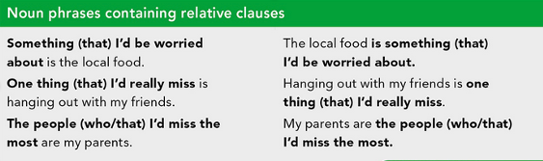

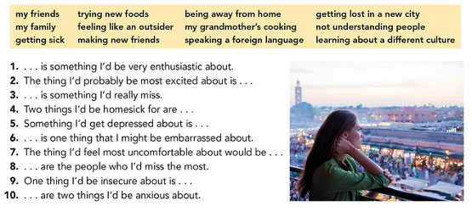

1. One thing I´d be insecure about is
2. Visit some pubs is something I´d be very enthusiastic about.
3. The thing I´d be probably be most excited about is pancake day.
4. Two things I´d be homesick for are drive with left hand and be very very polite.
5. Something I´d get depressed about is don´t see my family.
6. Drink tea at five o´clock every day Is one thing that I might be embarrassed about.
7. The thing I´d feel most uncomfortable about would be arrive very early.
8. My family are the people who I´d miss the most.
9. Go out with my friends is something I´d really miss.
10. Cook Christmas cookies and use cash back are two things I´d be anxious about.

**NOW FIND SOME PICTURES RELATED TO THE THINGS YOU WROTE ABOUT, RECORD YOUR VIDEO AND UPLOAD IT TO THE PADLET.**

**RUBRIC**

