**ESCUELA NORMAL DE EDUCACIÓN PREESCOLAR**

**Susana Abigail Rosas López**

**ENGLISH B1.2**

**UNIT 5 PROJECT**

**“EXPANDING YOUR HORIZONS”**



**Aim of the project:**

Give students practice discussing living abroad and talking about their greatest concerns.

**Preparation:**

* + - Choose a country you want to learn more about.
    - Read about the customs and lifestyle in this country and complete the preparation activities.
    - Make a 3 minute video with pictures and talk about the **customs** in the country you chose, you must also talk about how it would be for you to travel to this country (your concerns).

**Development:**

* Use varied time expressions to talk about your biggest concerns when living abroad and to talk about customs in a foreign country. Use grammar and vocabulary from the unit.
* Record a video where you include pictures and talk about the **customs** in the country you chose, you must also talk about how it would be for you to travel to this country (your concerns).**TRY NOT TO READ.**

**Products:**

* You must upload this **document** to Escuela en Red with the preparation activities completed.
* Go to <https://padlet.com/alvaradocris87/btrml0zwovpq7dv2> and upload your **video** to the Padlet.

**PREPARATION ACTIVITIES**

**Read these five cross-cultural situations. Write sentences describing what the visitors did wrong. USE THE EXPRESSIONS IN THE BOX.**

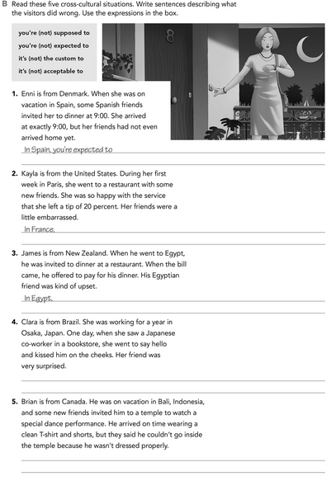

In indonesia you’re expected to dress up properly wen you are going inside a Temple

In Japan it’s not the custom to Kiss someone when you are going to say hello

It’s not acceptable to pay for your own food when someone has invited you to a restaurant

You’re not supposed to leave a tip to the waiter

arrive late

**Imagine you are going to travel to a country you have never visited before. Write sentences using the factors and feelings given. Then add another sentence explaining your feelings. Look at the example.**

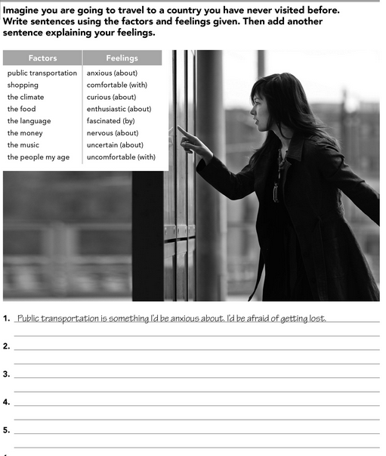

Something I’d be uncomfortable with is the music, even tho I’m open to listen diferent genders I’m really used to hear pop in english so I’d be weird and I don’t know if I’d like it

Getting to meet people my age is something I’d be curios about, I would be a little exited to know their interests and their likes.

The language is something I would be really enthusiastic about, It would be fantastic if I get to learn a brand new idiom.

Something I’d be nervous about it’s the food, usually I’m really picky with it so I’d be mortificated if I don’t like anything.

**Complete these sentences with information about yourself (1-4) and about a country you know well (5-8).**

T The food, I’d miss my mom’s cooking

The culture

I wouldn’t like to do

That I would like, because it would get me out of my confort zone

The United States celebrate Thanks Giving

It’s acceptable to leave a tip to the waiter ori f you see a jar of tips

Say hi you see someone you know

To stare at a woman she’s walking by, it’s just disrespectful

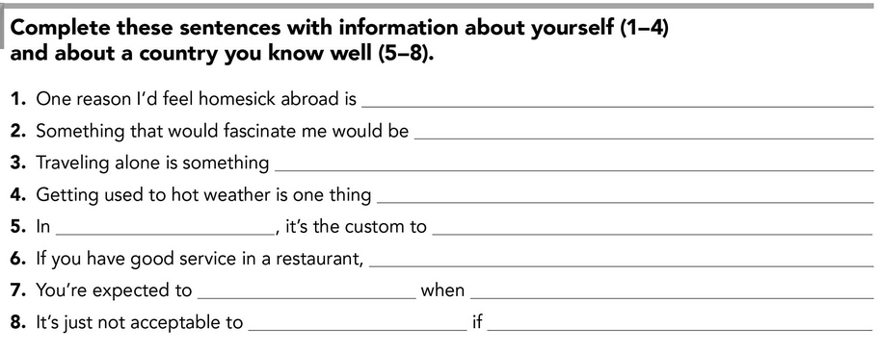

**DEVELOPMENT**

**Look at the example and complete the chart with your own pictures and sentences. Remember to include varied time expressions and verbs in affirmative and negative sentences.**

**NAME OF THE COUNTRY YOU CHOSE: FRANCE**

**FIND TEN CUSTOMS FROM THIS COUNTRY AND WRITE THEM USING THE FOLLOWING EXPRESSIONS:**

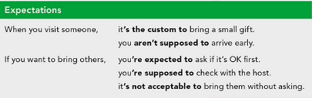

1. When you meet someone for the first time it’s acceptable to shake hands, never give them kisses.
2. When you are going to get on the subway you’re supposed to wait until the people who was on it get out, otherwise it’s unthoughtful.
3. If you are in a restaurant and you want more wine you’re expected to wait until the waiter serves you more, you can do it by your own if the waiter doesn’t come but you must ask to the person that’s sitting with you if they want wine and serve the person first.
4. When you’re eating with someone it’s the custom to have both hands on the table and your elbows must be out of sight never on the table.
5. When you’re eating any kind of soup it’s not acceptable to make noises while you’re eating it, it’s considered bad manners.
6. If you’re going to eat chesse you’re supposed to use the proper knife and also you must cut it correctly, French people use a different knife depending of the chesse and they also cut the chesse in a diferent way depending on the type.
7. When you see a friend somewhere and you want to say hi by giving them kisses it’s the custom to never touch their cheeks, and also the number of kisses you give depends on the region where the person lives.
8. When you’re hanging out with your friends you’re expected to wait until everyone has their beverage to start drinking, the same applies for the food, you must wait to start eating if someone doesn’t have their plate.
9. If you liked the service of a restaurant it’s not acceptable to leave a tip, people could get mad about it, in France the tip is usually charged on your count
10. If you’re trying to be nice and want to greet someone, you’re supposed to use the correct word, French people use different words to greet depending on the hour of the day.

**Write about how would your experience be if you had to move to the country you chose. Use some of the expressions below:**

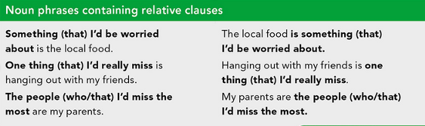

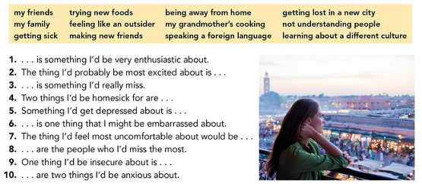

1. Learning about a different lifestyle and a brand new culture

2. Speaking a new language

3. My mother’s cooking

4. Being away from home and my routine

5. Not knowing anyone

6. Not understanding people

7. Getting lost in a new city

8. My family

9. Making new Friends

10. Trying new foods and getting sick

**NOW FIND SOME PICTURES RELATED TO THE THINGS YOU WROTE ABOUT, RECORD YOUR VIDEO AND UPLOAD IT TO THE PADLET.**

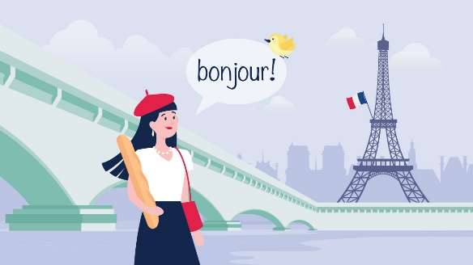

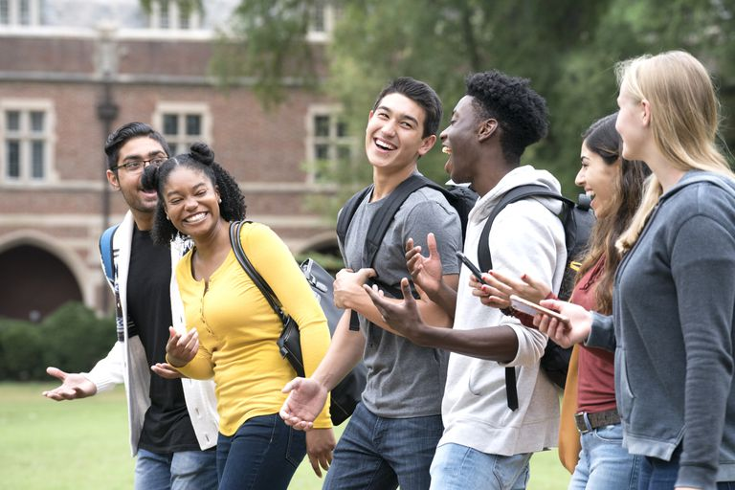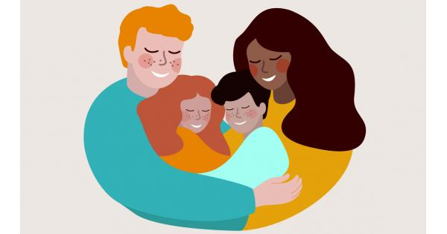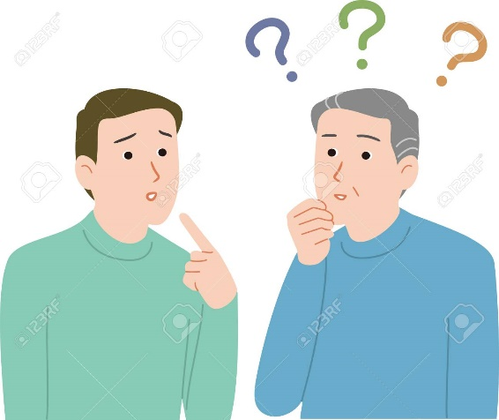

**RUBRIC**

