ESCUELA NORMAL DE EDUCACIÓN PREESCOLAR

***Ciclo 2020 – 2021***



**Student:** Dibeth Atziri Carreón

**Teacher:** Mayela Alejandra del Carmen Gaona García

**Subject:** ENGLISH B2 ONLINE

*“Platform Report of Advance”*

***Unit I.***

26 de abril de 2021 Saltillo, Coahuila

**UNIT 8 REPORT OF ADVANCE**

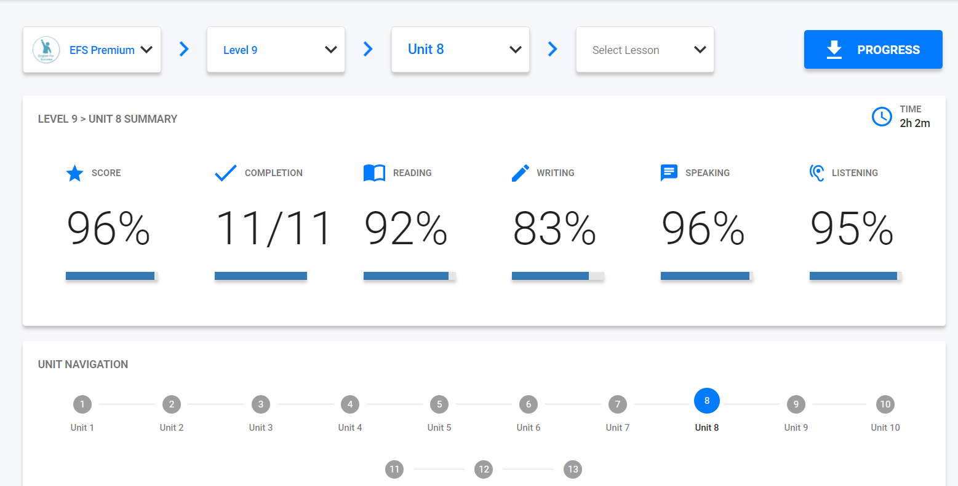

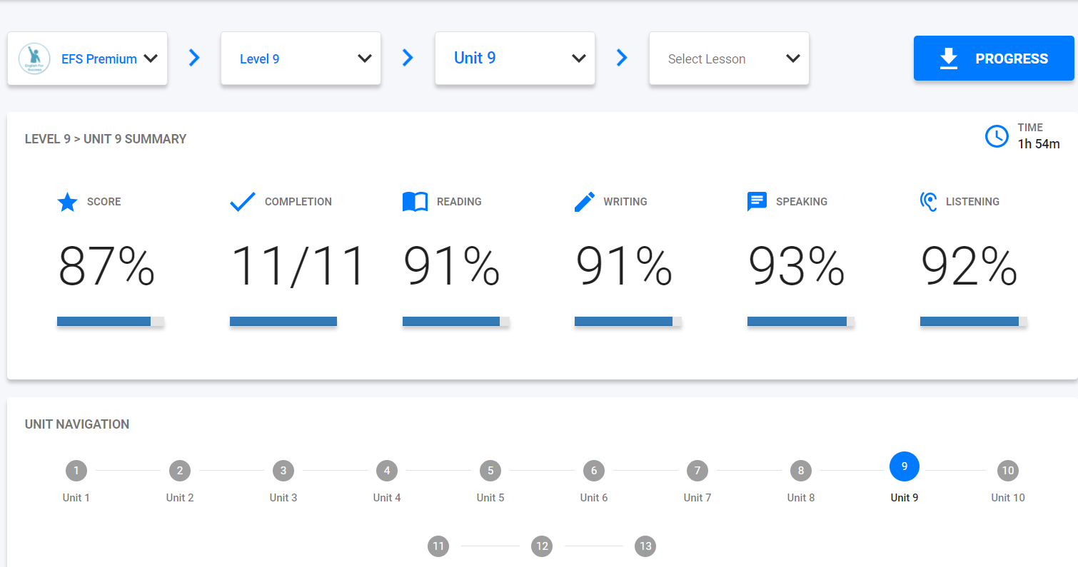**UNIT 9 REPORT OF ADVANCE**

