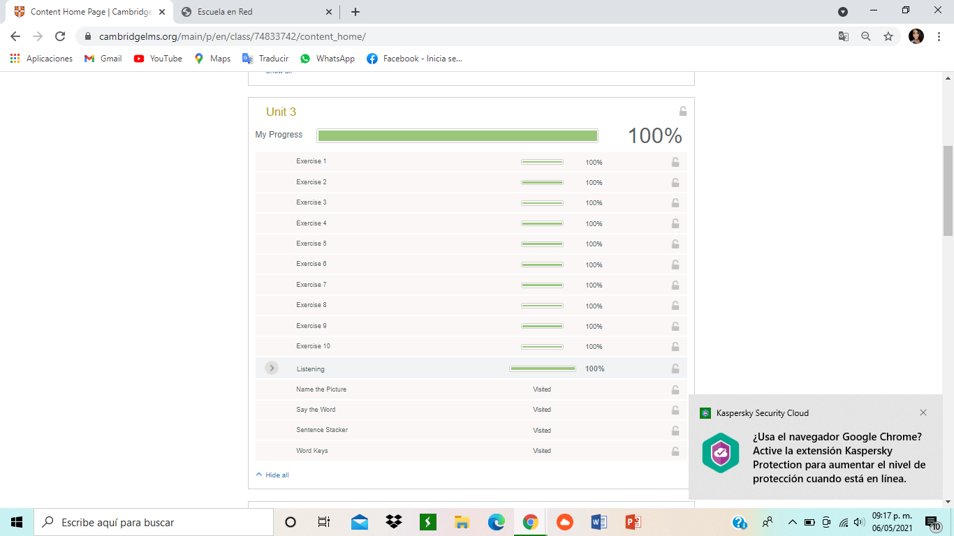**Student: Edna Natalya Dávila Bernal**