**ESCUELA NORMAL DE EDUCACIÓN PREESCOLAR**

**ENGLISH B1.2**

**UNIT 6 – THAT NEEDS FIXING**

**VOCABULARY**

Dear students, during the week we will describe problems and learn how to make complaints. Let’s start with some useful vocabulary!

**ACTIVITY 1 – ELECTRONICS AND PROBLEMS – 40 PTS.**

Write a definition for each word or expression in the picture, then write a sentence using each one of them.

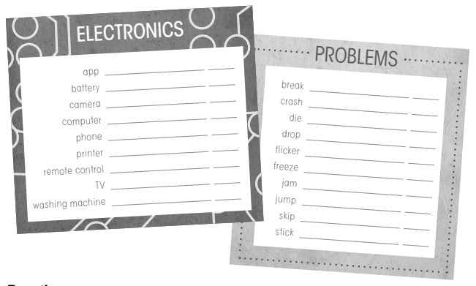

|  |  |  |
| --- | --- | --- |
| **WORD OR EXPRESSION** | **DEFINITION** | **SENTENCE** |
| app | an application, especially as downloaded to a device | *I just downloaded an amazing app on my cell phone* |
| battery | device that helps to function another electronic device | *the control does not work because it has no batteries* |
| camera | a device for recording visual images in the form of photographs, film, or video signals | *take a picture with your camera* |
| computer | an electronic device for storing and processing data | *I need to have a computer to do the homework* |
| phone | device used to make calls | *Can you lend me your phone to call my mom?* |
| printer | device that allows digital or physical formats to pass through paper and ink | *I have to print my homework* |
| remote control | appliance for turning on electronic devices | *the remote control does not work because it has no batteries* |
| TV | system for remote transmission and reception of images and sounds that simulate movements | *I like to watch my favorite series on tv* |
| washing machine | a machine for washing clothes. | *my washing machine is broken, and I couldn't wash my uniform* |
| break | separate or cause to separate into pieces as a result of a blow, shock, or strain | *my cell phone fell and the screen broke* |
| crash | collide violently with an obstacle | *I crashed my car and now I have to come walking* |
| die | stop living. | *my dog died in the past week* |
| drop | let something fall vertically. | *my brother drop the stairs* |
| Flicker | shine unsteadily; vary rapidly in brightness | *when the light starts flicker it means the battery is going to run out* |
| freezing | stay without doing anything | *my computer screen is freezing* |
| Jam | squeeze or pack tightly into a specified space. | *two of us were jammed in one compartment* |
| jump | push oneself off a surface and into the air by using the muscles in one's legs and feet. | *I like to jump on the trampoline* |
| skip | move along lightly, stepping from one foot to the other with a hop or bounce. | *ella comenzó a saltar por el camino* |
| Stick | a thin piece of wood that has fallen or been cut from a tree. |  |

**ACTIVITY 2 – ELECTRONICS AND PROBLEMS – 20 PTS.**

**ACTIVITY 3 – ELECTRONICS AND PROBLEMS – 20 PTS.**

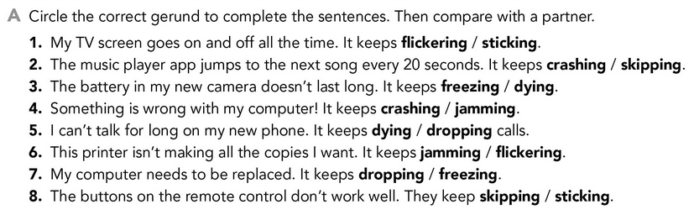



**ACTIVITY 4 – PROBLEMS – 20 PTS.**

