**ESCUELA NORMAL DE EDUCACIÓN PREESCOLAR**

**ENGLISH B1.2**

**BOOK UNIT 5 – EXPANDING YOUR HORIZONS**

**GRAMMAR**

Dear students, during the week we will discuss living in a foreign country and describing cultural expectations and differences.

**ACTIVITY 1 – READING ABOUT TRAVELING ABROAD – 10 PTS.**

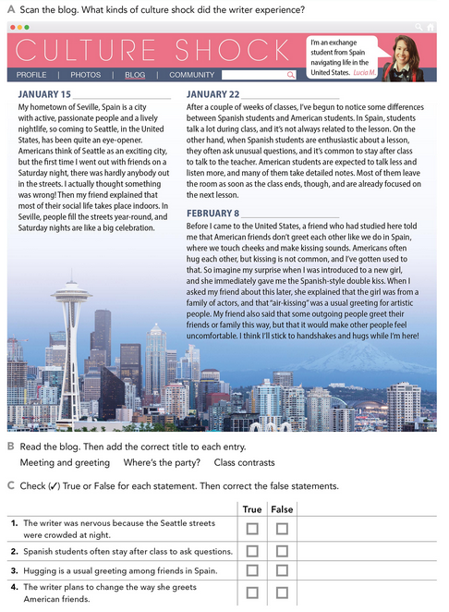

Meeting and greeting

Class contrasts

Where is the party?

**ACTIVITY 2 – NOUN PHRASES CONTAINING RELATIVE CLAUSES – 45 PTS.**

Read the following information and analyze the examples. These are expressions to discuss living in a foreign country.

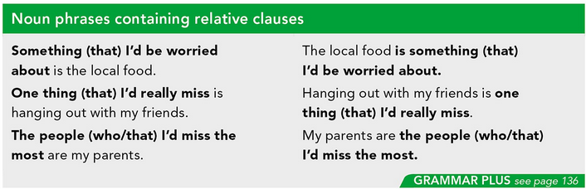

Complete the sentences about living in a foreign country using the phrases in the box. Look at the examples.

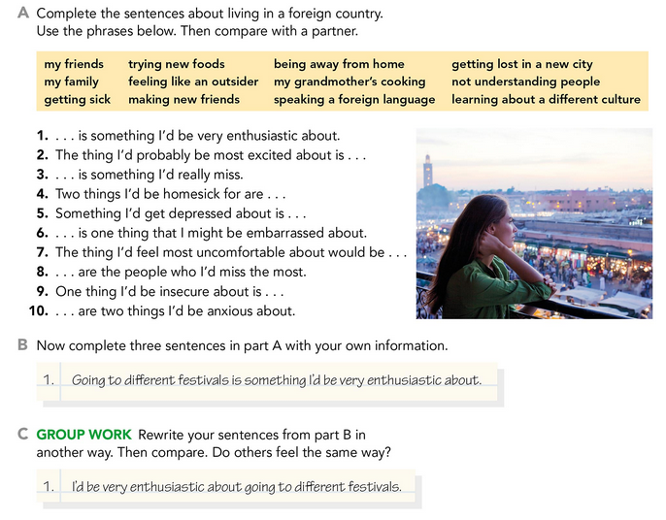

Feeling like an outsider.

Trying new foods and speaking a foreign language

Making new friends

My grandmother´s cooking and being away from home.

My Friends and family

Getting lost in a new city

Not understanding people

Being away from home

Learning about a different culture

Write your responses here:

1. Traveling to other countries is something I'd be very enthusiastic.

I´d be very enthusiastic about traveling to other countries.

1. The thing I´d probably be most excited is meeting new people.

Meeting new people is the thing I´d probably be most excited.

1. Eating Mexican food is something I´d really miss.

I´d really miss eating Mexican food.

1. Two things I´d be homesick for are being away of my friend and Mexican´s cooking.

Being away of my friend and Mexican´s cooking are two things I´d be homesick for.

1. Something I´d get depressed about is not seeing my family.

Not seeing my family is something I´d get depressed.

1. Not knowing a language is one thing I might be embarrassed about.

One thing I might be embarrassed about is not knowing a language.

1. The thing I´d feel most uncomfortable about would be living along.

Living along would be the thing I´d feel most uncomfortable.

1. My pets and family are the people who I´d miss the most.

The people who I´d miss the most are my pets and family.

1. One thing I´d be insecure about is talking with strangers.

Talking with strangers is one thing I´d be insecure about.

1. Going to a trip and making memories are two things I´d be anxious about.

Two things I´d be anxious about is going to a trip and making memories.

Write about living in a foreign country. In the first paragraph, write about two things you would enjoy. In the second paragraph, write about two things you might worry about. Look at the example.

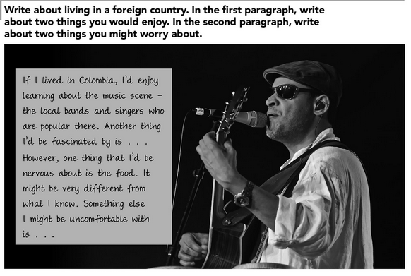

**If I lived in Brazil, I´d enjoy learning Portuguese, I love how it sound. Another thing I´d enjoy is speaking a new language.**

**Howeever one thing that I´d be nervous about is the culture. Knowing and being part of another culture is something strange for me. Something else is the traditions. Pratincing new thing make me feel panic.**

**ACTIVITY 3 – EXPECTATIONS – 45 PTS.**

Read the following information and analyze the examples. These are expressions to describe cultural differences and customs.

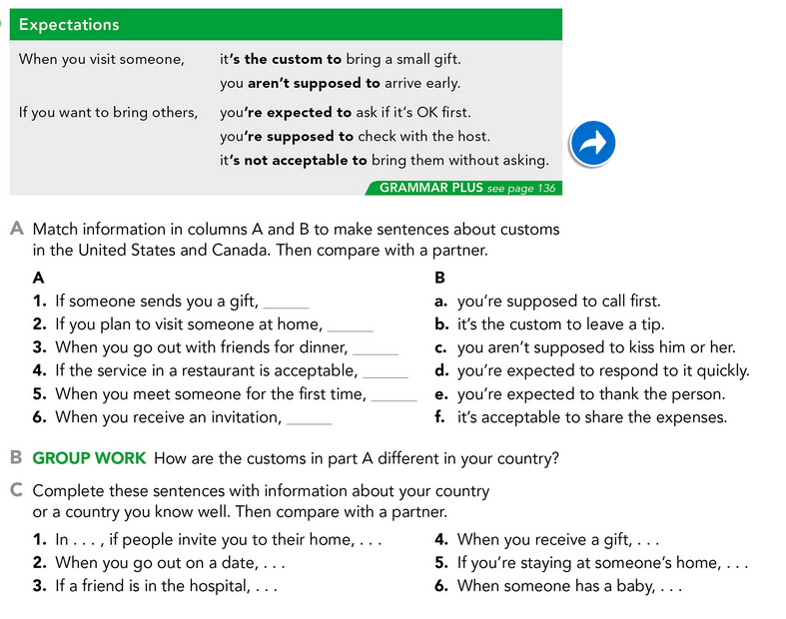

Write your responses here:

Complete these sentences by giving information about customs in a country you know.

