**ESCUELA NORMAL DE EDUCACIÓN PREESCOLAR**

**ENGLISH B1.2**

**UNIT 6 – THAT NEEDS FIXING**

**VOCABULARY**

Dear students, during the week we will describe problems and learn how to make complaints. Let’s start with some useful vocabulary!

**ACTIVITY 1 – ELECTRONICS AND PROBLEMS – 40 PTS.**

Write a definition for each word or expression in the picture, then write a sentence using each one of them.

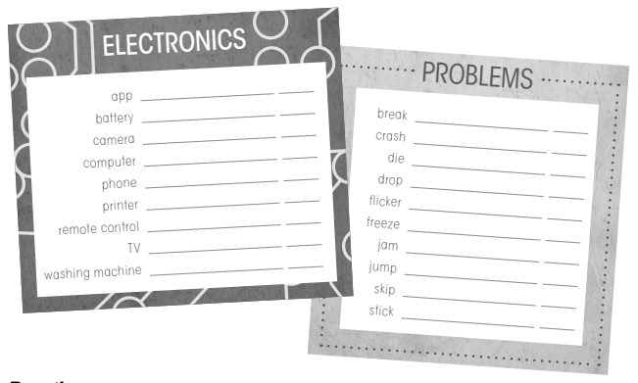

|  |  |  |
| --- | --- | --- |
| **WORD OR EXPRESSION** | **DEFINITION** | **SENTENCE** |
| App | An app typically refers to software used on a smartphone or mobile device such as the Android, iPhone, BlackBerry or iPad, as in “mobile app” or “iphone app.” ... For most of us, it's sufficient to think of an app this way: an app is a software program that you use online or on mobile devices. | My favorite apps are Instagram and whatsapp. |
| Battery | a container consisting of one or more cells, in which chemical energy is converted into electricity and used as a source of power. | My cell phone has a low battery, I need to charge it. |
| Camera | A camera is an optical instrument used to capture an image. | My brother bought a camera because he wants to be a photographer. |
| Computer | A computer is an electronic device that manipulates information, or data. It has the ability to store, retrieve, and process data. | I use my computer to make all my homeworks. |
| Phone | a device that uses either a system of wires along which electrical signals are sent or a system of radio signals to make it possible for you to speak to someone in another place who has a similar device | Could you answer the phone? |
| Printer | a machine for printing text or pictures onto paper, especially one linked to a computer. | *My brother is using the printer to print his homework.* |
| Remote control | a device that controls a machine, especially a television or VCR, from a distance. | *The buttons of my remote control don’t work well* |
| TV | (TV), sometimes shortened to tele or telly, is a telecommunication medium used for transmitting moving images in monochrome (black and white), or in color, and in two or three dimensions and sound. The term can refer to a television set, a television show, or the medium of television transmission. | My mom is using the Tv to watch her movie |
| Washing machine | a machine for washing clothes, sheets, and other things made of cloth | I put a load into the washing machine. |
| Break | to (cause something to) separate suddenly or violently into two or more pieces, or to (cause something to) stop working by being damaged | I think I've broken your phone. |
| Crash | If a vehicle crashes or someone crashes it, it is involved in an accident, usually a serious one in which the vehicle is damaged and someone is hurt | The plane crashed into a mountainside. |
| Die | to stop being alive, either suddenly or slowly | I'm sorry I didn't reply to your text - my phone died. |
| Drop | I'm sorry I didn't reply to your text - my phone died. | She dropped a hint that she'd like to come to the party. |
| Flicker | to appear for a short time or to make a sudden movement | A smile flickered across her face. |
| Freeze | If you freeze something, you lower its temperature below 0°C, causing it to become cold and often hard, and if something freezes, its temperature goes below 0°C | *Water freezes to ice at a temperature of 0°C.* |
| Jam | something that is stuck in a machine, or that prevents the parts of a machine from moving | She fed the documents into the machine making sure that there were no paper jams. |
| Jump | to push yourself suddenly off the ground in order to go over something | He suddenly jumped to his feet/jumped up and left. |
| Stick | a long, thin piece of something | At 84 he's still quite active, although he walks with the aid of a stick. |

**ACTIVITY 2 – ELECTRONICS AND PROBLEMS – 20 PTS.**

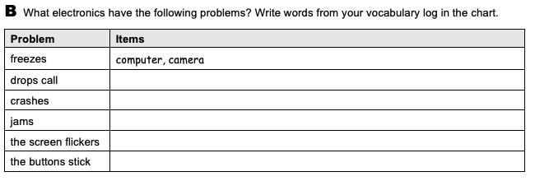

Remote control

Computer, tv

Computer, tv

Computer, camera, phone

Cell phone

**ACTIVITY 3 – ELECTRONICS AND PROBLEMS – 20 PTS.**

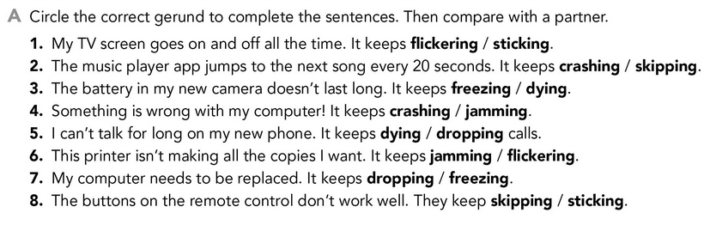

**ACTIVITY 4 – PROBLEMS – 20 PTS.**

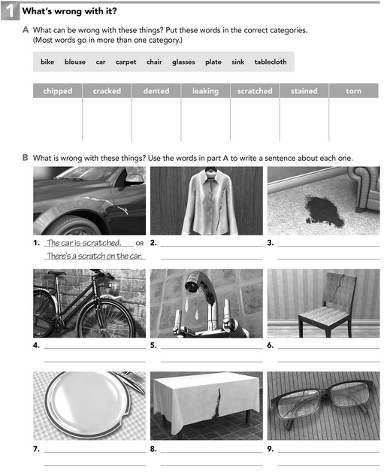

The glass is chipped.

There´s a chip on the glass.

The tablecloth is torn.

There´s a torno n the tablecloth.

The plate is chiped.

There´s a chipped on the plate.

The chair is cracked. There´s a cracked on the chair

The sink is leaking. There´s leaking on the sink

The carpet is stained, there´s stained on the carpet

The carpet is stained, there´s stained on the carpet

The blouse is torn. There´s a torno on the hook.

Blouse

tablecloth

car

carpet

car

sink

Bike

Chair

Glasses

Plate