**ESCUELA NORMAL DE EDUCACIÓN PREESCOLAR**

**ENGLISH B1.2**

**UNIT 6 – THAT NEEDS FIXING**

**VOCABULARY**

Dear students, during the week we will describe problems and learn how to make complaints. Let’s start with some useful vocabulary!

**ACTIVITY 1 – ELECTRONICS AND PROBLEMS – 40 PTS.**

Write a definition for each word or expression in the picture, then write a sentence using each one of them.

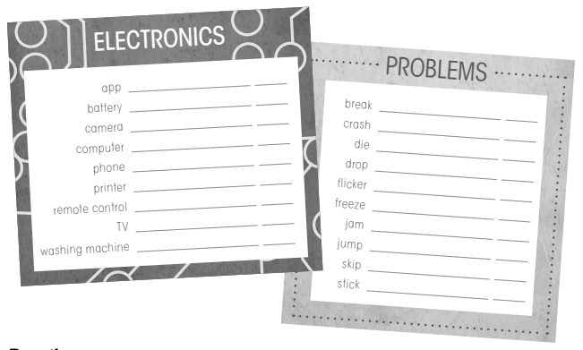

|  |  |  |
| --- | --- | --- |
| **WORD OR EXPRESSION** | **DEFINITION** | **SENTENCE** |
| app | Typically refers to software used on a smartphone or mobile device such as the Android, iPhone, BlackBerry or iPad | *Instagram is an app that can be used to take photos* |
| battery | A container consisting of one or more cells, in which chemical energy is converted into electricity and used as a source of power. | *The battery charger plugs into any mains socket.* |
| camera | A device for recording visual images in the form of photographs, film, or video signals. | *Jackson turned the camera on and stood beside her.* |
| computer | An electronic device for storing and processing data, typically in binary form, according to instructions given to it in a variable program. | *My friend's computer is state-of-the-art and she writes what you dictate to her.* |
| phone | A device that uses either a system of wires along which electrical signals are sent or a system of radio signals to make it possible for you to speak to someone in another place who has a similar device. | *I left the phone off the hook, so it wouldn't ring.* |
| printer | A machine that is connected to a computer and prints onto paper using ink | *My computer stopped working; a sheet was jammed.* |
| remote control | A system for controlling something such as a machine or vehicle from a distance, by using electrical or radio signals. | *Andrea's brother hid the remote control so that she would not switch to the tv.* |
| Tv | A device shaped like a box with a screen that receives electrical signals and changes them into moving images and sound, or the method or business of sending images and sound by electrical signals. | *Our new television has a very clear picture.* |
| washing machine | A machine for washing clothes, sheets, and other things made of cloth. | *The plumber is coming tomorrow to install the new washing machine.* |
| break | To (cause something to) separate suddenly or violently into two or more pieces, or to (cause something to) stop working by being damaged. | *I didn't mean to break your phone.* |
| crash | If a vehicle crashes or someone crashes it, it is involved in an accident, usually a serious one in which the vehicle is damaged and someone is hurt | *Convinced the plane was about to crash, many people were sobbing and in hysterics.* |
| die | To stop being alive, either suddenly or slowly. | *The engine just died on us.*  *I'm sorry I didn't reply to your text - my phone died.* |
| drop | to fall or to allow something to fall. | *She dropped her keys.*  *Amanda dropped her sunglasses in/into the fountain.* |
| flicker | to shine with a light that is sometimes bright and sometimes weak. | *Sofia's cell phone screen started to flicker like it was going to break down.* |
| freeze | If an engine or lock freezes, it stops working because its parts have become stuck and can no longer move. | *My old bicycle was so rusty that the gears had frozen.*  *If the lock has frozen up, try lubricating it with oil.* |
| jam | something that is stuck in a machine, or that prevents the parts of a machine from moving. | *She fed the documents into the machine making sure that there were no paper jams.* |
| jump | to avoid or leave out a point or stage from the correct order in a series. | *Armando's remote control jumps channels because It’s damaged.* |
| skip | to move lightly and quickly, making a small jump after each step | *Ana always skips the advertising videos on youtube.* |
| stick |  |  |

**ACTIVITY 2 – ELECTRONICS AND PROBLEMS – 20 PTS.**

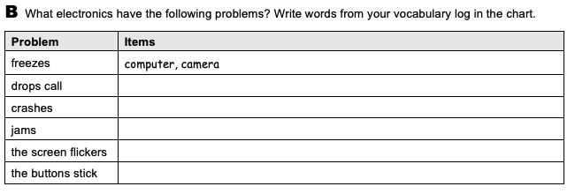

Remote control, cell phone, washing machine, printer, radio

Cell phone, Tablet, computer

Computer, printer

tablet

phone

**ACTIVITY 3 – ELECTRONICS AND PROBLEMS – 20 PTS.**

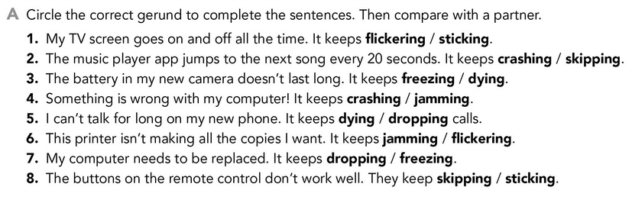

**ACTIVITY 4 – PROBLEMS – 20 PTS.**

