**ESCUELA NORMAL DE EDUCACIÓN PREESCOLAR**

**ENGLISH B1.2**

**UNIT 6 – THAT NEEDS FIXING**

**VOCABULARY**

Dear students, during the week we will describe problems and learn how to make complaints. Let’s start with some useful vocabulary!

**ACTIVITY 1 – ELECTRONICS AND PROBLEMS – 40 PTS.**

Write a definition for each word or expression in the picture, then write a sentence using each one of them.

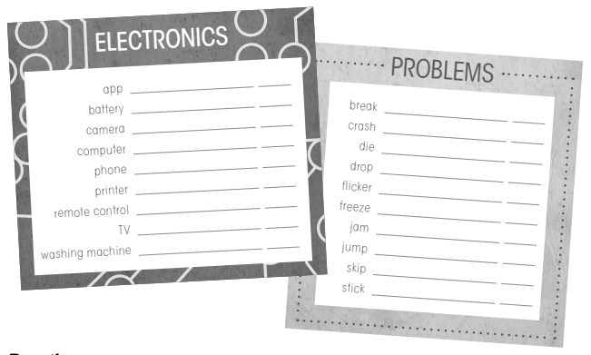



|  |  |  |
| --- | --- | --- |
| **WORD OR EXPRESSION** | **DEFINITION** | **SENTENCE** |
|  |  |  |
|  |  |  |
|  |  |  |
|  |  |  |
|  |  |  |
|  |  |  |
|  |  |  |
|  |  |  |
|  |  |  |
|  |  |  |
|  |  |  |
|  |  |  |
|  |  |  |
|  |  |  |
|  |  |  |
|  |  |  |
|  |  |  |
|  |  |  |

**ACTIVITY 2 – ELECTRONICS AND PROBLEMS – 20 PTS.**

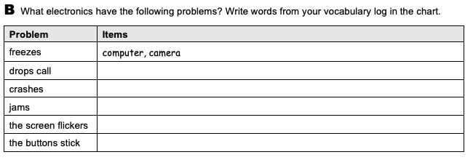



**ACTIVITY 3 – ELECTRONICS AND PROBLEMS – 20 PTS.**

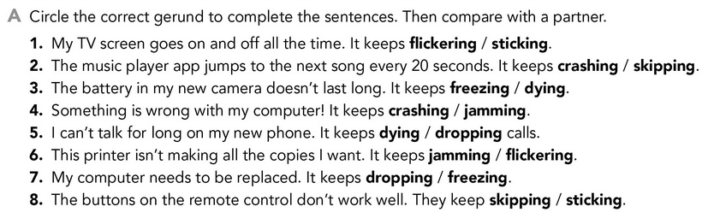



**ACTIVITY 4 – PROBLEMS – 20 PTS.**

