**ESCUELA NORMAL DE EDUCACIÓN PREESCOLAR**

**ENGLISH B1.2**

**UNIT 6 – THAT NEEDS FIXING**

**VOCABULARY**

Dear students, during the week we will describe problems and learn how to make complaints. Let’s start with some useful vocabulary!

**ACTIVITY 1 – ELECTRONICS AND PROBLEMS – 40 PTS.**

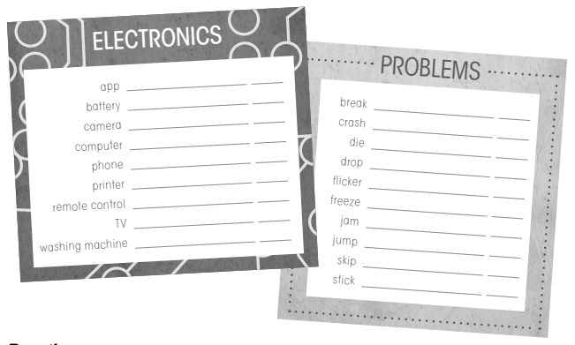Write a definition for each word or expression in the picture, then write a sentence using each one of them.

|  |  |  |
| --- | --- | --- |
| **WORD OR EXPRESSION** | **DEFINITION** | **SENTENCE** |
| App | computer programs that perform specific work | my cell phone has an app |
| Battery | Electromagnetic device capable of accumulating electrical energy | the battery of my cell phone does not work |
| Camera | Used to record still or moving images. | my camera was damaged |
| Computer | Electronic machine capable of storing information | I have a new computer |
| Phone | A portable device that can make or receive calls | my cell phone is white |
| Remote control | Device that remotely regulates the operation of a machine | my remote control was lost |
| Printer | Machine that is connected to an electronic computer and used to print information | my printer ran out of ink |
| TV | System of transmission of images and sounds at a distance by means of waves | my tv is new |
| Washing machine | Appliance for washing clothes | my mom bought a washing machine |
| Break | Break a thing into irregular pieces | we had a little break |
| Crash | Mutual interaction between two or more bodies | my neighbor had a crash |
| Drop | Action of falling or falling. | my flower pot has a drop |
| Flicker | Close and open the eyelids, once or repeatedly. | every day I flicker |
| Freeze | Low enough temperature. | my sandwich is freeze |
| Jam | Preserves sweet that is made by cooking fruit | strawberry jam is the best |
| Jump | Rising off the ground or other surface with momentum | I like to jump the count |
| Skip | move on to the next | I like to skip the introduction of the series |
| Stick | Longer than thick piece of wood | my dog ​​played with a stick |

**ACTIVITY 2 – ELECTRONICS AND PROBLEMS – 20 PTS.**

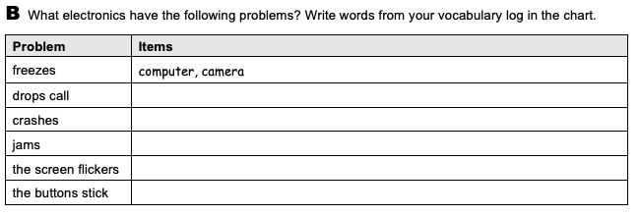

Phone,computer

Printer

Jam

Camera, phone

Remote control

**ACTIVITY 3 – ELECTRONICS AND PROBLEMS – 20 PTS.**

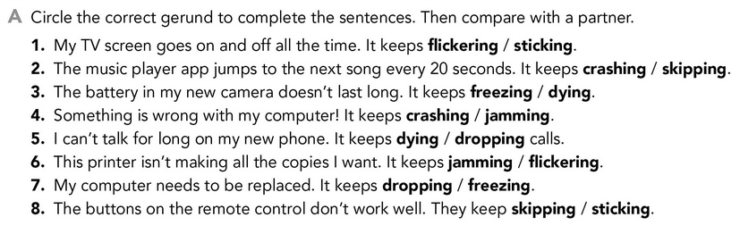

**ACTIVITY 4 – PROBLEMS – 20 PTS.**

