**ESCUELA NORMAL DE EDUCACIÓN PREESCOLAR**

**ENGLISH B1.2**

**BOOK UNIT 6 – THAT NEEDS FIXING**

**GRAMMAR**

Dear students, during the week we will describe problems and learn how to make complaints.

**ACTIVITY 1 – SOME COMMON COMPLAINTS – 25 PTS.**

Read about some common complaints. Then answer the questions.



Write your responses here:

1. **that hasn't happened to me**
2. **Banking : I'd call to ask what happened online shopping: I would ask for a change of size internet providers: I would change to another company restaurant: I would report it to the manager vehicles: I will sell my car repair services: I would hire another service parking garage : I would put cameras in my car**
3. **once I bought something online and my product never arrived**

**ACTIVITY 2 – DESCRIBING PROBLEMS 1 – 25 PTS.**

* We can use the **past participle as adjectives** to describe problems with certain places or products. Example: The car **is damaged**. / El carro está dañado or My pants **are stained.** / Mi pantalón está manchado. Remember that for regular verbs we add -ed in the past participle (ex. stained, damaged), irregular verbs change completely (ex. torn)
* To describe problems we can also use **nouns** to say that there is something wrong with the product or that it has a problem. Example: The car *has* **some damage**. / El carro tiene cierto daño or *There is* **a stain** in my pants. / Hay una mancha en mis pantalones.

Read and analyze the following examples.

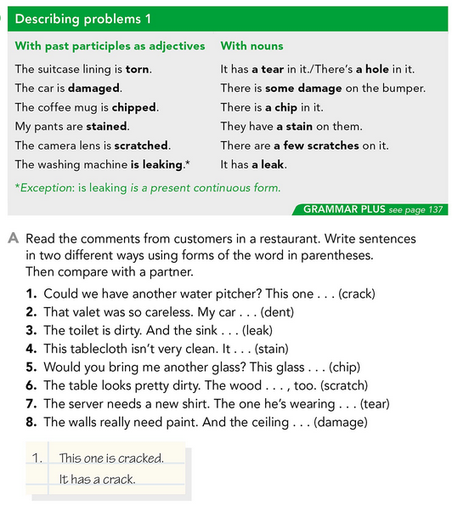

Complete the conversations with the correct words from the box.

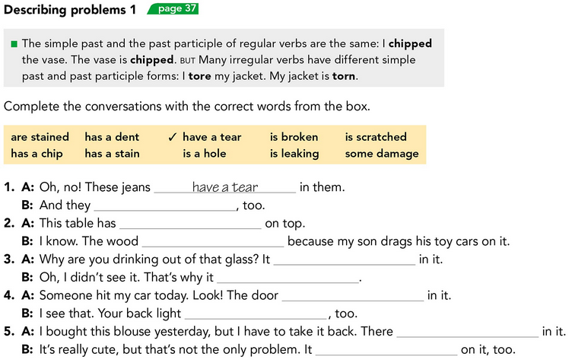



Read the comments from customers in a restaurant. Write sentences in two different ways using forms of the word in parentheses. Look at the example.



**2. My car was dent / it has dent**

**3. The sink is leak / it has leak**

**4. The tablecloth is stain / it has stain**

**5. The glass is chip/ it has chip**

**6. The wood is scratch/ it has scratch**

**7. These one is tear/ it has tear**

**8. The walls are damages/ it has damage**

**ACTIVITY 3 – DESCRIBING PROBLEMS 2 – 25 PTS.**

Another way to talk about problems with a place or product is talking about what needs to be done to fix it. In order to do this, we can use:

* **NEED** + **GERUND**: Ex. The car NEEDS FIXING. / El carro necesita arreglo.
* **NEED** + **PASIVE INFINITIVE**: Ex. The car NEEDS TO BE FIXED. / El carro necesita ser reparado.

We can also talk about problems with a product saying what continues happening with it using **KEEP** + **GERUND**. Ex. The monitor of my computer KEEPS FREEZING. / La pantalla de mi computadora se sigue congelando.

Read and analyze the following examples.

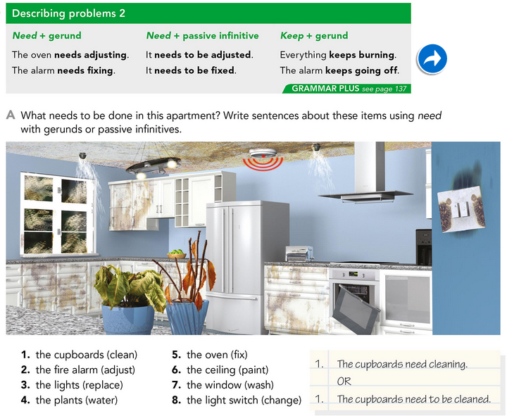

Complete the following exercises using the correct form of the verbs in parentheses.

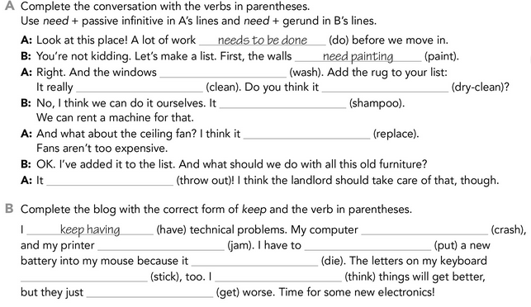





Write your responses here:

2. The fire alarm need to be adjusted

3. The light don’t need to be replaced

4. The plants needs watering

5. The oven need to be fixed

6. The ceiling need painting

7. The window need to be washed

8. The light switch need to be changed

**ACTIVITY 3 – WRITING ABOUT PROBLEMS AT HOME – 25 PTS.**

Think of five improvements you would like to make in your home. Which improvements will you most likely make? Which won’t you make?

“First the bedroom walls *need painting*. There are some small *cracks*…”

Write about your improvements here: first my room need to be painted because I don't like the color anymore, then I need to plant new flowers, the decorations in the room need to be changed ,I need to buy a new stove and the windows need cleaning.