Escuela Normal de Educación Preescolar
Licenciatura en Educación Preescolar
Ciclo escolar 2020-2021
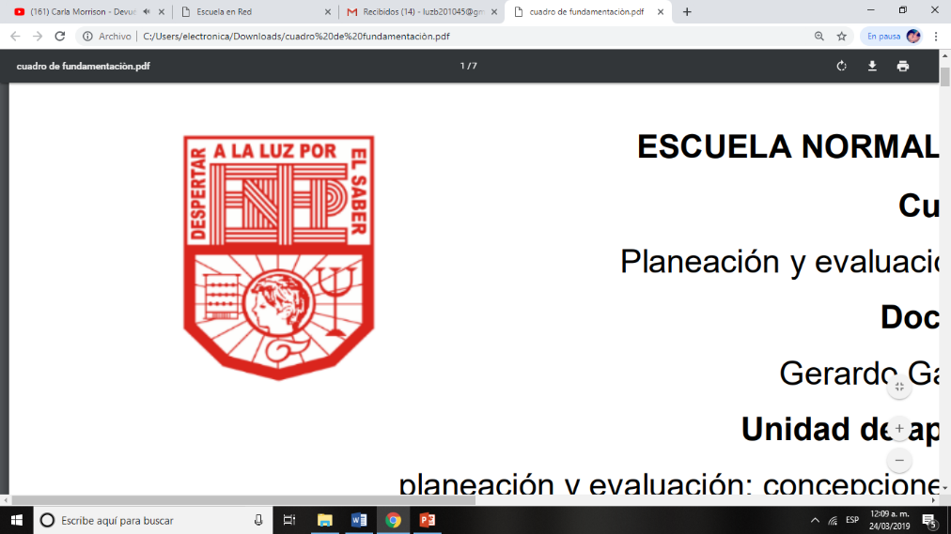

Curso:
Inglés

Profesora:
Brenda Bollain y Goytia de la Peña

Alumna:
Luz María Velásquez Mata #28

3° “B”

Unit 2- Final Project- I wish I could

19 de mayo de 2021 Saltillo, Coahuila
UNIT 2- FINAL PROJECT-I WISH I COULD-FLIPGRID
STUDENT: LUZ MARÍA VELÁSQUEZ MATA
Instructions. DEAR ALL, NOW IT'S TIME TO DEMONSTRATE YOUR SPEAKING SKILLS. IN THE FOLLOWING LINK YOU WILL FIND YOUR GUIDELINE AND GRADING CRITERIA FOR YOUR UNIT 2 PROJECT. https://docs.google.com/presentation/d/1IbyU4QL6LW8bbPfhmUU0pIBdC6Ed0CsICmYEOKuHQpo/edit?usp=sharing
SCREENSHOT OF MY VIDEO
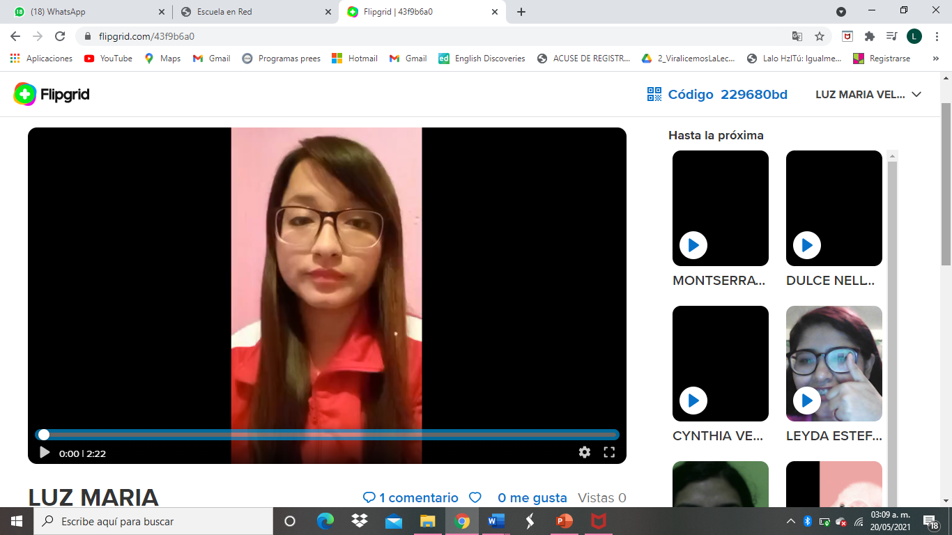
RUBRIC
