**ESCUELA NORMAL DE EDUCACION PREESCOLAR**

Licenciatura en educación preescolar

Ciclo escolar 2020- 2021



Ingles B1.1

Unit 2 – Final Project

**Teacher**: Brenda Bollain y Goytia de la Peña

**Alumna**: Briseida Guadalupe Medrano Gallegos

May 19 2021

Saltillo, Coahuila

Hello, my name is Briseida Medrano, in this video i Will comment on three points that i consider to be wrong in my city and a solution

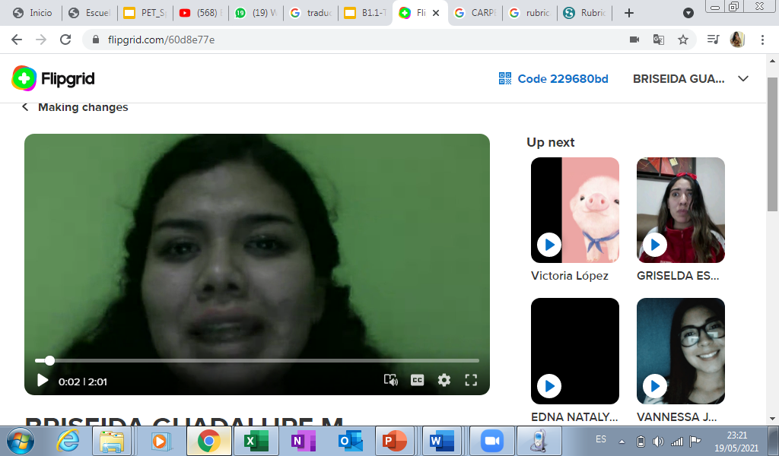

|  |  |  |  |
| --- | --- | --- | --- |
| **criteria** | **excellent** | **Good** | **needs improvement** |
| content | The content includes 3/3   statements  3 pts | The content includes only 2/ 3  2.5 pts | The content includes only 1 statement  2 pts |
| organization | The information is presented in a clear and organized way. It is delivered in a logical order  3 pts | The information is presented in a somewhat clear and organized way, as well as the logical order of ideas.  2.5  pts | The information lacks organization and the  ideas are not clearly stated and organized in a logical way.  2 pts |
| Language & delivery of speech | Language is used correctly and creatively, words varied and easy to follow. Good fluency  Includes grammar structures seen in the unit  3 pts | Most language is clear, easy to follow and understand. Most of the words are well pronounced. Voice is often clear and there is evidence of some grammar structures seen in the unit  2.5 pts | Language is unclear and hard to understand. Lots of grammar, vocabulary and pronunciation mistakes. Lack of fluency. Poor evidence of grammar structures seen in the unit.  2 pts. |
| participation | 2/2 responses to others’ participation  1 pt. | ½ responses to other’s participation  .5 pts | 0/2 responses to their classmates’ participation  0 pts |