**ENGLISH III. SHARING INFORMATION AND IDEAS 2020-2021**

**Semester II**

Learning Evidence 2

Interchange unit 6 and 9

**PROJECT: Sports star**

|  |  |  |
| --- | --- | --- |
| *Aims:* | 1. *Talk about routines* 2. *Talk about abilities* 3. *Identify people by describing how they look and what they’re doing* 4. *Ask for more information* 5. *Express surprise/disbelief* 6. *Agree* |  |

***FAMOUS ATHLETES***

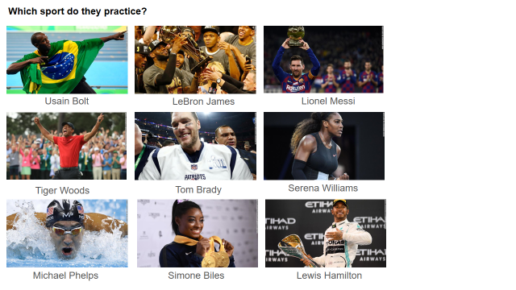

**Which sports do they practice? Complete the chart.**

|  |  |  |
| --- | --- | --- |
| Usain Bolt: running | LeBron James: basketball player | Lionel Messi: soccer player |
| Tiger Woods: golfer | Tome Brady: Football player | Serena Williams: tennis player |
| Michael Phelps: swimming | Simone Biles: gymnastics | Lewis Hamilton: race car driver |

* **WRITING EVALUATION CRITERIA /10pts**

|  |  |  |  |
| --- | --- | --- | --- |
| Punctuation and spelling | 1 | 2 |  |
| Correct use of simple grammatical structures | 1 | 2 | 3 |
| Sufficient vocabulary | 1 | 2 |  |
| Simple connectors and cohesive devices | 1 |  |
| Follow instructions | 1 | 2 |

* **SPEAKING EVALUATION CRITERIA**

|  |  |  |  |  |  |  |
| --- | --- | --- | --- | --- | --- | --- |
|  |  | **Poor** | **Fair** | **Good** | **Very good** | **Excellent** |
| **Fluency** | **0** | **1** | **2** | **3** | **4** | **5** |
| **Grammar** | **0** | **1** | **2** | **3** | **4** | **5** |
| **Vocabulary** | **0** | **1** | **2** | **3** | **4** | **5** |
| **Pronunciation** | **0** | **1** | **2** | **3** | **4** | **5** |

**Fluency = ability to speak quickly, naturally, and without many pauses.**

**Grammar = ability to use correct grammar and sentence structure.**

**Vocabulary = ability to understand and use vocabulary words and phrases.**

**Pronunciation = ability to use correct stress, rhythm, and intonation patterns.**

1. TEAM INFORMATION:

**ALVAREZ SANCHEZ LORENA PATRICIA**

**DURON DOMINGUEZ PAOLA JACQUELINE**

**FLORES PARDO FATIMA MONTSERRAT**

**LOPEZ RAMIREZ YESICA GUADALUPE**

1. DATE: Saturday May 22, 2021
2. LINK TO YOUR VIDEO:

Teams: <https://docentecoahuila-my.sharepoint.com/:v:/r/personal/paolajacqueline_duron_nml_alumnocoahuila_gob_mx/Documents/Recordings/Llamada%20con%20FATIMA%20y%202%20m%C3%A1s-20210522_230035-Grabaci%C3%B3n%20de%20la%20reuni%C3%B3n.mp4?csf=1&web=1&e=TyztJH>

Youtube: <https://youtu.be/SKHDchlSfk8>

1. SCRIPT (dialogue): <https://docs.google.com/document/d/1QaE-3IJSYUpOQcBV_wH340HQfp_keQuOSuGVAKGjD-A/edit?usp=sharing>