**ENGLISH III. SHARING INFORMATION AND IDEAS 2020-2021**

**Semester II**

Learning Evidence 2

Interchange unit 6 and 9

**PROJECT: Sports star**

|  |  |  |
| --- | --- | --- |
| *Aims:* | 1. *Talk about routines* 2. *Talk about abilities* 3. *Identify people by describing how they look and what they’re doing* 4. *Ask for more information* 5. *Express surprise/disbelief* 6. *Agree* |  |

***FAMOUS ATHLETES***

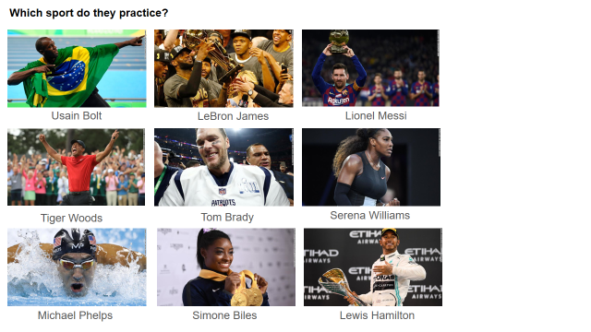

**Which sports do they practice? Complete the chart.**

|  |  |  |
| --- | --- | --- |
| Usain Bolt: running | LeBron James: Basketball player | Lionel Messi: Soccer player |
| Tiger Woods: Golfer | Tom Brady: Football quarterback | Serena Williams: Golfer |
| Michael Phelps: Olympic athlete | Simone Biles: gymnastics | Lewis Hamilton: Racing driver |

TEAM WORK.

**1. Plan**

Do you ever watch sports on TV or internet?

Who’s your favorite sport star?

What sport does he/she play?

Where is he/she from?

Where does he/she live now?

What interesting fact do you know about him/her?

ADDITIONAL RESOURCES:

|  |  |
| --- | --- |
| **WATCH the interview videos examples:**  <https://www.youtube.com/watch?v=v0BWsIyeqsc>  <https://www.youtube.com/watch?v=COptlt4rBXw>  <https://www.youtube.com/watch?v=LoldJNDLZHc> | **Check this out:**  <https://sportstarsmag.com/> |

**2. Prepare**

A) Choose two athletes.

B) Prepare an interview.

+ Write a complete description (general, age, height, hair, eyes) of the physical appearance to use during the introduction of the athletes. Example:

|  |
| --- |
| Interviewer: Today’s guest is tall. He’s in his twenties. He’s good-looking. He has light brown and long hair. He……..  Let’s welcome …(athletes names)!! |

+ Write ten questions for each athlete (20 questions). Include frequency questions, such as:

1. *How often do you practice?*
2. *How often do you have to eat?*
3. *When do you take a day off?*
4. *Do you lift weights?*
5. *How often?*
6. *Do you ever…?*
7. *How long do you spend…?*
8. *How well do you…?*
9. *How good are you at…?*
10. *A: Do you do anything else to keep fit? What else do you do? B: I also run/lift weights/swim/ etc.*

+ Research the answers in the Internet, magazines, and newspapers. Include adverbs of frequency and short answers. Learn as much as possible about your athletes. Make up the answers you don’t know or didn’t find.

+ Create a fresh and interesting dialogue. Include as many expressions as possible for interacting:

|  |  |  |
| --- | --- | --- |
| **Response:**  yeah | **Expressing interest:**  That’s cool.  Really? | **Expressing surprise**:  Wow! |
| **Starting a sentence:**  Well, . . .  Oh, . . .  So, . . . | **Thanking someone**:  Thanks anyway.  You’re welcome. | **Expressing doubt**:  Hmm. |
| **Pausing to think:**  Let’s see . . . | **Expressing interest**:  What an interesting . . . | **Expressing sincerity**:  I’m serious! |
| **Asking for more information:**  What else . . . ? | **Expressing surprise/disbelief:**  Seriously? | **Agreeing:**  All right.  No problem. |
| **Adding information:**  By the way, . . . | **Inviting someone**:  Would you like to . . . ?  Do you want to . . . ?  Let’s . . . | **Accepting an invitation**:  Yes, I would.  Thanks. I’d love to. |

C) Perform the interview (as a conversation). Two students pretend to be the athletes and the rest of the team members ask the questions.

**Interview sections:**

1) Introduce the athletes’ physical appearance description. Tell your audience you have celebrity guests. Don’t give the celebrities’ names at this point.

2) Welcome your guests. Start interviewing. Questioning and answering.

3) Each athlete brings a picture of their family to show their family members. Example:

|  |
| --- |
| Interviewer: Who’s your son Diego?  Athlete: He’s the boy wearing a blue shirt/talking to Brooke.  Interviewer: Which one is your daughter Paula?  Athlete: She’s the one in jeans/near the window.  Interviewer: Which ones are your grandparents?  Athlete: They’re the people/the ones on the couch. |

RESOURCES. Units 9 and 6:

* Language Summary (vocabulary and expressions).
* PowerPoint Presentations
* Work book pages

**3. Present**

Video record the interview. Use the electronic device of your preference. Remember there’s always the option to perform and record the conversation in a TEAMS video conference meeting.

Use the proper intonation. Speak naturally. Disguise, perform and have fun.

**Place the interview script and the link to your video in this WORD file, after the Evaluation Criteria. Instructions and Evaluation Criteria must be included in your product.**

**All team members have to turn this project in by Friday May 21st, 2021.**

* **WRITING EVALUATION CRITERIA /10pts**

|  |  |  |  |
| --- | --- | --- | --- |
| Punctuation and spelling | 1 | 2 |  |
| Correct use of simple grammatical structures | 1 | 2 | 3 |
| Sufficient vocabulary | 1 | 2 |  |
| Simple connectors and cohesive devices | 1 |  |
| Follow instructions | 1 | 2 |

* **SPEAKING EVALUATION CRITERIA**

|  |  |  |  |  |  |  |
| --- | --- | --- | --- | --- | --- | --- |
|  |  | **Poor** | **Fair** | **Good** | **Very good** | **Excellent** |
| **Fluency** | **0** | **1** | **2** | **3** | **4** | **5** |
| **Grammar** | **0** | **1** | **2** | **3** | **4** | **5** |
| **Vocabulary** | **0** | **1** | **2** | **3** | **4** | **5** |
| **Pronunciation** | **0** | **1** | **2** | **3** | **4** | **5** |

**Fluency = ability to speak quickly, naturally, and without many pauses.**

**Grammar = ability to use correct grammar and sentence structure.**

**Vocabulary = ability to understand and use vocabulary words and phrases.**

**Pronunciation = ability to use correct stress, rhythm, and intonation patterns.**

1. TEAM INFORMATION:

***Mariana Ávila Olivares:*** *Interviewer.*

***Andrea Esquivel Alonzo:*** *Daniela Pulido Professional player soccer in the Guadalajara Team, Female Category.*

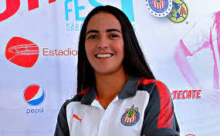

1. DATE:

*May 22nd 2021*

1. LINK TO YOUR VIDEO:

https://youtu.be/HFZQWnGMCVM

1. SCRIPT (dialogue):

Interviewer: Hi Daniela how are you?.

Daniela: I'm fine and you?.

Interviewer: very well, tell us, what do you do?.

Daniela: I’m a professional soccer player, I play in the Guadalajara team, Female Category.

Interviewer: it's great!! How well do you play soccer?

Daniela: I play pretty well

Interviewer: Wow! is incredible! How often do you practice?

Daniela: I practice twice a week

Interviewer: How often do you have to eat?

Daniela: from weekdays I prepare my diet, on weekends as what I want

Interviewer: When do you take a day off?

Daniela: one day before the game

Interviewer: Do you lift weights?

Daniela: Yeah

Interviewer: How often?

Daniela: when I go to the gym three times a week

Interviewer: Do you ever practice yoga for your training?

Daniela: Yes! more when they are very bad days

Interviewer: How long do you spend in the gym?

Daniela: I spend about 1 hour to an hour and a half

Interviewer: How good are you at practice martial arts?

Daniela: I'm not good, I don't have much skill.

Interviewer: Do you do anything else to keep fit?

Daniela: Daily in the morning I go for a run and prepare my healthy diets

Interviewer: What else do you do?

Daniela: Also 4 times a month I go for a bike ride with my friends and, with my family I go for a walk twice a month.

Interviewer: Really? that's incredible, well Daniela is all for today, see you soon!

Daniela: See you soon! Bye!