**EDGAR LEYVA BUENDIA**

**ESCUELA NORMAL DE EDUCACIÓN PREESCOLAR**

**ENGLISH A2.2**

**UNIT 8 – HOW’S THE NEIGHBORHOOD?**

**VOCABULARY**

Dear students, during the week we will practice asking about and describing places. You will learn how to describe a neighborhood. Let’s start with some useful vocabulary!

**ACTIVITY 1 – PLACES IN MY NEIGHBORHOOD – 30 PTS.**

* Locate the following places near your neighborhood and write a name for each one of them. Copy the chart in your notebook.

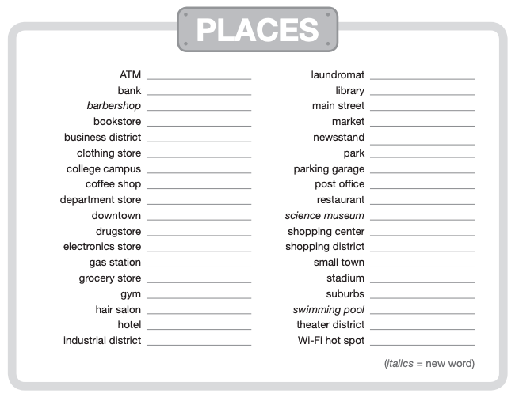

Lava-Más

Banorte

**ACTIVITY 2 – PLACES AND DEFINITIONS – 30 PTS.**

* Match the places and the definitions. Write them in your notebook.

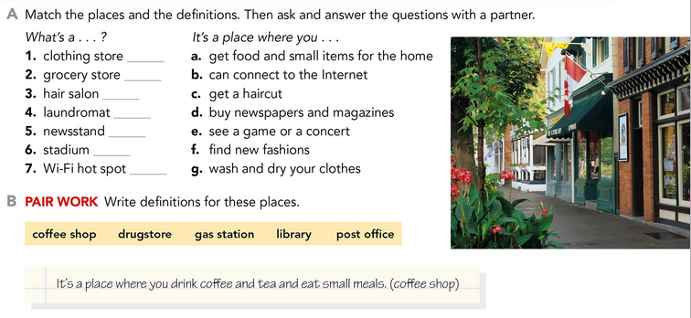

* Write definitions for these places in your notebook. Check the examples.

Examples:

*A* ***coffee shop*** *is a place where you drink coffee and tea and eat small meals.*

*A* ***hair salon*** *is a place where you get a hair cut.*

A **restaurant** is a place where you…

A **drugstore** is a place where you…

A **gas station** is a place where you…

A **library**…

A **post office**…

A **shopping mall**…

A **night club**…

A **theater…**

**ACTIVITY 3 – COUNT AND NONCOUNT NOUNS – 20 PTS.**

Complete the chart in your notebook. Use words from the box.

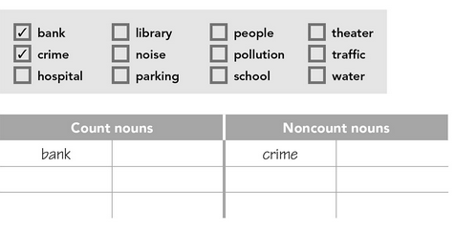

**ACTIVITY 4 – PREPOSITIONS – 20 PTS.**

Rewrite the sentences in your notebook using the words in the box to complete them according to the map.

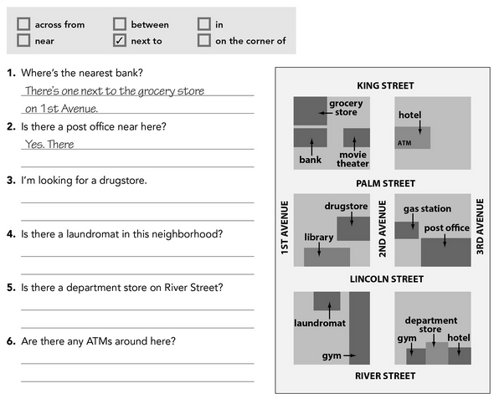



1. There is a bank _____ the grocery store.
2. There is a post office _____ of Lincoln Street and 3rd Avenue.
3. There is a drugstore _____ the gas station on 2nd Avenue.
4. There is a laundromat on Lincoln Street _____ the gym.
5. There is a department store _____ the gym and the hotel.
6. There is an ATM _____ the hotel on 2nd Avenue.

