**ESCUELA NORMAL DE EDUCACIÓN PREESCOLAR**

**ENGLISH B1.2**

**UNIT 6 PROJECT**

**“THAT NEEDS FIXING”**



**Aim of the project:**

Give students practice explaining things that need to be done in your neighborhood.

This activity can be done in PAIRS.

**Preparation:**

* + - Complete the preparation tasks included in this document (activities 1 and 2)

**Development:**

* + - Each student write the five biggest problems in their neighborhood using gerunds and the passive infinitive (activity 3)
    - Students choose one of the lists.
    - Students draw, download or take pictures to document each problem described.
    - Students come up with solutions to the problems described.
    - Prepare a presentation with pictures and record a video where you share your solutions with the class. Explain the problems and explain why you think the solutions will work. **DO NOT READ.**

**Products:**

* You must upload this **document** to Escuela en Red with the preparation activities completed.
* Go to <https://padlet.com/alvaradocris87/btrml0zwovpq7dv2> and upload your **video** to the Padlet.

**PREPARATION ACTIVITIES**

**ACTIVITY 1**

**Look at the picture and complete the sentences to describe the problems using the vocabulary you learned in class and use gerunds or past participles of the verbs in parentheses.** *Example: The wall needs to be painted / The wall needs painting.*

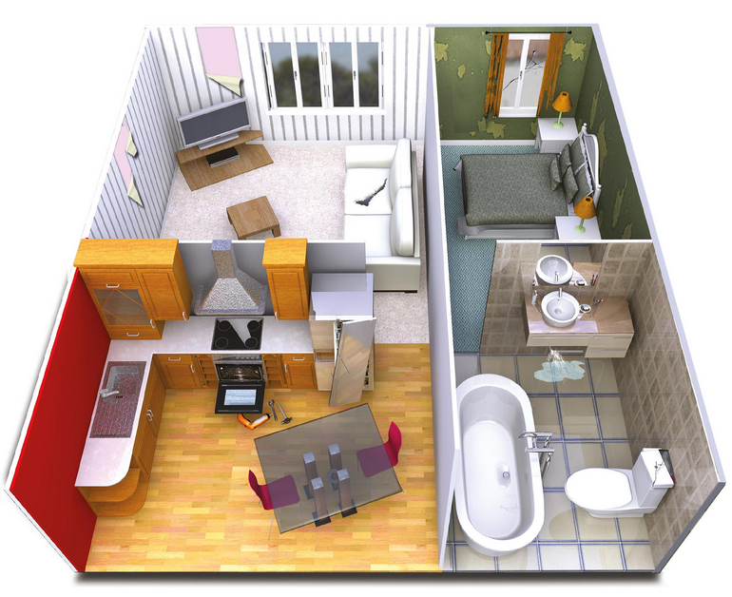

1. The living room’s wall is teared, it needs painting (paint)
2. The oven doesn’t working, it needs to be fixed (fix)
3. The bathroom’s sink is leaking, it needs to be repaired (repair)
4. The sofa is dented, it needs replacing (replace)
5. The bedroom’s window has a crack, it needs to be changed (change)
6. The door of the fridge is torn, it needs adjusting (adjust)

**ACTIVITY 2**

**Look at the picture and write five sentences describing the problem and explaining what needs to be done. Use the vocabulary you learned in class as well as gerunds and past participles.**

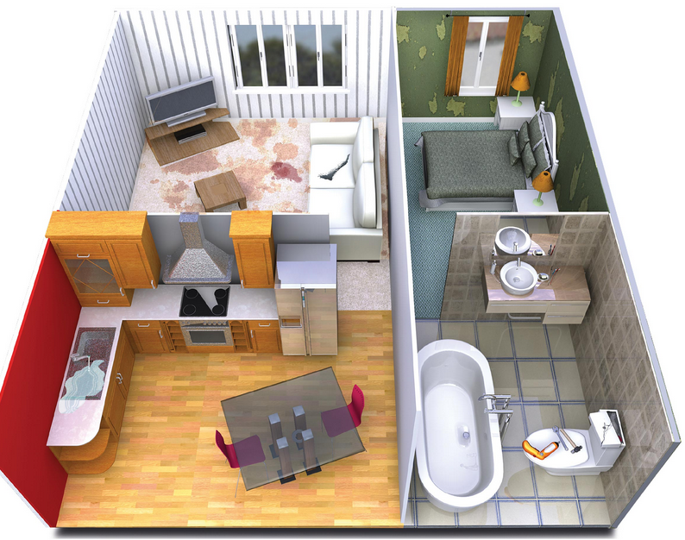

1. The couch is torn, it needs to be patched
2. The carpet has a stain, it needs to be cleaned.
3. The sink has a leak, it needs to be repaired
4. The wc it’s cracked, it needs to be fixed.
5. The walls are stained, it need to be painted

**DEVELOPMENT**

**ACTIVITY 3**

**What do you like about your neighborhood? What do you dislike? Discuss and write the five biggest problems in your neighborhood. Use the vocabulary you learned in class as well as gerunds and past participles.**

**STUDENT 1**

1. In my neighborhood the streets are cracked
2. The park's games are stained
3. the hydrant has a leak
4. In my neighborhood many cars are deant
5. The streetlamps have cracked

**STUDENT 2**

1. In my neighborhood the park’s benches are scratch
2. In my neighborhood there is an abandoned house that is scratched
3. The pedestrian paths are stained
4. the streets are cracked
5. the park fountain has a leak

**Choose five of the problems described and imagine you are city planners. You have a budget to solve these problems. Write some creative solutions to present to the class.**

1. **The park's games are stained**

going to remodel them, giving them maintenance, and adding more games

1. **the park fountain has a leak**

fix and remodel it to be a little game

1. **In my neighborhood the park’s benches are scratch**

will be replaced by benches that form sculptures

1. **In my neighborhood there is an abandoned house that is scratched**

repair it to create a place where children can learn arts and paint it with murals

1. **The pedestrian paths are stained**

paint them so that they form a specific drawing

**Prepare a presentation with pictures and record a video where you share your solutions with the class. Explain the problems and explain why you think the solutions will work. DO NOT READ**

**RUBRIC**

