**ESCUELA NORMAL DE EDUCACIÓN PREESCOLAR**

**ENGLISH B1.2**

**UNIT 6 PROJECT**

**“THAT NEEDS FIXING”**

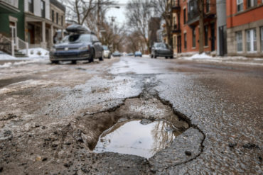

Students:

Daiva Ramírez Treviño

Aneth Giselle Saavedra Salais

**Aim of the project:**

Give students practice explaining things that need to be done in your neighborhood.

This activity can be done in PAIRS.

**Preparation:**

* + - Complete the preparation tasks included in this document (activities 1 and 2)

**Development:**

* + - Each student write the five biggest problems in their neighborhood using gerunds and the passive infinitive (activity 3)
    - Students choose one of the lists.
    - Students draw, download or take pictures to document each problem described.
    - Students come up with solutions to the problems described.
    - Prepare a presentation with pictures and record a video where you share your solutions with the class. Explain the problems and explain why you think the solutions will work. **DO NOT READ.**

**Products:**

* You must upload this **document** to Escuela en Red with the preparation activities completed.
* Go to <https://padlet.com/alvaradocris87/btrml0zwovpq7dv2> and upload your **video** to the Padlet.

**PREPARATION ACTIVITIES**

**ACTIVITY 1**

**Look at the picture and complete the sentences to describe the problems using the vocabulary you learned in class and use gerunds or past participles of the verbs in parentheses.** *Example: The wall needs to be painted / The wall needs painting.*

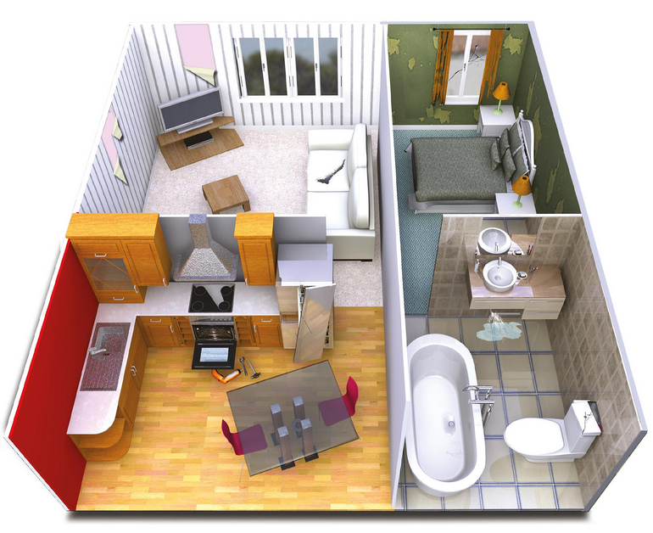

1. The living room’s wall is torn, it needs painting (paint)
2. The oven doesn’t work, it needs to be fixing (fix)
3. The bathroom’s sink is leaking, it needs to be repaired (repair)
4. The sofa is torn, it needs replacing (replace)
5. The bedroom’s window has a crack, it needs to be changed (change)
6. The door of the fridge is broken, it needs adjusting (adjust)

**ACTIVITY 2**

**Look at the picture and write five sentences describing the problem and explaining what needs to be done. Use the vocabulary you learned in class as well as gerunds and past participles.**

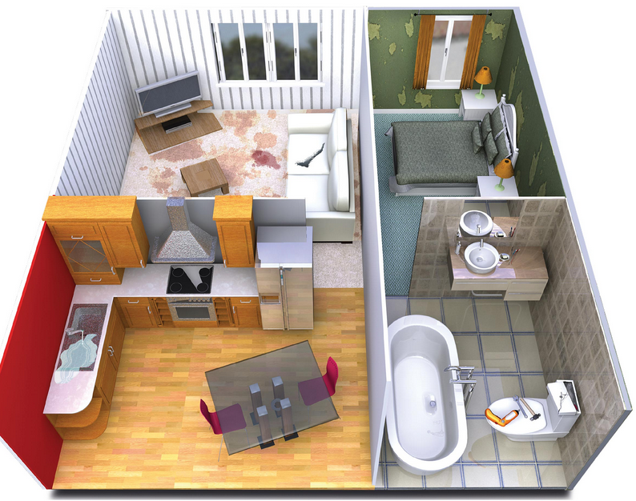

1. TheTV carpet has stained, it needs washing.
2. There´s a leaking on the sink, it needs to be replaced.
3. The toilet is chipped, it needs to be fixed.
4. The sofa is cracked, it needs replacing
5. The bed room’s wall is torn, it needs painting.

**DEVELOPMENT**

**ACTIVITY 3**

**What do you like about your neighborhood? What do you dislike? Discuss and write the five biggest problems in your neighborhood. Use the vocabulary you learned in class as well as gerunds and past participles.**

**STUDENT 1**

1. The street needs to be paved. It is full of holes and potholes. When there are storms, the street floods and the cars get stuck.

2. The streetlight needs to be adjusted, some nights the light is flickering or does not turn on.

3. The neighborhood park needs to be cleaned up because it has been full of trash lately.

4. Neighbors need to keep their pets indoors, especially large breeds.

5. Signs need to be changed, because some are scratched or damaged.

**STUDENT 2**

1. The neighborhood has a park, but it has a lot of trash. It needs to be cleaned.
2. Also, the street needs to be repaired, it has a lot of potholes. When I´m running my legs ache from stepping wrong because the street has potholes.
3. My street lights needs to be fixed, they don't have a light bulb.
4. There is a little green space with some plants, but they need watering.
5. The wall of the fence is torn, it needs painting.

**Choose five of the problems described and imagine you are city planners. You have a budget to solve these problems. Write some creative solutions to present to the class.**

**Title: There is a little green space with some plants, but they need watering.**

The first problem we will solve is making a irrigation system to watering the green space that doesn't have enough water and they're dry. ´

It will be automatic so every day at a certain time it will be watered.

**Title: The wall of the fence is torn, it needs painting.**

We will solve this problem with a community strategy. Where the neighbor will help painting the walls that are torn. We will provide water-resistant paint and tools for fixing the walls, so it doesn't have to be repainted in a few years.

The main purpose of this strategy is to make the community aware of the importance of maintenance of the neighborhood.

**Title: The streetlight needs to be adjusted, some nights the light is flickering or does not turn on.**

We are going to solve this problem, changing the bulbs of each streetlight for a better quality LED light system to avoid flickering or not turning on. Each of the streetlights will be turned on at a scheduled time after sunset.

**Title: The neighborhood has a park, but it has a lot of trash. It needs to be cleaned.**

We are going to solve this problem by calling the neighbors and inviting them to clean up the neighborhood park one weekend. Trash will be picked up, lawns will be trimmed, paint on swings, slides, etc. will be changed. Subsequently, a role will be made for each family who will be in charge of keeping the park clean once a month**.**

**Title: The street needs to be repaired, it is full of holes and potholes**

We will solve it by writing a letter to the government and collecting signatures from neighbors to demand a pothole-free street. Waiting for the request to be met, the wells will be filled with a cement paste, in order to have a more balanced street. Unnecessary potholes will be removed and exchanged for bumps.

**Prepare a presentation with pictures and record a video where you share your solutions with the class. Explain the problems and explain why you think the solutions will work. DO NOT READ.**

**RUBRIC**

