**Escuela Normal de Educación Preescolar**

**Ciclo escolar 2020-2021**



**Curso:** Inglés B1. 2 1

**Docente:** Cristina Aracely Alvarado Chavarría

***Alumnas:***

***María Paula González Valdez***

***Caro Ortega***

**ESCUELA NORMAL DE EDUCACIÓN PREESCOLAR**

**ENGLISH B1.2**

**UNIT 6 PROJECT**

**“THAT NEEDS FIXING”**

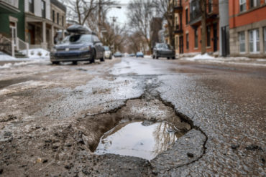

**Aim of the project:**

Give students practice explaining things that need to be done in your neighborhood.

This activity can be done in PAIRS.

**Preparation:**

* + - Complete the preparation tasks included in this document (activities 1 and 2)

**Development:**

* + - Each student write the five biggest problems in their neighborhood using gerunds and the passive infinitive (activity 3)
    - Students choose one of the lists.
    - Students draw, download or take pictures to document each problem described.
    - Students come up with solutions to the problems described.
    - Prepare a presentation with pictures and record a video where you share your solutions with the class. Explain the problems and explain why you think the solutions will work. **DO NOT READ.**

**Products:**

* You must upload this **document** to Escuela en Red with the preparation activities completed.
* Go to <https://padlet.com/alvaradocris87/btrml0zwovpq7dv2> and upload your **video** to the Padlet.

**PREPARATION ACTIVITIES**

**ACTIVITY 1**

**Look at the picture and complete the sentences to describe the problems using the vocabulary you learned in class and use gerunds or past participles of the verbs in parentheses.** *Example: The wall needs to be painted / The wall needs painting.*

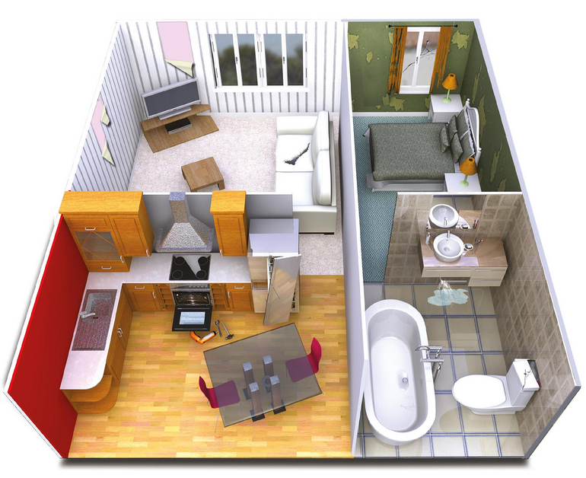

1. The living room’s wall is ripped, it needs painting (paint)
2. The oven doesn’t work, it needs to be fixed (fix)
3. The bathroom’s sink is leaking, it needs to be repaired (repair)
4. The sofa is tear, it needs replacing (replace)
5. The bedroom’s window has a crack, it needs to be changed (change)
6. The door of the fridge is broken, it needs adjusting (adjust)

**ACTIVITY 2**

**Look at the picture and write five sentences describing the problem and explaining what needs to be done. Use the vocabulary you learned in class as well as gerunds and past participles.**

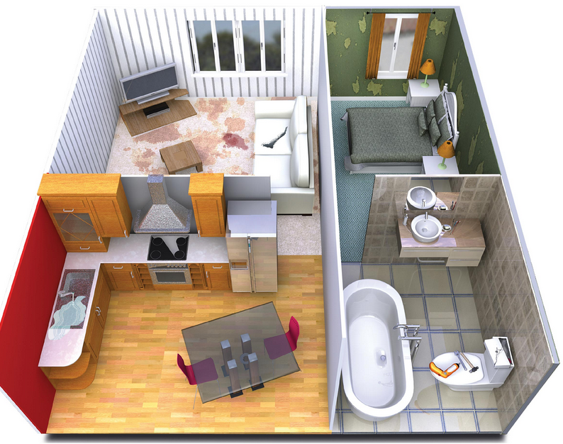

1. The living room’s carpet is stained, it needs cleaning.
2. The kitchen’s faucet is leaking, it needs to be adjusted.
3. The bedroom walls are ripped, they need to be painted.
4. The department need to be cleaned; all the rooms are dirty.
5. The sink is leaking, it needs to be fixed.

**DEVELOPMENT**

**ACTIVITY 3**

**What do you like about your neighborhood? What do you dislike? Discuss and write the five biggest problems in your neighborhood. Use the vocabulary you learned in class as well as gerunds and past participles.**

**STUDENT 1**

1. My neighbor's chair is chipped, I was injured when I went to his house, he needs to fix it or change it.
2. I don’t like that my neighbor always forgets the password for the alarm, and I always called the police because the alarm keeps going off.
3. My neighbor has a bucket, and needs to be empty, because it doesn’t smell good.
4. My neighbor’s wall is stained, it needs to be painted.
5. My neighborhood has been without electricity for days, the electricity needs to be fixed.

**STUDENT 2**

1. The trash can in the park is broken, it needs to be replaced.
2. The lamp from the second street is blinking, it needs adjusting.
3. The water faucet in the park is leaking, it needs to be repaired.
4. The plants in my neighbor’s house are very dry, they need watering.
5. My neighbor’s car is dented, it needs to be repaired and painted.

**Choose five of the problems described and imagine you are city planners. You have a budget to solve these problems. Write some creative solutions to present to the class.**

The problem of the bad-smelling bucket can be solved very easily. The solution would be to talk seriously with the neighbor and tell him that this smell bothers others and ask him to please empty it.

The electricity problem affects the citizens of the neighborhood, so it is a situation that must be solved quickly, in this case it is to call the electricity contacts and ask that they put the neighborhood into operation, after it is arranged to have constant audits to verify that this type of situation does not happen again.

Repair each of the garbage cans that are broken, to prevent the garbage from coming out.

Another problem is that the trash can in the park is broken and it needs to be replaced, to solve this problem, new trash cans will be purchased and installed around the park to provide more options for pet waste disposal. Likewise, the water faucet in the park is leaking and it needs to be replaced, to solve it, the water faucet will be changed and a person in charge will be appointed to verify that it doesn’t leak again.

In the other hand, another problem or concern that we have is that the plants of some neighbors are very dry, and they need watering, that’s why we propose to implement a service that will take care of the plants of the neighbors, charging a monthly fee.

Link:

<https://drive.google.com/file/d/1L84yb3fsdmlCLWA--0iFGX2IQYJH-> eu/view?usp=sharing

**Prepare a presentation with pictures and record a video where you share your solutions with the class. Explain the problems and explain why you think the solutions will work. DO NOT READ.**

**RUBRIC**

