**ESCUELA NORMAL DE EDUCACIÓN PREESCOLAR**

LICENCIATURA EN EDUCACIÓN PREESCOLAR

***FINAL PROJECT- FLIPGRID***

ENGLISH

**TEACHER:** BRENDA BOLLAIN Y GOYTIA DE LA PEÑA

**STUDENT:** MARIANA GUADALUPE VALDÉS JIMÉNEZ

A1.2 N° 31



SALTILLO COAHUILA, MAY 25th 2021

**EVIDENCE PICTURE**

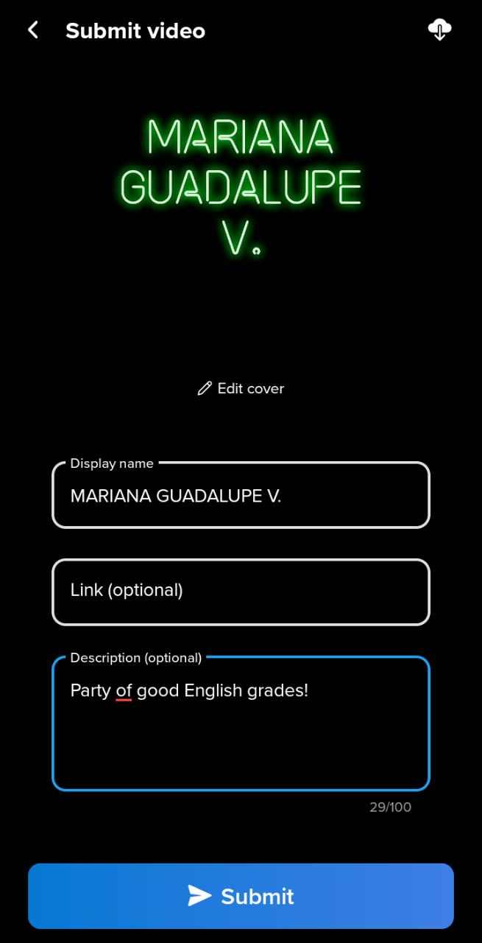 

**RUBRIC**

|  |  |  |  |
| --- | --- | --- | --- |
| **criteria** | **Excellent** | **Good** | **Needs improvement** |
| content | The content includes 4/4   statements with suggestions about food  **3 pts** | The content includes only 3/ 4 statements with suggestions about food  **2.5 pts** | The content includes less than 3 /4 statements  **2 pts** |
| organization | The information is presented in a **clear and organized** way.  **3 pts** | The information is presented in a **somewhat** clear and organized way,  **2.5  pts** | The information **lacks** organization and the  ideas are not clear  **2 pts** |
| Language & delivery of speech | Language is used correctly and creatively, words varied and easy to follow. Good fluency  Includes grammar structures seen in the unit  **3 pts** | **Most** language is clear, easy to follow and understand. **Mos**t of the words are well pronounced. Voice is **often** clear and there is evidence of some grammar structures seen in the unit  **2.5 pts** | Language is **unclear** and **hard** to understand. Lots of grammar, vocabulary and pronunciation mistakes**. Lack** of fluency. Poor evidence of grammar structures seen in the unit.  **2 pts.** |
| participation | 2/2 responses to others’ participation  **1 pt.** | 1/ 2  responses to other’s participation  **.5 pts** | 0/2 responses to their classmates’ participation  **0 pts** |