**ESCUELA NORMAL DE EDUCACIÓN PREESCOLAR**

**ENGLISH B1.2**

**UNIT 7 – WHAT CAN WE DO?**

**VOCABULARY**

Dear students, during the week we will discuss environmental problems and compare solutions to social problems. Let’s start with some useful vocabulary!

**ACTIVITY 1 – SNAPSHOT – 20 PTS.**

**Read the following information and answer the questions below.**

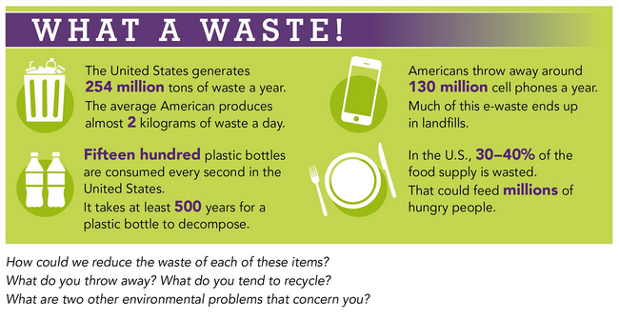

**Answer the following questions:**

1. **What do you throw away? What do you tend to recycle?**

I used to throw away everything that I think is trash or it doesn’t have a value for me. I used to recycle the bottles or the tuppers of the food.

1. **What are two other environmental problems that concern you?**

The plastic and the straws people throw at the ocean.

**How concerned are you about these problems? Check your answers.**

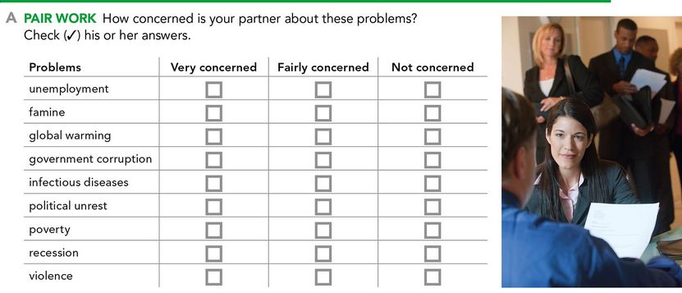

v

**ACTIVITY 2 – VOCABULARY – 50 PTS.**

**Match the nouns and the definitions.**

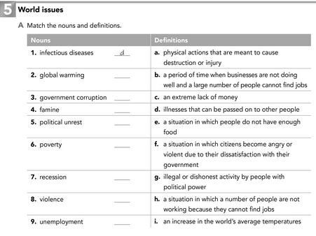

f

b

g

h

a

c

e

i

**Choose the correct noun from the previous exercise to complete each sentence. You will not use all of the words.**

Infectiuos diseases

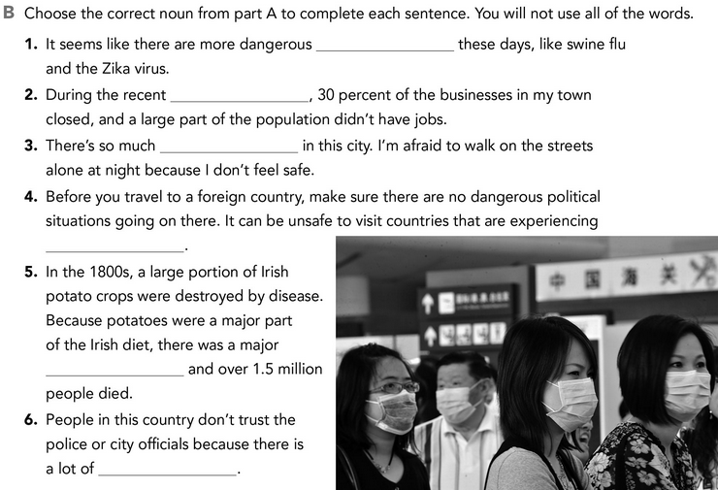

Political unrest

Political unrest

recession

famine

violence

**Write a definition and a sentence for the words in the chart.**

|  |  |  |
| --- | --- | --- |
| WORD | DEFINITION | SENTENCE |
| Acid rain | Acid rain, or acid deposition, is a broad term that includes any form of precipitation with acidic components, such as sulfuric or nitric acid that fall to the ground from the atmosphere in wet or dry forms. This can include rain, snow, fog, hail or even dust that is acidic. | Half its forests are damaged from acid rain. |
| Deforestation | is the permanent removal of trees to make room for something besides forest. This can include clearing the land for agriculture or grazing, or using the timber for fuel, construction or manufacturing. | The process of reckless deforestation is perceptible in certain districts |
| Homelessness | the state of having no home. | He has gone forth from home into homelessness, and has not where to lay his head. |
| Pollution | also called environmental pollution, the addition of any substance (solid, liquid, or gas) or any form of energy (such as heat, sound, or radioactivity) to the environment at a rate faster than it can be dispersed, diluted, decomposed, recycled, or stored in some harmless form. | The tests showed high levels of pollution in the water. |
| Waste | use or expend carelessly, extravagantly, or to no purpose. | we can't afford to waste electricity |

**How serious are the problems in your country? Write the problems from the box in order from 1 (most serious) to 14 (least serious)**

**WORLD PROBLEMS**

Acid rain deforestation famine global warming

Government corruption homelessness infectious diseases

Political unrest pollution poverty recession unemployment violence waste

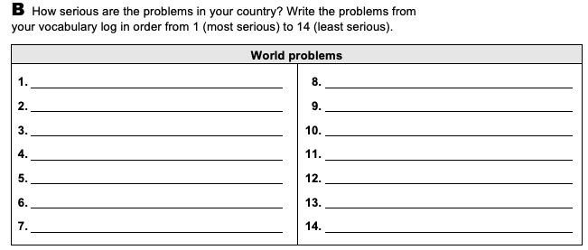

Political Unrest

Famine

Waste

Recession

Homeleness

Violence

Goverment corruption

Infectiuos disease

Infectiuos disease

Unemployment

Pollution

Global warming

Poverty

Deforestation

**ACTIVITY 3 – VERBS AND NOUNS – 20 PTS.**

**Complete the chart**

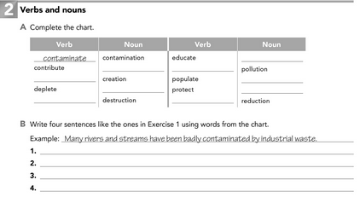

depletion

reduce

protection

population

pollute

Education

destruct

Create

Contribution

**Write ten sentences using words from the chart.**

1. There is already a high level of environmental contamination.
2. He contribute money to a cause
3. I love to create wonderful material for my classmates.
4. God made a beautiful creation in the world we live.
5. Our city has a depletion of natural resources.
6. It was a huge destruction that they made to construct the mall.
7. She loves to educate kids.
8. My sister loves to protect the animals rights
9. We need to reduce the pollution of the trash at the ocean.

**ACTIVITY 4 – MORE VOCABULARY – 10 PTS.**

**Choose the correct words or phrases.**

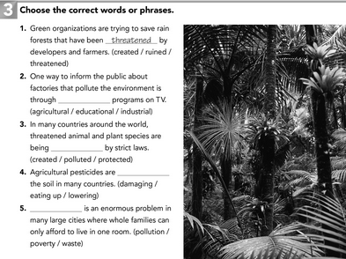

**Poverty**

**damaging**

**protected**

**educational**