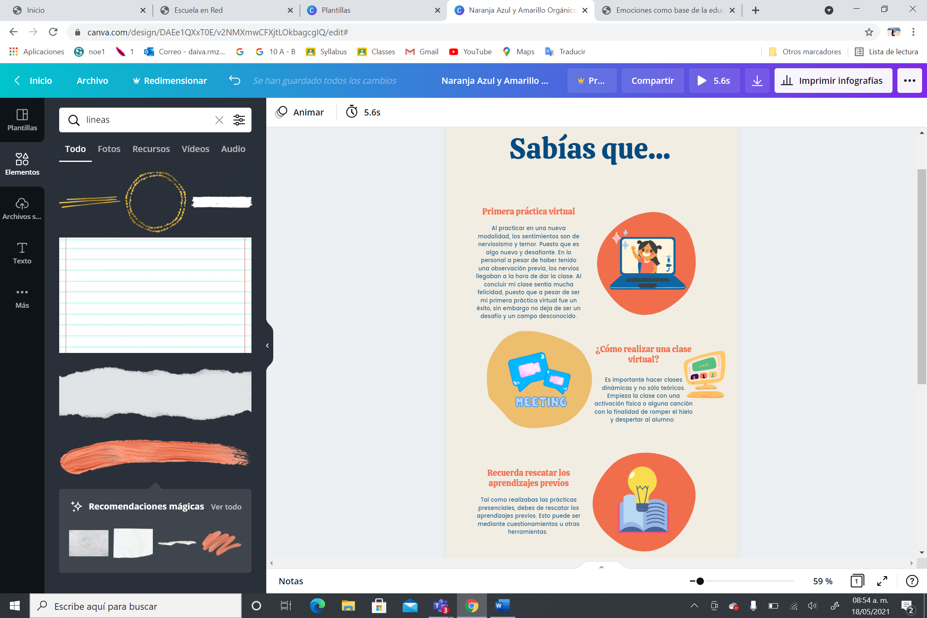

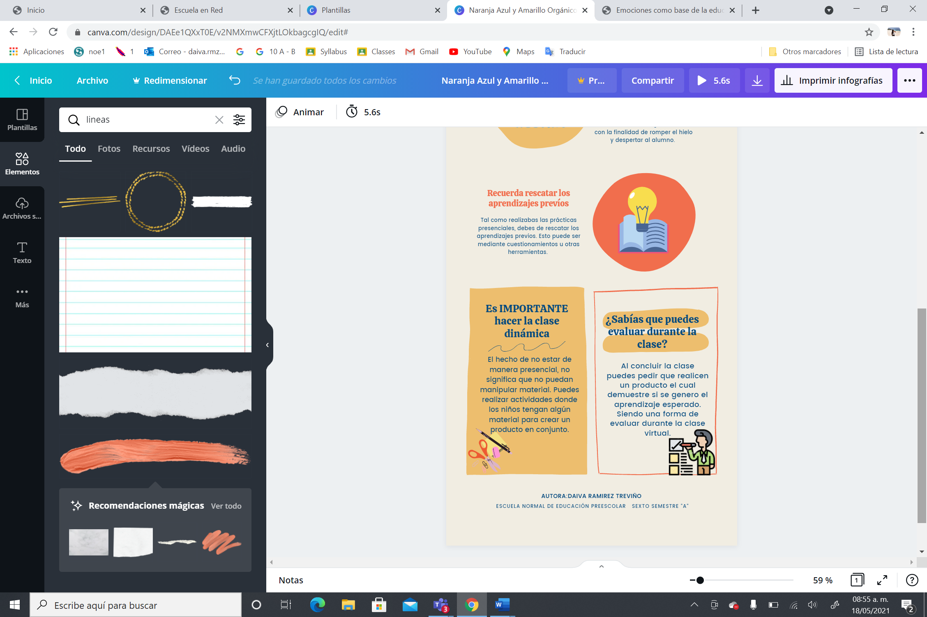

<https://www.canva.com/design/DAEe1QXxT0E/v2NMXmwCFXjtLOkbagcgIQ/edit#>