**ESCUELA NORMAL DE EDUCACIÓN PREESCOLAR**

**ENGLISH B1.2**

**UNIT 7 PROJECT**

**USE YOUR VOTE!**

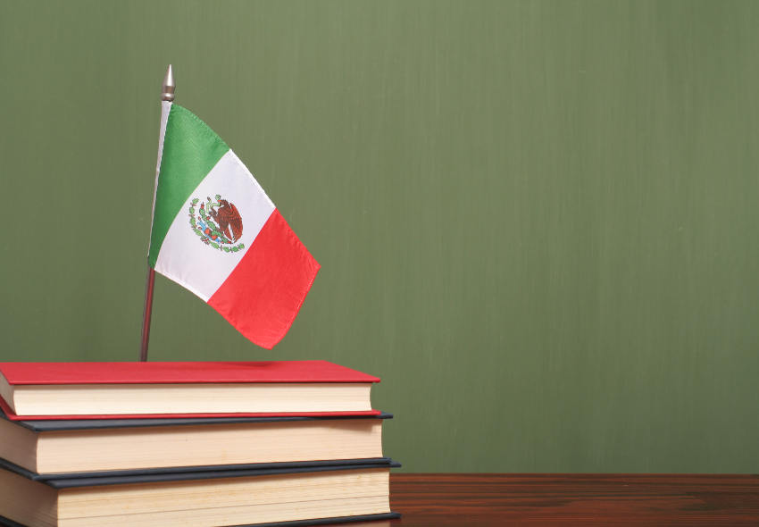

**Aim of the project:**

Give students practice discussing problems and using infinitive clauses and phrases.

This activity will be done in the TEAMS assigned by the teacher.

**Preparation:**

* Visit the following websites and analyze the information about the main problems in Mexico’s educational system.
* <https://www.milenio.com/politica/sep-identifica-seis-problemas-en-sistema-educativo>
* <http://trazandoelrumbo.ibero.mx/la-problematica-persistente-de-la-educacion-en-mexico/#:~:text=El%20acceso%20a%20la%20escuela,han%20concluido%20su%20educaci%C3%B3n%20b%C3%A1sica>.
* <https://merida.anahuac.mx/posgrado/blog/problemas-del-sistema-educativo-en-mexico-y-sus-posibles-soluciones>
* <https://wenr.wes.org/2019/05/education-in-mexico-2>

**Development:**

* Imagine you will elect a Minister of Education for your country. Decide who will be the candidate. Then assign each student a job for the campaign.

Minister of Education (candidate): Mafer Barron

Campaign Manager: Fersita Davila

Speechwriter: Angela and Karen

* Choose the five most important problems in Mexico’s Educational System and list ways you want to improve education or schools in your country. Then write a speech explaining the improvements and how your candidate will achieve them. **Use the passive voice and prepositions to describe the problem, and infinitive clauses to discuss ways in which these problems can be solved.**

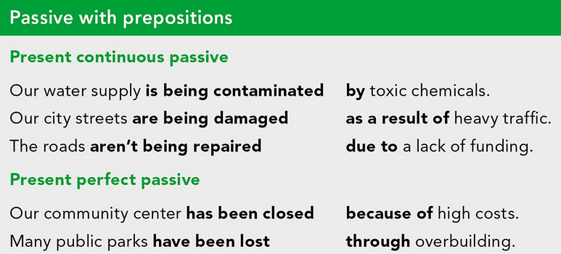

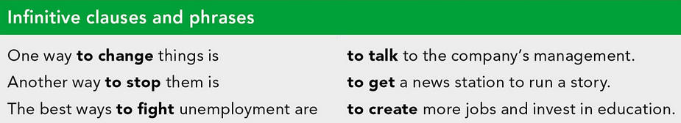

***Example:***

*The most vulnerable groups of our society* ***are not being attended******as a result of*** *the insufficient public expenditure in education and the inequality in its distribution.*

*One way* ***to improve*** *the education in México is* ***to increase*** *the public spending on education and create committees to ensure that these resources are well invested inside schools and communities.*

* Make a presentation with posters, buttons, and signs to help promote your candidate and upload a promotional video to the PADLET. Your classmates will watch your video and use their vote to choose the best Minister of Education for our country.

**Products:**

* Go to <https://padlet.com/alvaradocris87/btrml0zwovpq7dv2> and upload your **video** to the Padlet.

**DEVELOPMENT OF THE PROJECT**

**Imagine you will elect a Minister of Education for your country. Decide who will be the candidate. Then assign each student a job for the campaign.**

Minister of Education (candidate): Mafer Barrón

Campaign Manager: Fersita Dávila

Speechwriter: Angela and Karen

**Choose the five most important problems in Mexico’s Educational System and list ways you want to improve education or schools in your country. Then write a speech explaining the improvements and how your candidate will achieve them. Use the passive voice and prepositions to describe the problem, and infinitive clauses to discuss ways in which these problems can be solved.**

**INCLUDE YOUR SPEECH DESCRIBING THE PROBLEMS AND PROVIDING SOLUTIONS HERE:**

Hello, my name is Mafer Barron and today I come to share with you some of the educational problems that we identified and the ways in which our political party ¨Renewal of Education ¨ could help you.

One of the problems of Mexico's educational system is public schools are being affected by a lack of resources and investment in education infrastructure. So, urban and rural public schools have been lost school days due to limited financial resources for their maintenance and optimization.

One possible solution to help the basic needs of schools and improve the educational infrastructure in Mexico is to create a company called "In Mexico everyone studies", which collects financial aid and donations of teaching resources through financial planning from public servants, to build new classrooms in rural schools and deliver teaching resources to the schools that need them most.

Another of the problems that educaction has to deal with the poor quiality and the poor performance of teachers and principals as a result National and international evaluations report that young people do not reach the essential learning for development.

The best way to fight this problematic is to invest in teaching programs that are consistent with each social context and culture. The equitable distribution of teachers as well as school materials and inclusive content that take into account gender issues must be addressed. Another way to stop this is that governments must also be more attentive to the information that have to do with the competencies of the students, creating guidelines that coordinate the information under policies that ensure the availability, reliability and comparability of the information.

Other problems in higher education include deficiencies in the quality of the teaching and learning processes, a famine of pedagogical innovation and being guided by a single model as a result is not efficient to the demands of young people.

The best ways to minimize this problem is to identify innovations regarding curricular models, educational processes, materials and use of TIC. As well as organizing and holding meeting spaces on educational innovation, in which Mexican and foreign specialists take place about the innovation in higher education. And promote the exchange of information, research, practices and innovative experiences between national and international organizations.

The mismatch between the educational and productive systems, in Mexico there is a mismatch between the educational and productive systems. The educational policy is being affected by the loss of growth, of 6 graduates only 1 generates employment.

We know that it is a common educational problem, so the best way to change this situation is to make an alternative scheme to education so that everyone has a social participation. It is urgent to combat corruption and the misuse of educational policies.

The access to school is not yet democratized, in this case, millions of students between the ages of 3 and 14 are being damaged in their educational process as a result of the lack of school democracy. This problem made everything worse because of the educational exclusion.

One way to avoid this problem, is to ensure access and full participation to an equitable education for all children, in case of lack of school in low-resource places, campaigns can be created where the family has contact with an educational system and that all children in that rural area have free access to education.

These are some of our proposals, we hope you consider voting for us for a better Mexico with quality education.

**RUBRIC**

